**546 CONTENTS**

**Figure S1–S8. 1H NMR spectrum of compounds 1–8........................................................ 1-4**

**Figure S9–S12. 13C NMR spectrum of compounds 2, 4, 5, 8...........................................5-6**

**Figure S1–S8. FTIR spectrum of compounds 1–8............................................................7-10**

DMSO

e

d

c

b

a

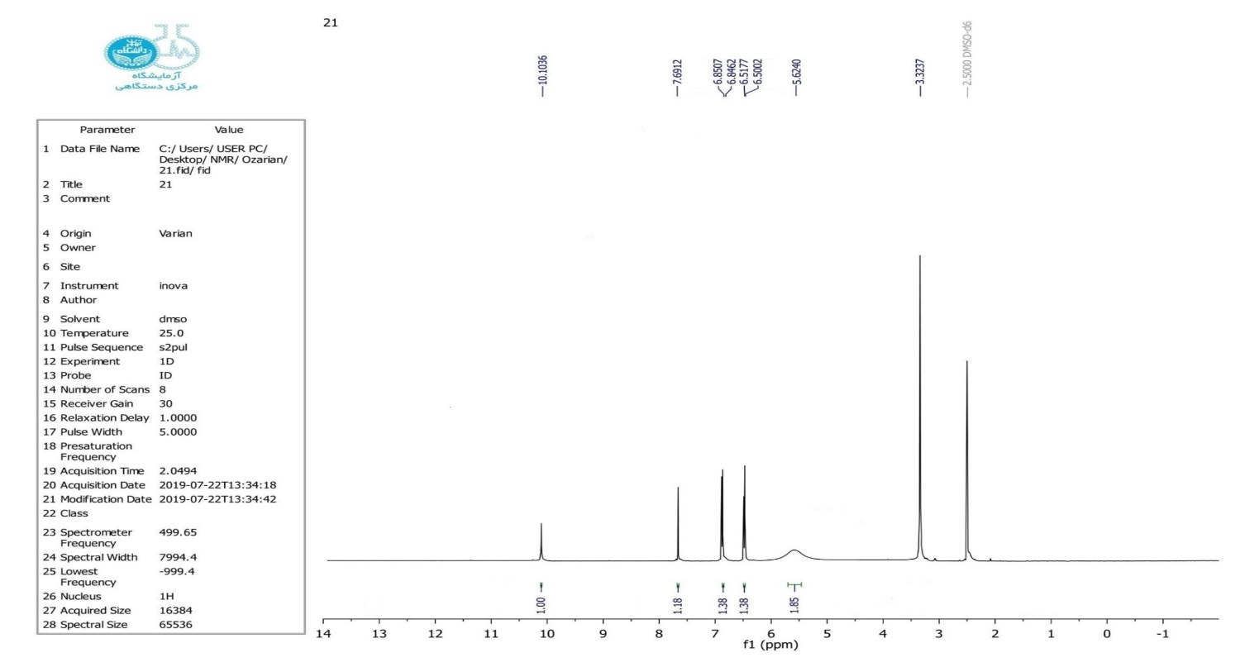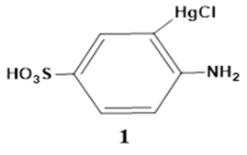

e

d

c

b

a

DMSO

**Figure S1**. 1H NMR spectrum of compound 1.

e

DMSO

d

c

b

a

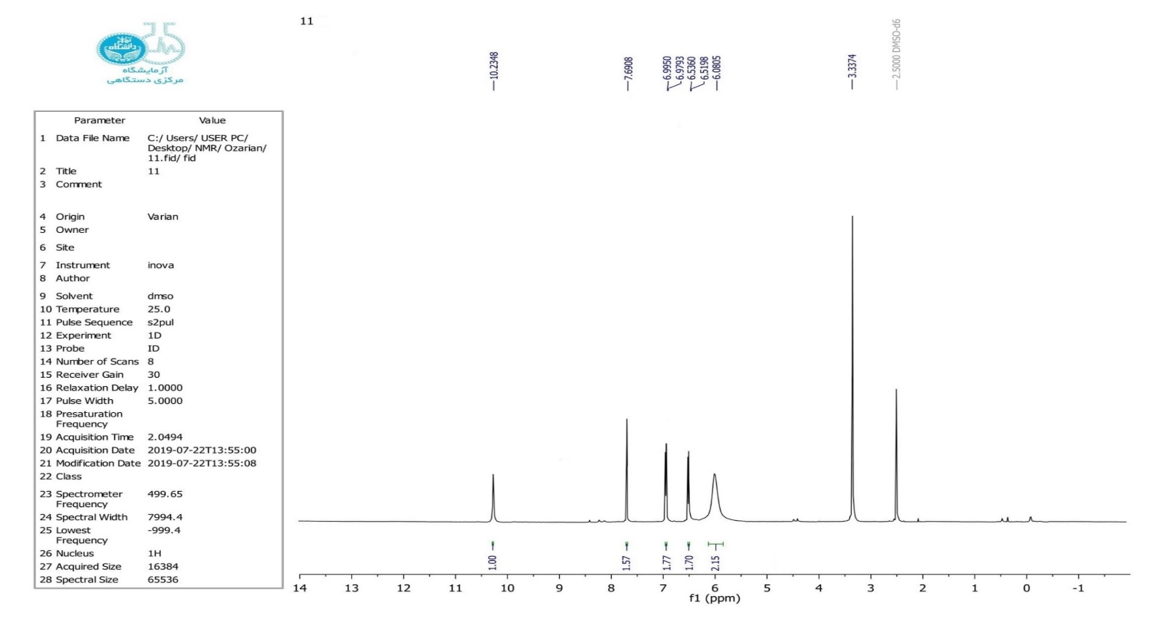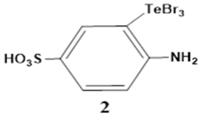

**Figure S2**. 1H NMR spectrum of compound 2.

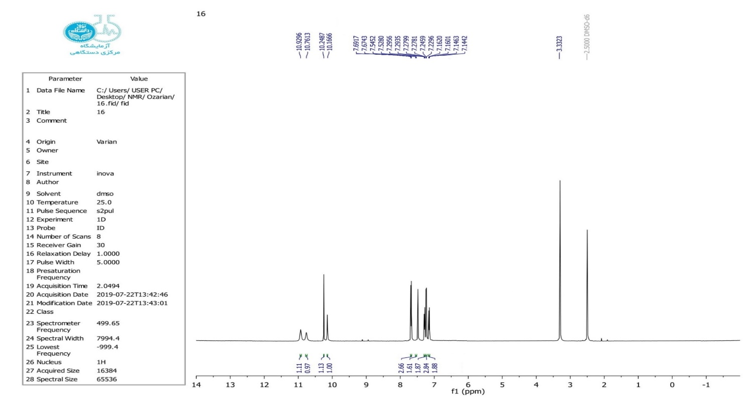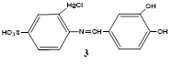

DMSO

d

]

b

c

a

**Figure S3**. 1H NMR spectrum of compound 3.

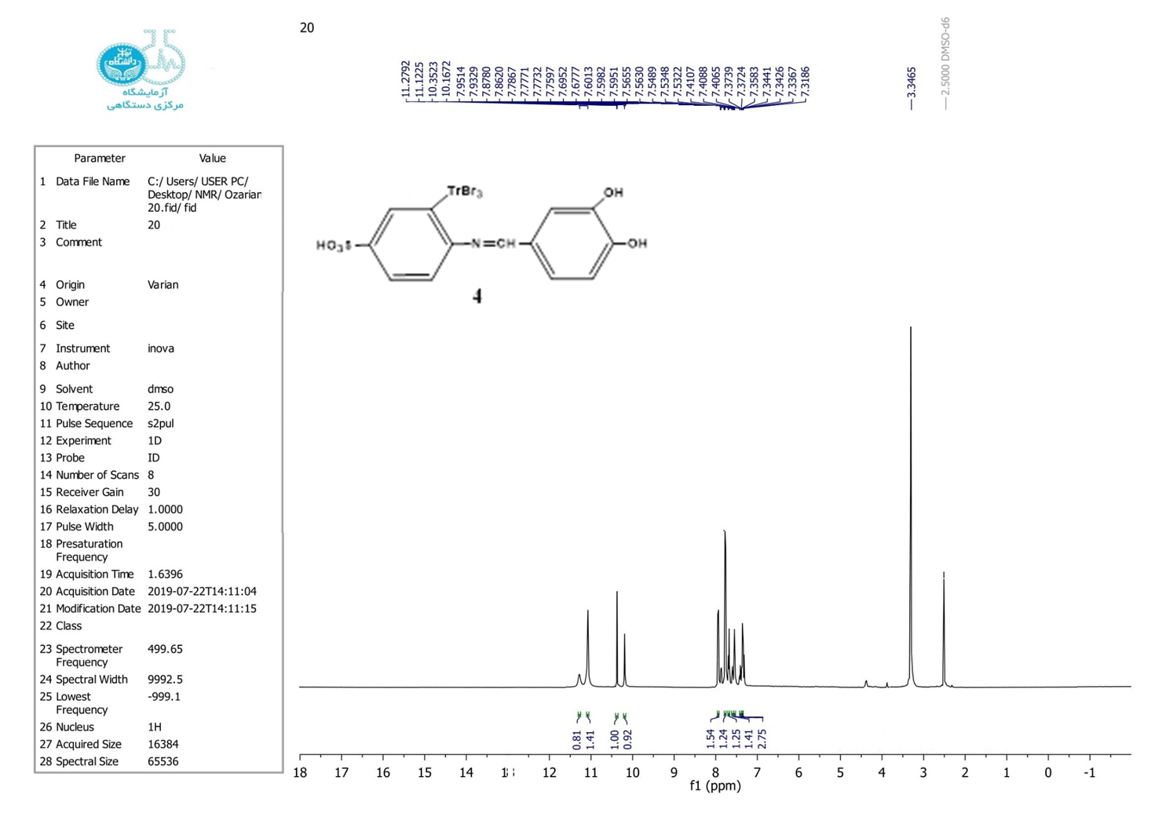

d

]

c

b

a

**Figure S4**. 1H NMR spectrum of compound 4.

d

c

b

a

DMSO

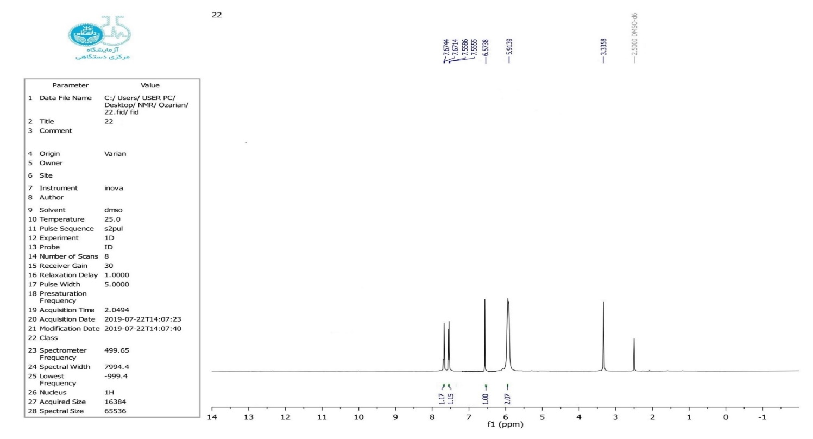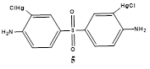

**Figure S5**. 1H NMR spectrum of compound 5.

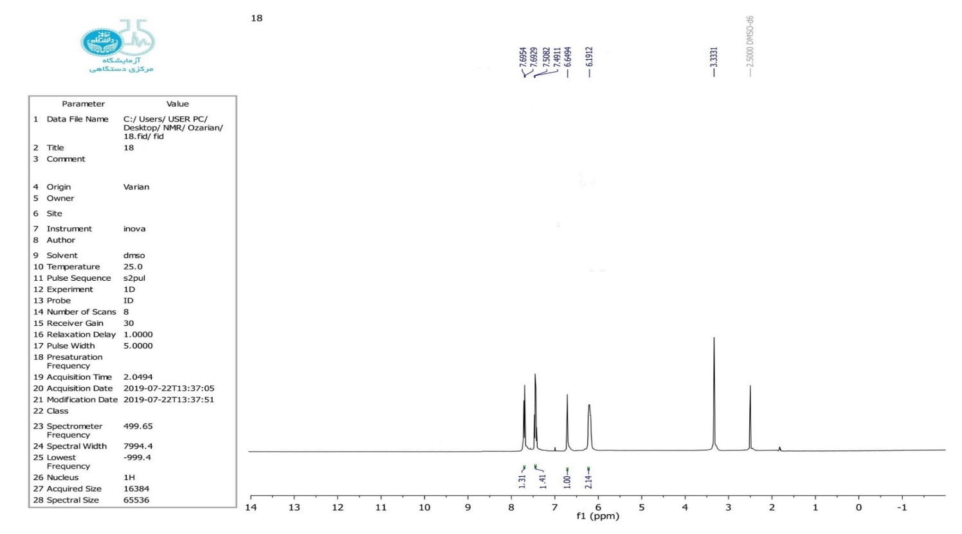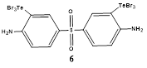

DMSO

b

d

c

a

**Figure S6**. 1H NMR spectrum of compound 6.

DMSO

b

]

a

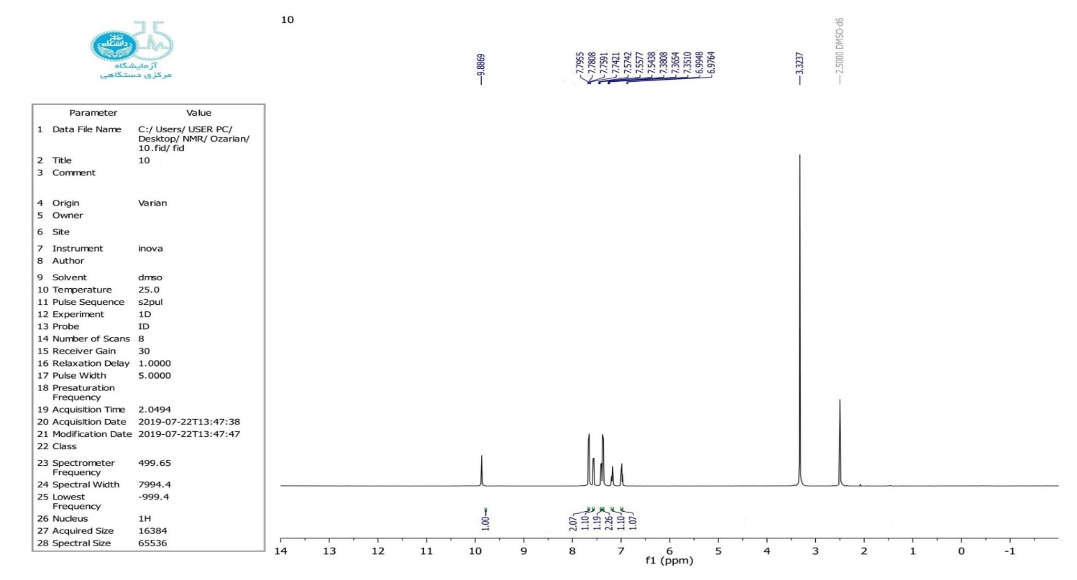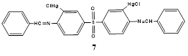

**Figure S7**. 1H NMR spectrum of compound 7.

DMSO

b

]

a

**Figure S8**. 1H NMR spectrum of compound 8.

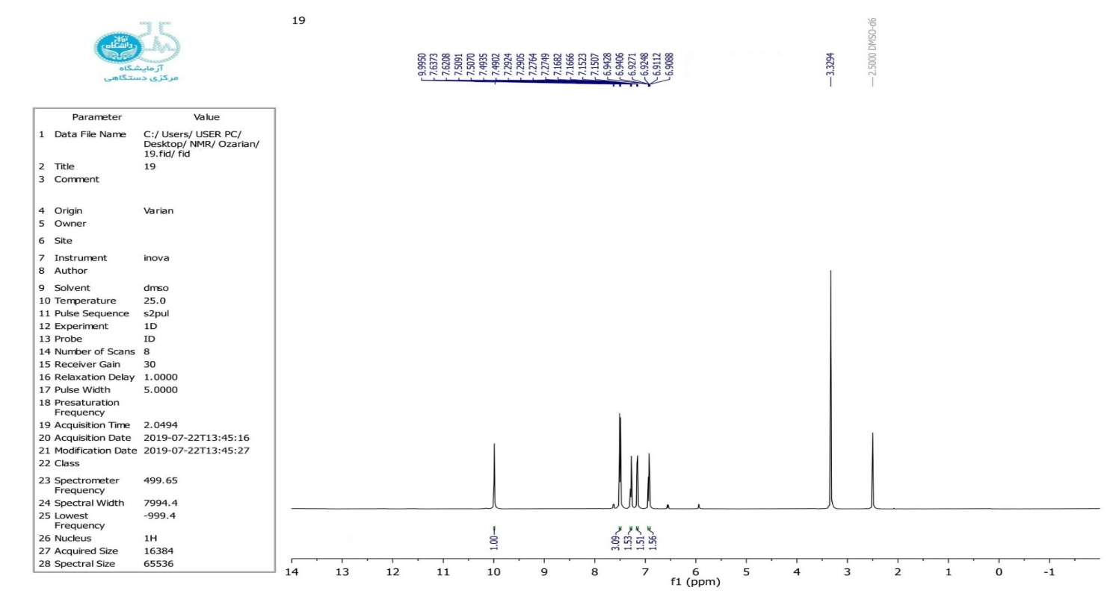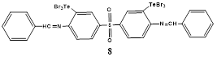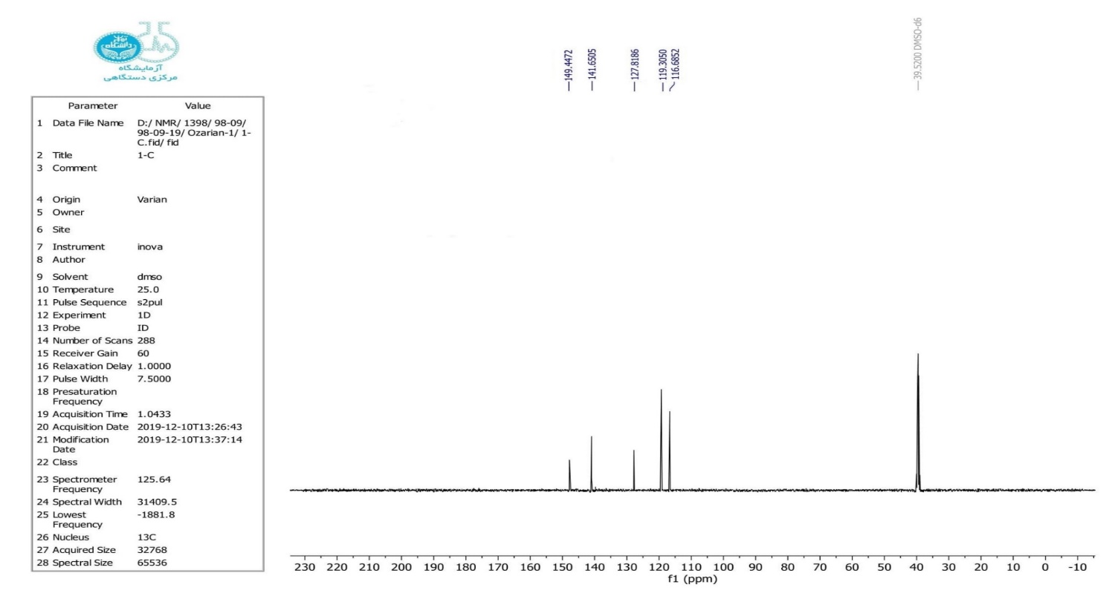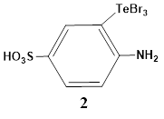

**Figure S9**. 13C NMR spectrum of compound 2.

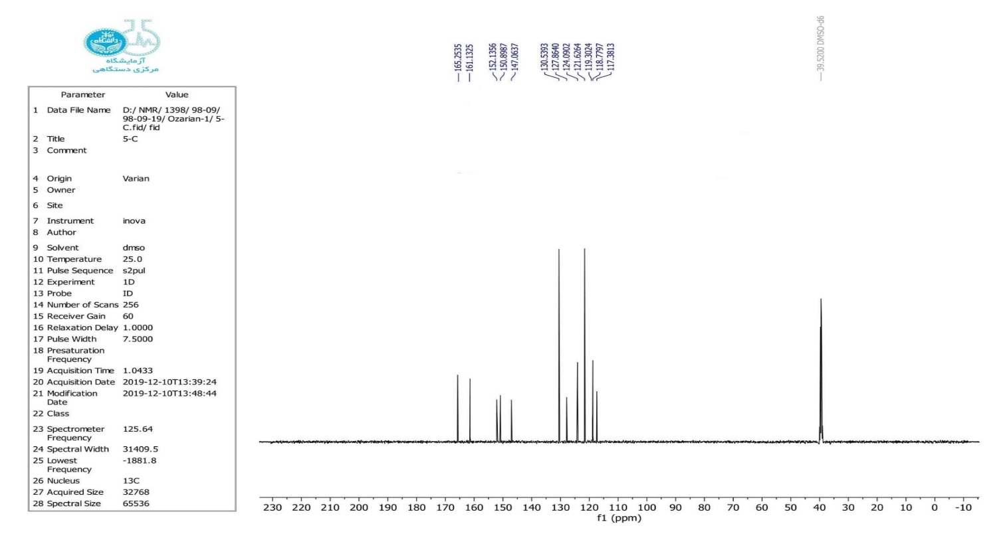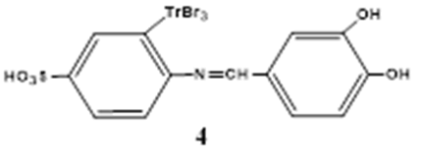

**Figure S10**. 13C NMR spectrum of compound 4.

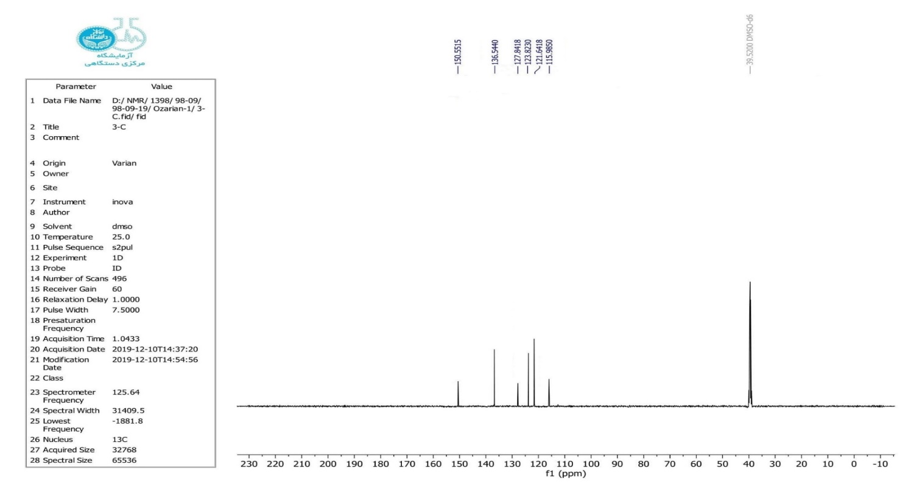

**Figure S11**. 13C NMR spectrum of compound 5.

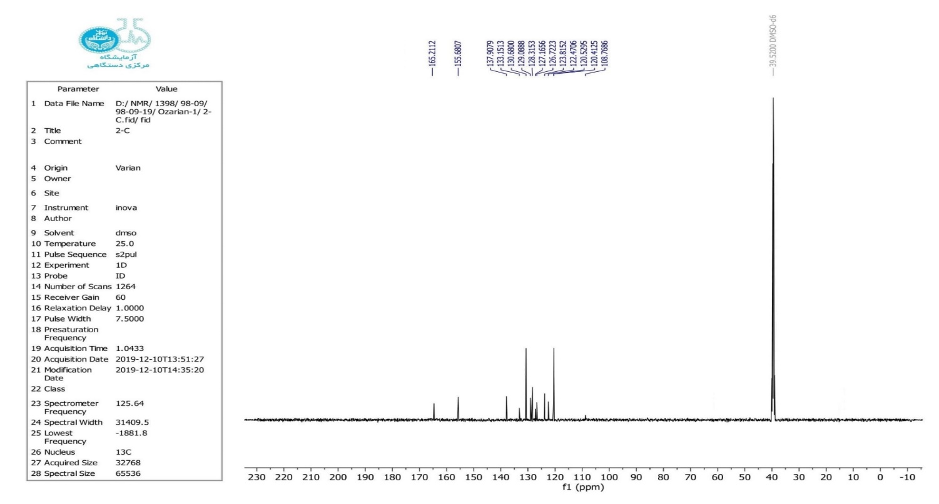

**Figure S12**. 13C NMR spectrum of compound 8.

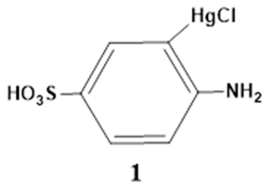

**Figure S13**. FTIR spectrum of compound 1.



**Figure S14**. FTIR spectrum of compound 2.

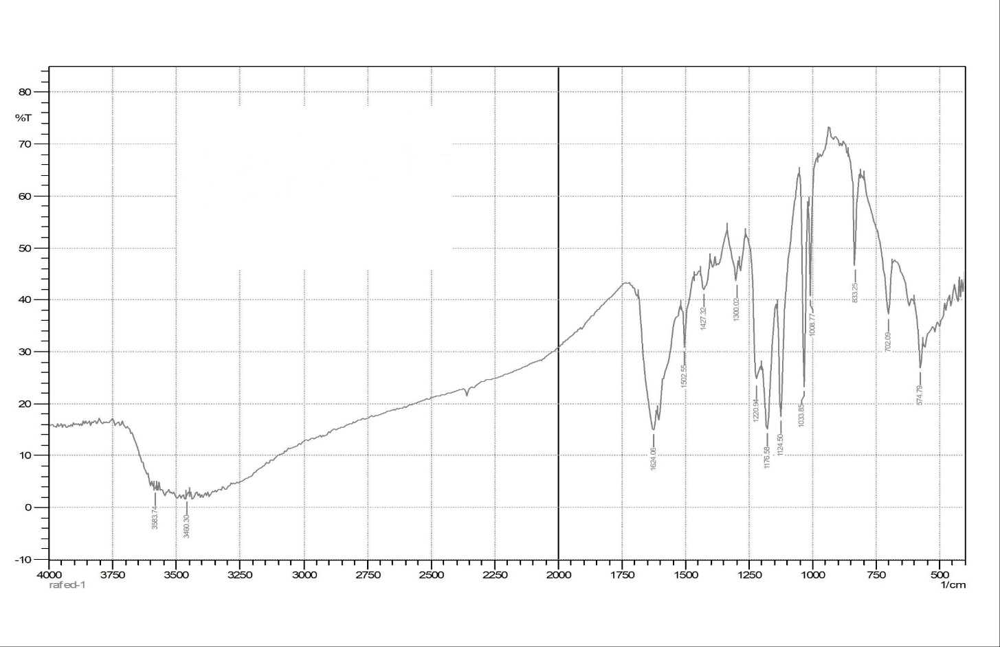

**Figure S15**. FTIR spectrum of compound 3.

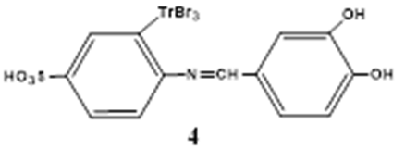

**Figure S16**. FTIR spectrum of compound 4.



**Figure S17**. FTIR spectrum of compound 5.



**Figure S18**. FTIR spectrum of compound 6.

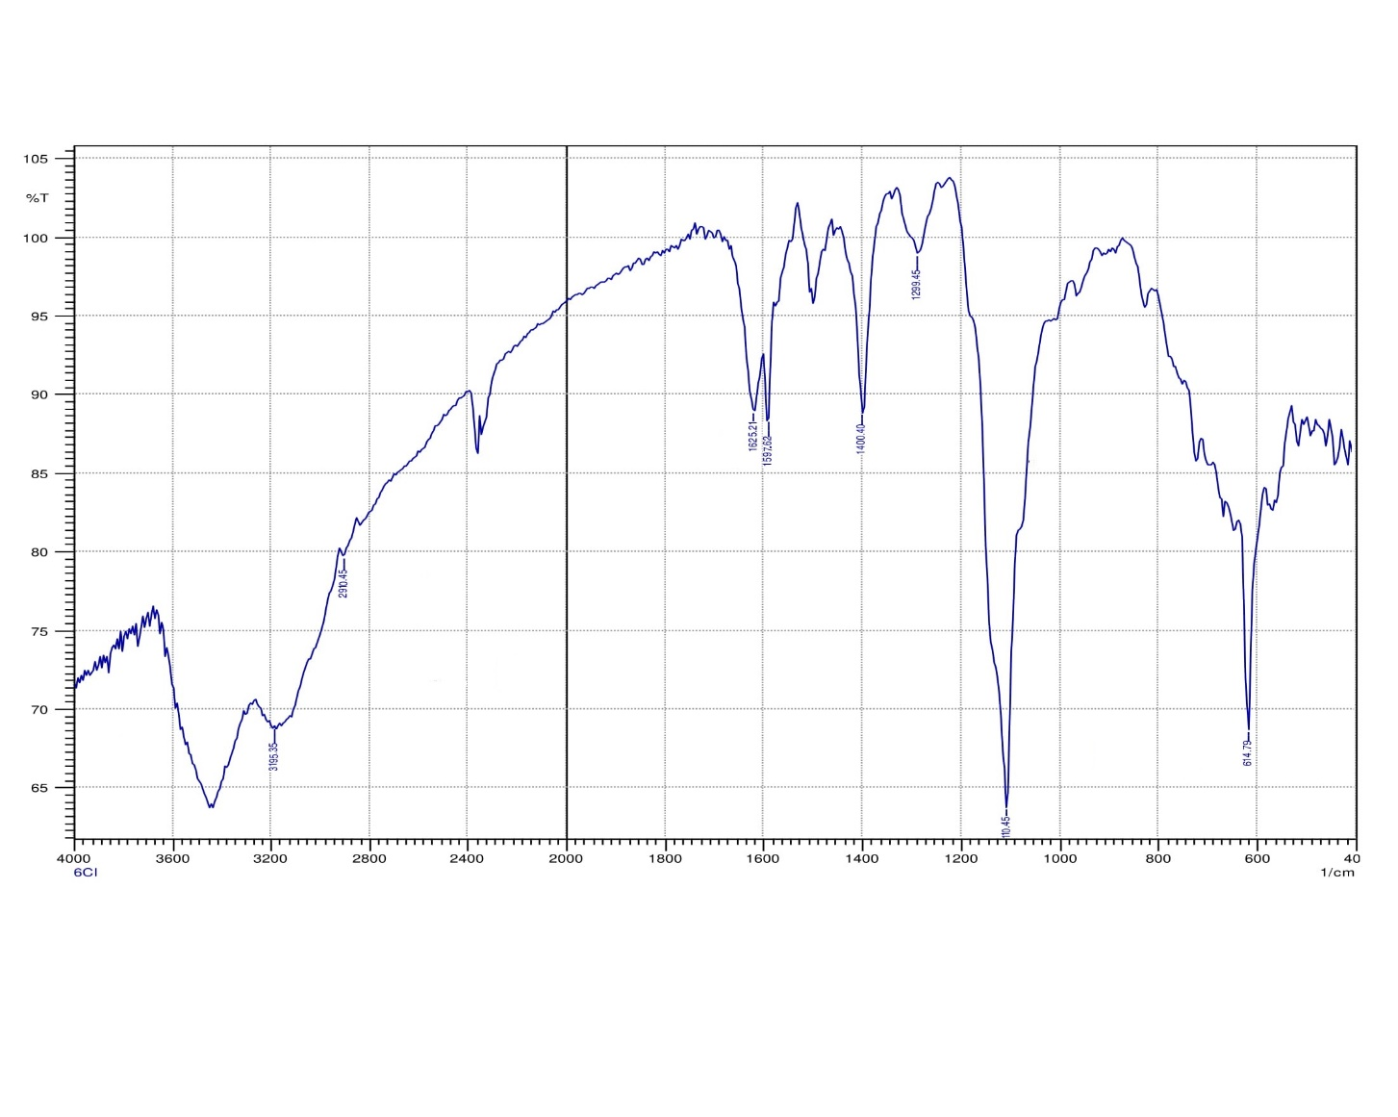

**Figure S19**. FTIR spectrum of compound 7.



**Figure S20**. FTIR spectrum of compound 8.