Figure (1S): Material used in RMC (source: AQR, 2017 [5]).

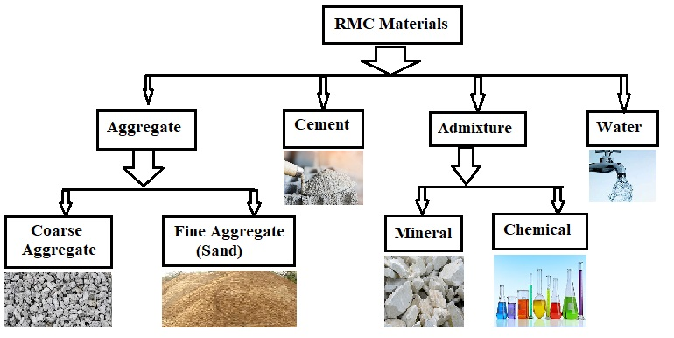

Figure (2S): Typical Ready-Mixed Concrete processes (source: Trought, 2010 [26]).

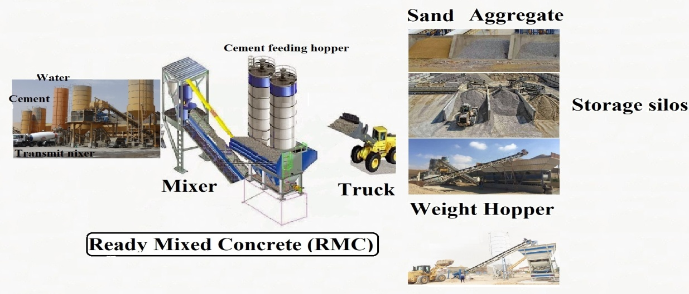

Figure (3S): PM emitted from basic process in RMC (source: USEPA, 1995 [27]).



Figure (4S): Sensitive land uses near RMC (source: EPA, 1998 [9]).

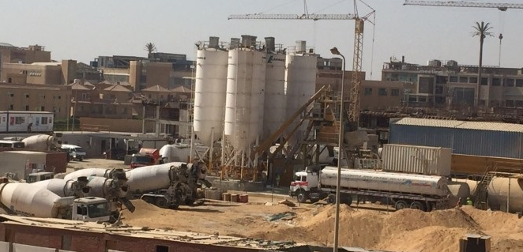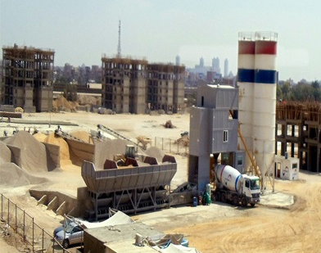

Table-1S: Description of specifications of each RMC plant

| Plant | | A | B | C | D | E |
| --- | --- | --- | --- | --- | --- | --- |
| Coordinates | Latitude | 29.920139° | 30.005391° | 30.139364° | 30.102814° | 30.229985° |
| Longitude | 30.882262° | 31.065396° | 31.389727° | 31.356676° | 31.445665° |
| Wind speed (km/h, average for Cairo) | | 13 | 13 | 14 | 14 | 14 |
| Prevailing direction (for Cairo) | | NNE | NNE | NNE | NNE | NNE |
| RH% (average for Cairo) | | 53% | 53% | 53% | 53% | 53% |
| RMC area (m2) | | 60000 | 800000 | 90000 | 90000 | 360000 |
| Maximum daily production rate (m3/day) | | 300 | 900 | 600 | 600 | 1000 |
| No. of workers (person) | | 15 | 50 | 245 | 200 | 125 |
| Maximum working hours per day (hour/day) | | 12 | 12 | 16 | 16 | 12 |
| Annual operating days (day/year) | | 200 | 200 | 200 | 200 | 200 |
| Annual hours of operation (hour/year) | | 2400 | 2400 | 3200 | 3200 | 2400 |
| Diesel consumption for Generator (m3/hour) | | 0.05 | 0.7 | 0.1 | 0.1 | 1 |
| Diesel consumption for Equipment (m3/hour) | | 0.05 | 1.3 | 0.5 | 0.5 | 1 |

Table-2S: Description of t-Test (Paired Samples Test)

|  |  |  |  |  |  |  |  |  |  |
| --- | --- | --- | --- | --- | --- | --- | --- | --- | --- |
| pairs | | Paired Differences | | | | | t | df | Sig. (2-tailed)  Significance |
| Mean | Std. Deviation | Std. Error Mean | 95% Confidence Interval of the Difference | |
| Lower | Upper |
| A | TSP - PM10 | 0.272 | 0.491 | 0.245 | -0.508 | 1.053 | 1.111 | 3 | 0.348 |
| TSP - PM2.5 | 0.34833 | 0.52613 | 0.21479 | -0.20381 | 0.90048 | 1.622 | 5 | 0.001* |
| PM10 - PM2.5 | 0.13400 | 0.11216 | 0.05016 | -0.00527 | 0.27327 | 2.671 | 4 | 0.056 |
| B | TSP - PM10 | 1.052 | 1.098 | 0.448 | -0.101 | 2.204 | 2.346 | 5 | 0.066 |
| TSP - PM2.5 | 1.31714 | 0.80579 | 0.30456 | 0.57192 | 2.06237 | 4.325 | 6 | 0.005* |
| PM10 - PM2.5 | 0.26333 | 0.29221 | 0.11929 | -0.04332 | 0.56999 | 2.207 | 5 | 0.078 |
| C | TSP - PM10 | 0.212 | 0.694 | 0.283 | -0.517 | 0.940 | 0.747 | 5 | 0.489 |
| TSP - PM2.5 | 0.49143 | 0.30732 | 0.11616 | 0.20720 | 0.77566 | 4.231 | 6 | 0.005* |
| PM10 - PM2.5 | 0.24000 | 0.44412 | 0.18131 | -0.22607 | 0.70607 | 1.324 | 5 | 0.243 |
| D | TSP - PM10 | 0.232 | 0.727 | 0.297 | -0.532 | 0.995 | 0.780 | 5 | 0.471 |
| TSP - PM2.5 | 0.52286 | 0.31758 | 0.12003 | 0.22914 | 0.81657 | 4.356 | 6 | 0.005* |
| PM10 - PM2.5 | 0.24333 | 0.47154 | 0.19250 | -0.25151 | 0.73818 | 1.264 | 5 | 0.262 |
| E | TSP - PM10 | 0.950 | 0.934 | 0.381 | -0.030 | 1.930 | 2.493 | 5 | 0.055 |
| TSP - PM2.5 | 1.46429 | 0.66575 | 0.25163 | 0.84857 | 2.08001 | 5.819 | 6 | 0.001* |
| PM10 - PM2.5 | 0.41167 | 0.43861 | 0.17906 | -0.04862 | 0.87196 | 2.299 | 5 | 0.070 |

*Significant (p < 0.05)

Table 3S: Comparison between levels of pollutants from RMC plants in the current study and other plants at USA

| Site / Pollutant | | Concentration (mg/m3) | | | | | | | |
| --- | --- | --- | --- | --- | --- | --- | --- | --- | --- |
| TSP | PM10 | PM2.5 | NO2 | SO2 | VOC | H2S | CO |
| The current study Cairo, Egypt | Plant - A | 0.37 | 0.21 | 0.14 | 0.06 | 0.12 | 1.36 | 0.10 | 0.62 |
| Plant - B | 1.58 | 0.58 | 0.38 | 0.04 | 0.04 | 1.58 | 0.14 | 3.68 |
| Plant - C | 0.67 | 0.43 | 0.25 | 0.06 | 0.21 | 9.50 | 0.11 | 1.25 |
| Plant - D | 0.72 | 0.45 | 0.27 | 0.25 | 0.24 | 9.77 | 0.16 | 1.10 |
| Plant - E | 1.92 | 0.79 | 0.37 | 0.05 | 0.25 | 12.63 | 0.22 | 0.93 |
| USA, North Carolina1 | Plant - 1 | - | 0.130 | 0.0012 | - | - | - | - | - |
| Plant - 2 | - | 0.427 | 0.0136 | - | - | - | - | - |
| Plant - 3 | - | 0.983 | 0.0163 | - | - | - | - | - |
| Plant - 4 | - | 0.495 | 0.0098 | - | - | - | - | - |
| Plant - 5 | - | 1.511 | 0.0108 | - | - | - | - | - |
| Plant - 6 | - | 0.855 | 0.0049 | - | - | - | - | - |
| USA, Toronto 2 | Plant - 1 | 0.046 | 0.0095 | 0.0080 | 0.35 | 0.069 | - | - | 0.082 |

Sources: 1 Richards and Brozell, 2005 [18]; 2 TPH, 2015 [20].

Table 4S: Comparison between emissions rate (g/s) of pollutants from RMC in the current study and other at different countries around the world

| Site / Pollutant | | | Emission Rate (g/s) | | | | | | | |
| --- | --- | --- | --- | --- | --- | --- | --- | --- | --- | --- |
| TSP | PM10 | PM2.5 | NO2 | SO2 | VOC | H2S | CO |
| The current study | | Plant - A | 1.42 | 0.43 | 0.055 | 0.47 | 0.89 | 9.04E-07 | 0.04 | 0.57 |
| Plant - B | 1.42 | 0.43 | 0.055 | 4.14 | 3.63 | 1.39E-05 | 0.59 | 9.16 |
| Plant - C | 0.78 | 0.24 | 0.031 | 0.84 | 3.02 | 1.26E-05 | 0.53 | 1.25 |
| Plant - D | 0.78 | 0.24 | 0.031 | 3.69 | 3.48 | 1.29E-05 | 0.55 | 1.49 |
| Plant - E | 1.42 | 0.43 | 0.055 | 2.09 | 11.09 | 5.02E-05 | 2.12 | 6.57 |
| USA | Virginia1 | Plant - 1 | 7.21 | 2.19 | 0.07 | 1.010 | 0.45 | 0.07 | - | 0.24 |
| Nevada2 | Plant - 1 | - | 2.73 | 1.04 | 1.240 | 0.61 | 0.39 | - | 2.09 |
| California3 | Plant - 1 | - | 0.0279 | 0.0067 | 0.038 | 0.0001 | - | - | 0.142 |
| Plant - 2 | - | 0.0005 | 0.0001 | - | - | - | - | - |
| Plant - 3 | - | 0.00001 | 0.000002 | - | - | - | - | - |
| North Carolina4 | Plant - 1 | 1.4E-07 | 10E-08 | 5.0 E -08 | - | - | - | - | - |
| Plant - 2 | 7.4 E -07 | 30 E -08 | 28 E -08 | - | - | - | - | - |
| Plant - 3 | 2.8 E -07 | 10 E -08 | 4.6 E -08 | - | - | - | - | - |
| Plant - 4 | 3.9 E -07 | 14 E -08 | 12 E -08 | - | - | - | - | - |
| Plant - 5 | 29E-07 | 73 E -08 | 1.7 E -08 | - | - | - | - | - |
| Portland5 | Plant - 1 | 0.272 | 0.067 | - | - | - | - | - | - |
| Plant - 2 | 0.544 | 0.134 | - | - | - | - | - | - |
| [Serbia](https://en.wikipedia.org/wiki/Serbia) | Belgrade6 | Plant - 1 | 0.711 | 0.193 | 0.0015 | 0.016 | 0.005 | 0.076 | - | 0.004 |
| Plant - 2 | 0.628 | 0.199 | 0.045 | 0.486 | 0.17‬ | 0.737 | - | 0.723 |

Sources: 1 Richards and Brozell, 2004 [17]; 2 USEPA, 2003 [14]; 3 MDEQ, 2011[23]; 4 AQR, 2017 [5]; 5 Woodson, 2012 [30]; 6 Marinković, 2013 [29].