**Supporting information**

**Synthesis and physicochemical characterization of Schiff base complexes and examination of their selectivity index for breast and colon cancer cells.**

**Rania H. Taha1,2,*, Esmail M. El-Fakharany3,*, Zienab A. El-Shafiey2, Aida A. Salman2, Mai M. Mansour2, Mohamed Yahia4,*.**

1Chemistry Department, College of Science, Jouf University, P.O. Box: 2014, Sakaka, Saudi Arabia.

2Department of Chemistry, Faculty of Science (Girls), Al-Azhar University, P.O. Box: 11754, Yousef Abbas Str., Nasr City, Cairo, Egypt.

3Protein Research Department, Genetic Engineering and Biotechnology Research Institute (GEBRI), City of Scientific Research & Technological Applications (SRTA-City), New Borg El-Arab City, P.O. Box: 21934, Alexandria, Egypt.

4Department of Chemistry, Faculty of Science, Helwan University, Ain-Helwan, 11795 Cairo, Egypt.

**\*Corresponding authors:**

Dr. Rania H. Taha ([mhmd_mosad@yahoo.com](mailto:mhmd_mosad@yahoo.com) ; [rhaly@ju.edu.sa](mailto:rhaly@ju.edu.sa) );

Dr. Mohamed Yahia ([mohamed.yahia@science.helwan.edu.eg](mailto:mohamed.yahia@science.helwan.edu.eg) ; [Yahia_sci@yahoo.com](mailto:Yahia_sci@yahoo.com) ).

**Table S1:** Analytical data and some physical properties of Schiff base ligand, and its complexes

|  |  |  |  |  |  |  |  |  |  |
| --- | --- | --- | --- | --- | --- | --- | --- | --- | --- |
| Elem. Anal . found (calcd. ) | | | | | | *Ʌ* m * | M.P(0c) | Colour | Molecular formula (M.Wt) |
| M | **Cl** | **O** | **N** | **H** | **C** |  |  |  |  |
| ------- | ------- | 8.12  (8.05) | 10.98  (10.57) | 5.77  (5.84) | 75.65  (75.53) | 0.68 | 155 | Orange | HL  C25H23N3O2 (397.51) |
| 11.72  (10.81) | 7.88  (6.50) | 13.97  (14.68) | 7.42  (7.71) | 4.99  (5.18) | 54.08  (55.09) | 7.42 | 170 | Yellowish green | (1)[Co(HL)Cl (H2O)3]  CoC25H22N3O2Cl(H2O)3(544.95) |
| 22.62  (18.78) | 5.88  (5.92) | 13.98  (13.36) | 7.53  (7.02) | 4.55  (4.72) | 50.02  (50.17) | 1.78 | 210 | Yellowish White | (2)[Cd(HL)Cl.(H2O)3]  CdC25H22N3O2Cl(H2O)3 (598.42) |
| 20.34  (19.86) | -------- | 23.78  (23.03) | 10.67  (10.08) | 3.65  (3.78) | 44.23  (43.22) | 7.17 | 188 | Yellow | (3)[La(HL)(NO3)3(H2O)]  LaC25H22N3O2(NO3)3 (H2O)2 (694.56) |
| 21.98  (22.02) | ------- | 22.98  (22.41) | 10.09  (9.81) | 3.55  (3.67) | 42.76  (42.06) | 1.58 | 195 | Yellow | (4) [Gd(HL)(NO3)3(H2O)]  GdC25H22N3O2(NO3)3 (H2O)2 (713.81) |
| 21.85  (22.02) | ------- | 22.38  (22.41) | 9.19  (9.81) | 3.24  (3.67) | 41.62  (42.06) | 1.50 | 115 | Yellow | (5) [Gd(HL)(NO3)3(H2O)]  GdC25H22N3O2(NO3)3 (H2O)2 (713.81) (nano) |

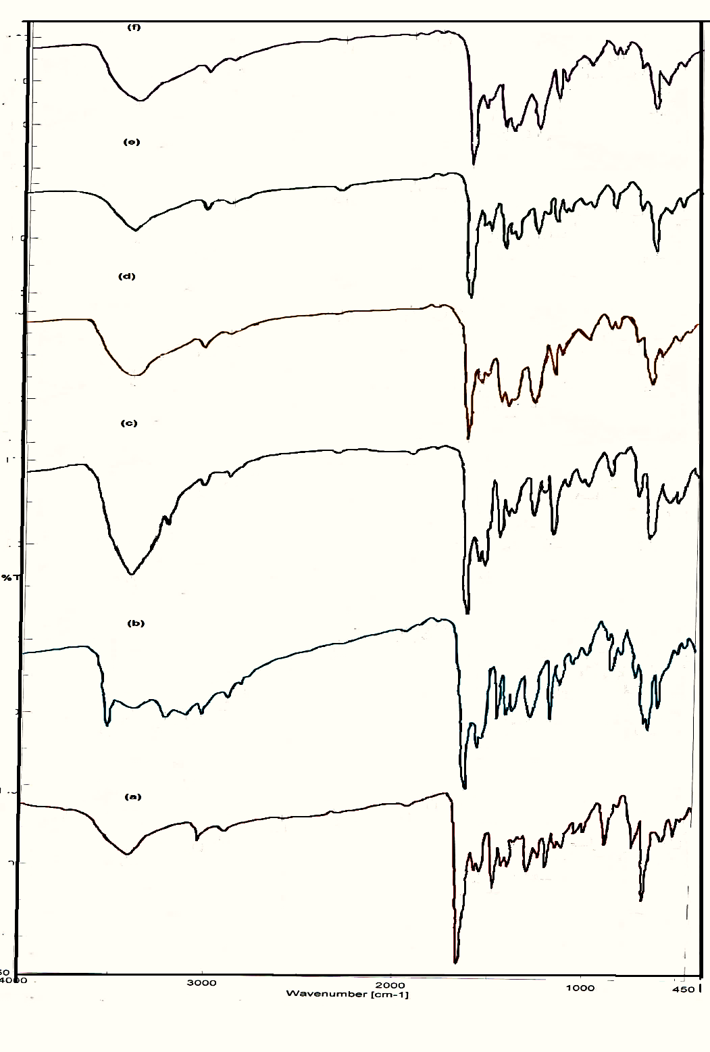

**Fig.S1.** IR spectrum analysis of (a) HL ligand, (b) complex of cobalt [Co(HL)Cl.3H2O], (c) complex of cadmium [Cd(HL)Cl.3H2O], (d) complex of lithium [La(HL)(NO3)3.H2O], (e) complex of Gadolinium [Gd(HL)(NO3)3.H2O] and (f) nano-complex of lithium [La(HL)(NO3)3.H2O].

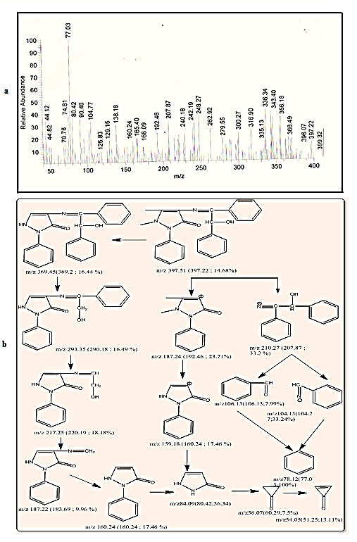

**Fig.S2.** Mass spectrum fragmentation pathway of the ligand (b).

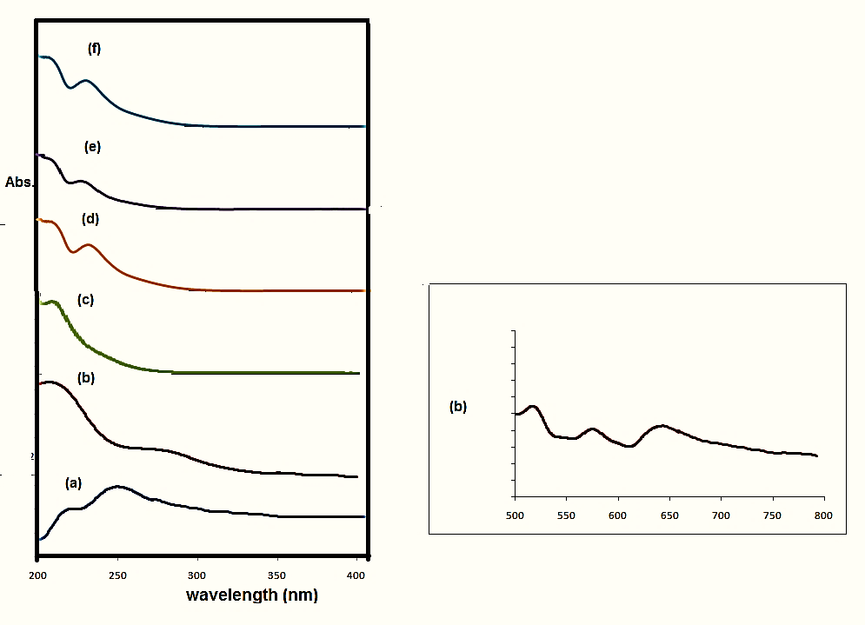

**Fig.S3.** UV spectra analysis of (a) HL ligand, (b) [Co(HL)(Cl).3H2O], (c) [Cd(HL)(Cl).3H2O], (d) [La(HL).(NO3)3.H2O], (e) [Gd(HL).(NO3)3.H2O] and (f) [Gd(HL).(NO3)3.H2O] (nano).

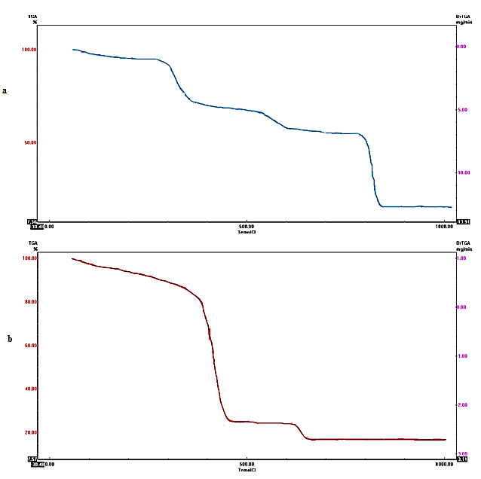

**Fig.S4.** TGA curve of (a) [Co(HL).Cl.3H2O] complex and (b) TGA curve of the [La(HL).(NO3)3 .H2O] complex.



**Fig.S5.** Illustration represents the proposed structure of the metal complexes.