Synthesis, Characterization, Crystal structure of 4-(4-Bromo-phenyl)-2,6-dimethyl-1,4-dihydro-pyridine-3,5-dicarboxylic acid diethyl ester: Hirshfeld surface analysis and DFT calculations
D. Parthasarathiª, M. Syed Ali Padusha^{a*}, S. Suganya^{b}, P. Kumaradhas^{b}, Ayyiliath M. Sajith^{,c} Muthipeedika Nibin Joy^{d}

Fig.S1. ¹H NMR spectrum of 4-(4-Bromo-phenyl)-2,6-dimethyl-1,4-dihydro-pyridine-3,5-dicarboxylic acid diethyl ester

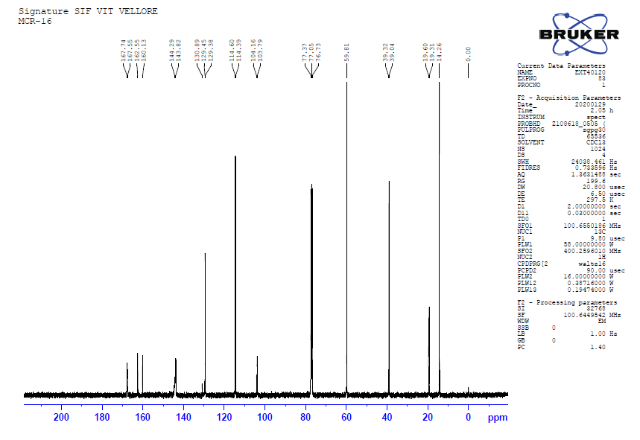
Fig.S2. ¹³C NMR spectrum of 4-(4-Bromo-phenyl)-2,6-dimethyl-1,4-dihydro-pyridine-3,5-dicarboxylic acid diethyl ester

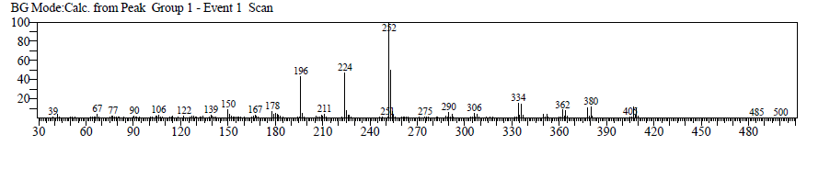 Fig.S3. GC-MS spectrum of 4-(4-Bromo-phenyl)-2,6-dimethyl-1,4-dihydro-pyridine-3,5-dicarboxylic acid diethyl ester

Table S1. Geometric Parameters for crystal phase (CP) and DFT phase
Bonds | Crystal Phase | DFT  Phase | Bonds | Crystal Phase | DFT
Br1—C6 | 1.901 (3) | 1.9224 | C2—C1 | 1.389 (4) | 1.3933
O3—C12 | 1.215 (3) | 1.2157 | C2—H2 | 0.95 (3) | 1.0836
O1—C17 | 1.347 (4) | 1.3559 | C1—H1 | 0.95 (3) | 1.0825
O1—C18 | 1.454 (4) | 1.4466 | C15—H15A | 0.96 | 1.0865
O4—C12 | 1.342 (3) | 1.3594 | C15—H15B | 0.96 | 1.0937
O4—C13 | 1.449 (3) | 1.4488 | C15—H15C | 0.96 | 1.0928
N1—C9 | 1.377 (3) | 1.3886 | C5—C4 | 1.379 (4) | 1.3926
N1—C10 | 1.381 (3) | 1.3875 | C5—H5 | 0.93 (4) | 1.0825
N1—H1A | 0.85 (3) | 1.0075 | C4—H4 | 0.94 (4) | 1.0829
O2—C17 | 1.207 (3) | 1.2164 | C16—H16A | 0.96 | 1.0947
C11—C10 | 1.352 (3) | 1.3591 | C16—H16B | 0.96 | 1.0947
C11—C12 | 1.461 (3) | 1.4709 | C16—H16C | 0.96 | 1.0853
C11—C7 | 1.526 (3) | 1.5296 | C13—C14 | 1.450 (6) | 1.5202
C10—C15 | 1.500 (3) | 1.5068 | C13—H13A | 0.97 | 1.0903
C3—C2 | 1.380 (4) | 1.3978 | C13—H13B | 0.97 | 1.0907
C3—C4 | 1.381 (4) | 1.3989 | C18—C19 | 1.435 (6) | 1.5203
C3—C7 | 1.523 (3) | 1.5354 | C18—H18A | 0.97 | 1.0907
C8—C9 | 1.350 (4) | 1.3579 | C18—H18B | 0.97 | 1.0904
C8—C17 | 1.472 (3) | 1.475 | C19—H19A | 0.96 | 1.0922
C8—C7 | 1.521 (3) | 1.5225 | C19—H19B | 0.96 | 1.094
C7—H7 | 1.02 (2) | 1.088 | C19—H19C | 0.96 | 1.091
C9—C16 | 1.500 (4) | 1.504 | C14—H14A | 0.96 | 1.0928
C6—C1 | 1.363 (4) | 1.3897 | C14—H14B | 0.96 | 1.0907
C6—C5 | 1.371 (4) | 1.3903 | C14—H14C | 0.96 | 1.094
C17—O1—C18 | 117.8 (3) | 117.0344 | C10—C15—H15B | 109.5 | 110.1583
C12—O4—C13 | 118.2 (2) | 116.567 | H15A—C15—H15B | 109.5 | 108.8023
C9—N1—C10 | 123.6 (2) | 123.9165 | C10—C15—H15C | 109.5 | 110.9229
C9—N1—H1A | 120 (2) | 116.7783 | H15A—C15—H15C | 109.5 | 107.1514
C10—N1—H1A | 116 (2) | 117.0055 | H15B—C15—H15C | 109.5 | 108.2906
C10—C11—C12 | 124.5 (2) | 125.38 | C6—C5—C4 | 119.5 (3) | 119.0794
C10—C11—C7 | 120.9 (2) | 119.8379 | C6—C5—H5 | 122 (2) | 120.4297
C12—C11—C7 | 114.58 (19) | 114.7809 | C4—C5—H5 | 119 (2) | 120.4907
C11—C10—N1 | 119.0 (2) | 118.1477 | C5—C4—C3 | 121.6 (3) | 121.3262
C11—C10—C15 | 128.4 (2) | 128.3138 | C5—C4—H4 | 120 (2) | 119.5898
N1—C10—C15 | 112.6 (2) | 113.516 | C3—C4—H4 | 118 (2) | 119.0742
C2—C3—C4 | 117.4 (2) | 118.1539 | C9—C16—H16A | 109.5 | 110.4112
C2—C3—C7 | 121.0 (2) | 121.9995 | C9—C16—H16B | 109.5 | 110.051
C4—C3—C7 | 121.5 (2) | 119.8345 | H16A—C16—H16B | 109.5 | 108.0239
C9—C8—C17 | 120.9 (2) | 120.9129 | C9—C16—H16C | 109.5 | 111.4658
C9—C8—C7 | 120.9 (2) | 119.8506 | H16A—C16—H16C | 109.5 | 106.9855
C17—C8—C7 | 118.0 (2) | 119.2064 | H16B—C16—H16C | 109.5 | 109.7996
C8—C7—C3 | 111.23 (18) | 112.8531 | O4—C13—C14 | 109.4 (3) | 111.6913
C8—C7—C11 | 110.82 (19) | 110.7438 | O4—C13—H13A | 109.8 | 108.7912
C3—C7—C11 | 110.58 (18) | 110.9364 | C14—C13—H13A | 109.8 | 111.1041
C8—C7—H7 | 109.2 (14) | 108.4527 | O4—C13—H13B | 109.8 | 104.1482
C3—C7—H7 | 108.9 (14) | 106.3825 | C14—C13—H13B | 109.8 | 111.3948
C11—C7—H7 | 105.9 (14) | 107.1854 | H13A—C13—H13B | 108.2 | 109.4585
O3—C12—O4 | 122.1 (2) | 122.0076 | C19—C18—O1 | 111.5 (4) | 111.3991
O3—C12—C11 | 123.2 (2) | 123.3481 | C19—C18—H18A | 109.3 | 111.2034
O4—C12—C11 | 114.6 (2) | 114.6359 | O1—C18—H18A | 109.3 | 108.8115
C8—C9—N1 | 119.3 (2) | 118.4698 | C19—C18—H18B | 109.3 | 111.4188
C8—C9—C16 | 127.2 (2) | 127.7333 | O1—C18—H18B | 109.3 | 104.1754
N1—C9—C16 | 113.5 (2) | 113.7707 | H18A—C18—H18B | 108 | 109.5789
O2—C17—O1 | 121.9 (3) | 122.3563 | C18—C19—H19A | 109.5 | 110.7508
O2—C17—C8 | 127.0 (3) | 126.5793 | C18—C19—H19B | 109.5 | 109.7676
O1—C17—C8 | 111.0 (2) | 111.0633 | H19A—C19—H19B | 109.5 | 108.3947
C1—C6—C5 | 120.6 (3) | 121.0242 | C18—C19—H19C | 109.5 | 110.64
C1—C6—Br1 | 120.0 (2) | 119.434 | H19A—C19—H19C | 109.5 | 108.944
C5—C6—Br1 | 119.4 (2) | 119.5416 | H19B—C19—H19C | 109.5 | 108.2765
C3—C2—C1 | 121.5 (2) | 121.3728 | C13—C14—H14A | 109.5 | 110.8596
C3—C2—H2 | 119.8 (19) | 119.9587 | C13—C14—H14B | 109.5 | 110.5998
C1—C2—H2 | 118.6 (19) | 118.6662 | H14A—C14—H14B | 109.5 | 109.0211
C6—C1—C2 | 119.3 (3) | 119.0432 | C13—C14—H14C | 109.5 | 109.7555
C6—C1—H1 | 118 (2) | 120.3913 | H14A—C14—H14C | 109.5 | 108.2299
C2—C1—H1 | 123 (2) | 120.5647 | H14B—C14—H14C | 109.5 | 108.3037
C10—C15—H15A | 109.5 | 111.4044
C12—C11—C10—N1 | 174.4 (2) | 170.5713 | C17—C8—C9—N1 | -178.7 (2) | -174.973
C7—C11—C10—N1 | -6.2 (3) | -9.0038 | C7—C8—C9—N1 | 6.0 (3) | 7.0375
C12—C11—C10—C15 | -4.0 (4) | -7.5793 | C17—C8—C9—C16 | -0.6 (4) | 3.0407
C7—C11—C10—C15 | 175.3 (2) | 172.8455 | C7—C8—C9—C16 | -175.8 (2) | -174.949
C9—N1—C10—C11 | -13.4 (4) | -16.3313 | C10—N1—C9—C8 | 13.6 (4) | 17.4349
C9—N1—C10—C15 | 165.3 (2) | 162.0863 | C10—N1—C9—C16 | -164.9 (2) | -160.849
C9—C8—C7—C3 | 101.2 (2) | 96.8254 | C18—O1—C17—O2 | -6.8 (4) | -0.2994
C17—C8—C7—C3 | -74.2 (3) | -81.1984 | C18—O1—C17—C8 | 172.6 (3) | -179.943
C9—C8—C7—C11 | -22.3 (3) | -28.2233 | C9—C8—C17—O2 | -3.4 (4) | 0.9975
C17—C8—C7—C11 | 162.4 (2) | 153.7529 | C7—C8—C17—O2 | 171.9 (3) | 178.9997
C2—C3—C7—C8 | -65.8 (3) | -39.0984 | C9—C8—C17—O1 | 177.2 (2) | -179.377
C4—C3—C7—C8 | 115.3 (3) | 142.1897 | C7—C8—C17—O1 | -7.5 (3) | -1.3749
C2—C3—C7—C11 | 57.8 (3) | 85.8456 | C4—C3—C2—C1 | -1.2 (4) | 0.2013
C4—C3—C7—C11 | -121.1 (3) | -92.8663 | C7—C3—C2—C1 | 179.9 (3) | -178.531
C10—C11—C7—C8 | 22.4 (3) | 29.2955 | C5—C6—C1—C2 | 1.0 (5) | 0.047
C12—C11—C7—C8 | -158.2 (2) | -150.323 | Br1—C6—C1—C2 | -179.8 (2) | -179.81
C10—C11—C7—C3 | -101.4 (3) | -96.8298 | C3—C2—C1—C6 | 0.0 (5) | -0.1678
C12—C11—C7—C3 | 77.9 (3) | 83.5518 | C1—C6—C5—C4 | -0.7 (5) | 0.034
C13—O4—C12—O3 | 8.4 (4) | -1.2759 | Br1—C6—C5—C4 | -180.0 (2) | 179.8907
C13—O4—C12—C11 | -173.3 (3) | 179.7446 | C6—C5—C4—C3 | -0.6 (5) | 0.0025
C10—C11—C12—O3 | -165.5 (3) | -177.65 | C2—C3—C4—C5 | 1.5 (4) | -0.1175
C7—C11—C12—O3 | 15.2 (4) | 1.9443 | C7—C3—C4—C5 | -179.6 (3) | 178.6435
C10—C11—C12—O4 | 16.3 (4) | 1.3143 | C12—O4—C13—C14 | 87.4 (4) | 84.5792
C7—C11—C12—O4 | -163.1 (2) | -179.092 | C17—O1—C18—C19 | -93.7 (4) | -85.9985

