Study of Efficient Ecofriendly Degradation of Some Organophosphate Pesticides Using Silver Vanadate Nanoparticles and Analytical Qualification of Their Fragmentations
Islam R. Ghoniemª *, Hassan A. El- Gammalª, Ashraf M. Elmarsafyª, Mohamed A. Amerª, Mohamed M. Abo Aly^{b}, Mostafa A. Sayed^{b}
ªCentral Laboratory of Residue Analysis of Pesticides and Heavy Metals in Foods,
Agricultural Research Center, Dokki, Giza, Egypt.
^{b}Departmentof Chemistry, Faculty of Science, Ain Shams University, Cairo, Egypt.

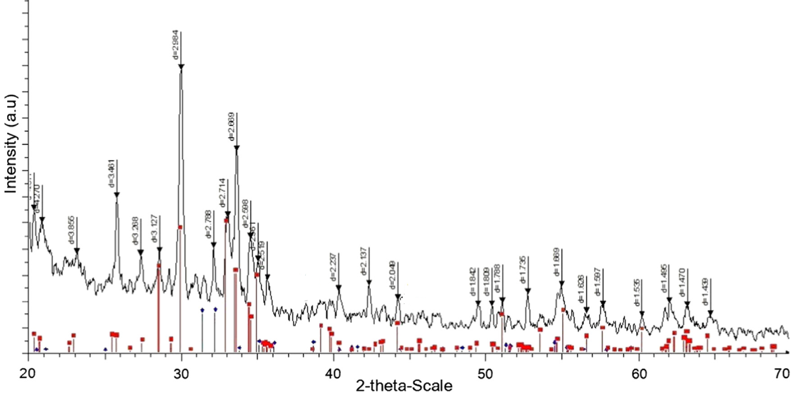
Fig. S1: XRD patterns of α-Ag₃VO₄ nanoparticles

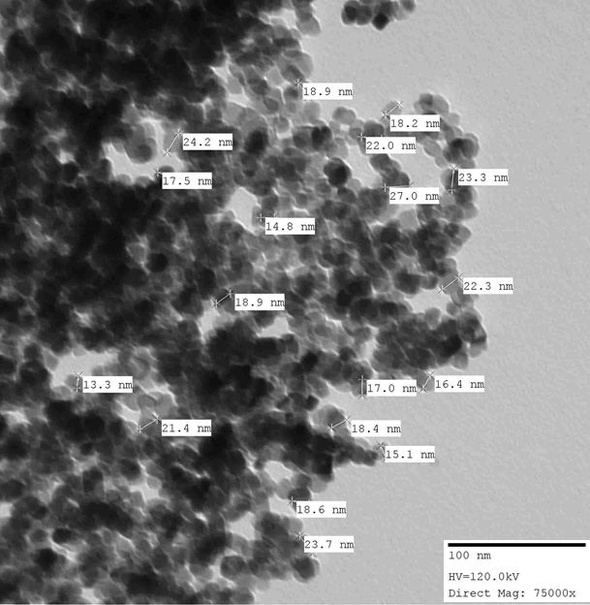
Fig. S2: TEM image of α-Ag₃VO₄ nanoparticles

