Optimization for Ultrasonic-Assisted Extraction of Aframomum melegueta Phenolics Using Response Surface Methodology

Supplementary material

Table S1 1H-NMR and ¹³C-NMR data of compounds C1-C3

Position | ¹H-NMR  (400 MHz, CDCl₃, δ in ppm, J in Hz) |  |  | ¹³C-NMR (100 MHz, CDCl_{3,} δ in ppm)
 | C1 | C2 | C3 | C1 | C2 | C3
1 | 2.74 (2H, t, J=7.6) | 2.76 (2H, m) | 2.73 (2H, brd, J=6.8) | 31.6 | 31.3 | 31.7
2 | 2.61 (2H, t, J=7.6) | 2.76 (2H, m) | 2.65 (2H, brd, J=6.8) | 43.1 | 42.0 | 45.4
3 |  |  |  | 210.7 | 199.9 | 211.5
4 | 2.28 (2H, t, J=7.6) | 5.99 (1H, d, J=16) | 2.44 (2H, m) | 44.6 | 130.3 | 49.4
5 | 1.47 (2H, t, J=6.8) | 6.72 (1H, m) | 3.94 (1H, m) | 23.8 | 147.9 | 67.7
6 | 1.18 (2H, m) | 2.09 (2H, m | 1.21 (2H, m) | 29.2 | 32.5 | 36.5
7 | 1.18 (2H, m) | 1.36 (2H, m) | 1.21 (2H, m) | 29.1 | 27.8 | 25.1
8 | 1.18 (2H, m) | 1.20 (2H, m) | 1.21 (2H, m) | 29.5 | 29.9 | 29.2
9 | 1.18 (2H, m) | 1.20 (2H, m) | 1.21 (2H, m) | 22.6 | 22.4 | 22.6
10 | 0.79 (3H, t, J=6.8) | 0.81 (3H, t, J=6.8) | 0.80 (3H, t, J=6.8) | 14.1 | 13.9 | 14.0
1` |  |  |  | 133.1 | 133.2 | 132.6
2` | 6.61 (1H, brs) | 6.62 (1H, brs) | 6.58 (1H, s) | 111.1 | 111.1 | 111.1
3` |  |  |  | 146.4 | 146.5 | 146.6
4` |  |  |  | 143.9 | 143.9 | 144.0
5` | 6.72 (1H, d, J=8) | 6.72 (1H, m) | 6.73 (1H, d, J=8) | 114.4 | 114.4 | 114.5
6` | 6.56 (1H, dd, J= 8, 1.6) | 6.58 (1H, dd, J=8, 1.6) | 6.56 (1H, dd, J=8, 1.6) | 120.8 | 120.8 | 120.7
OCH₃ | 3.77 (3H, s) | 3.77 (3H, s) | 3.76 (3H, s) | 55.9 | 55.9 | 55.9

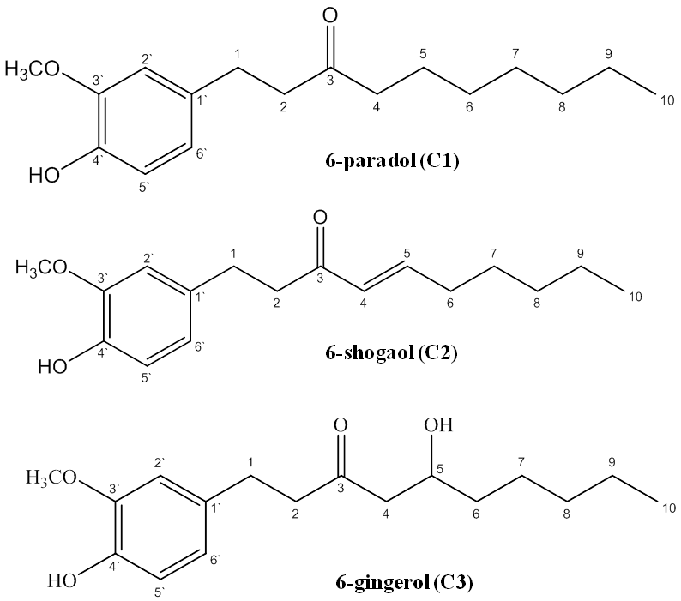

Fig S1 Structure of major compounds isolated from AMS
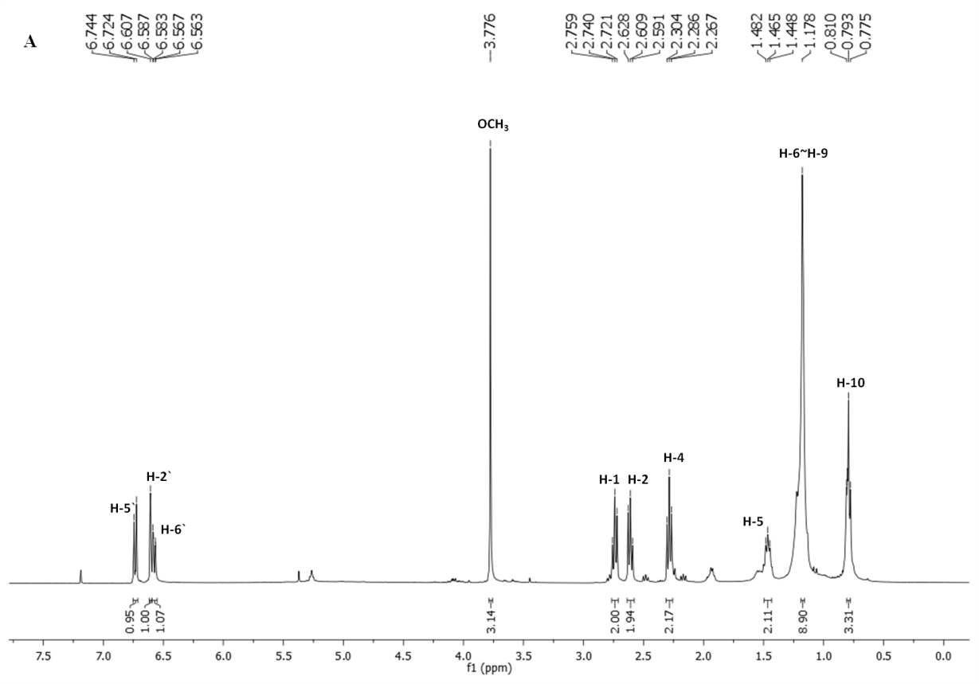

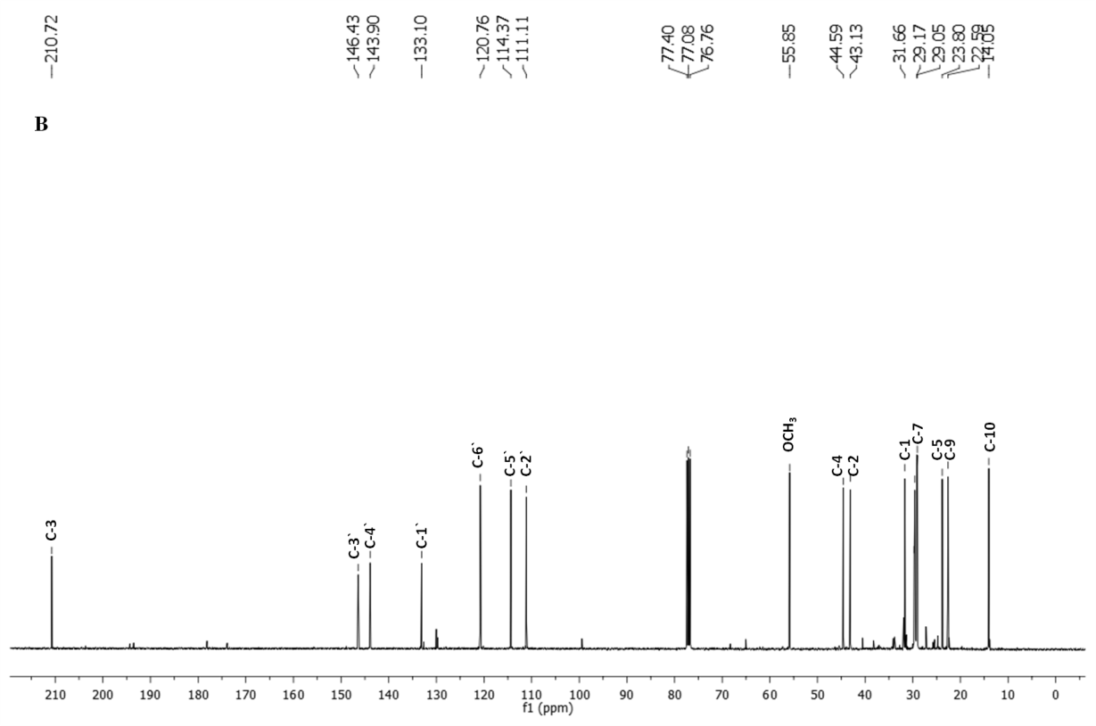

Fig. 2S ¹H-NMR (A) and ¹³C-NMR (B) spectra of 6-paradol

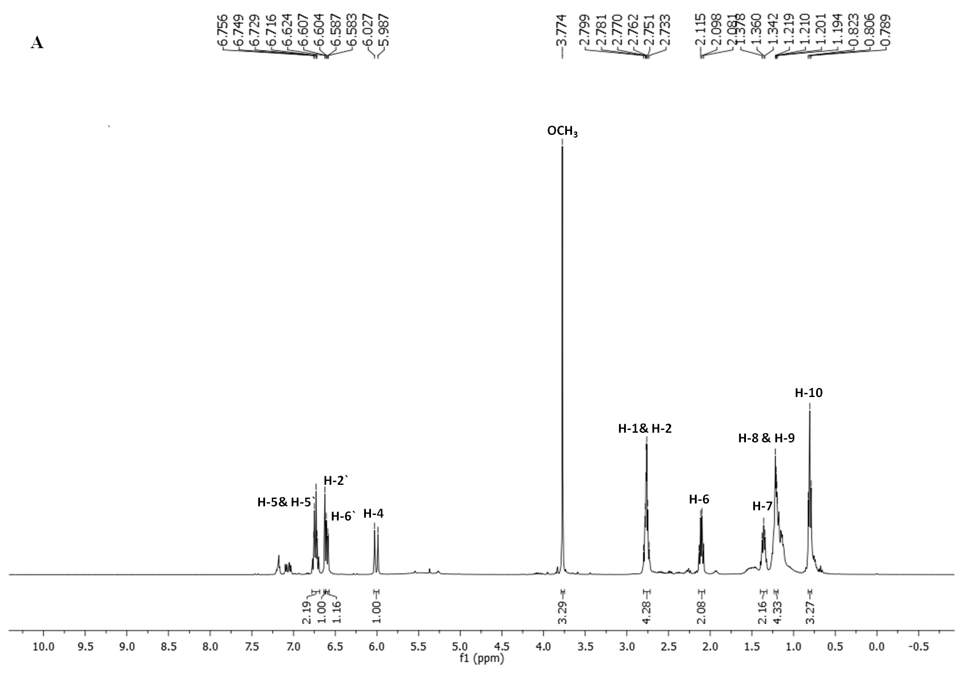

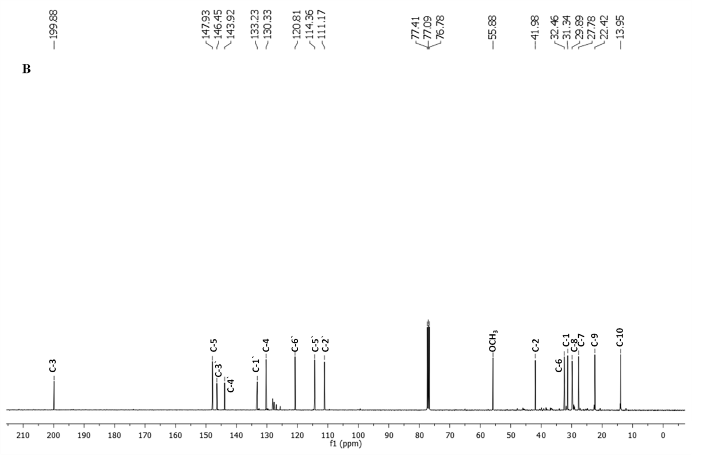

Fig. 3S ¹H-NMR (A) and ¹³C-NMR (B) spectra of 6-shogaol

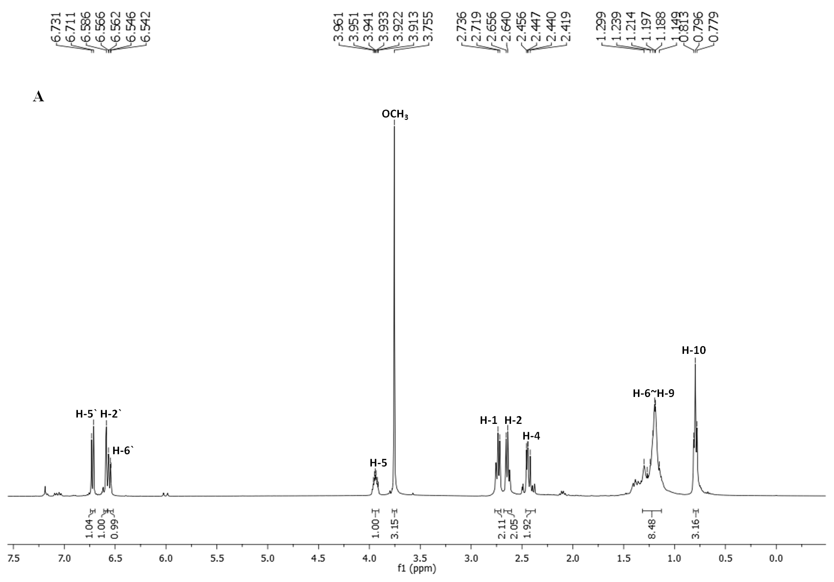

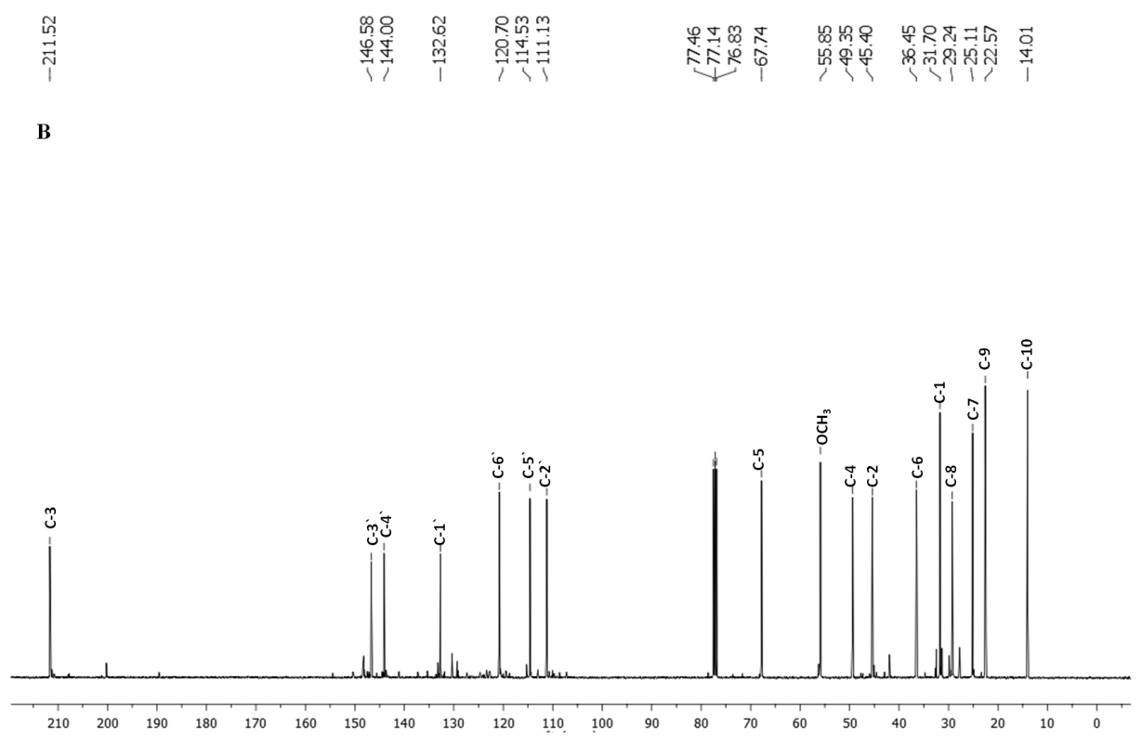

Fig. 4S ¹H-NMR (A) and ¹³C-NMR (B) spectra of 6-gingerol

