*Egypt. J. Chem.* **Vol. 67**, No. 12 pp. 129 - 141 (2024)

**New Nanoparticle Metal Complexes Based on Cefaclor and 2,2′-Bipyridineligands: Synthesis, Characterization, DFT Studies and Their Antimicrobial Evaluation**

**H. A. Abdallah, S. A. Sadeek*, M. M. Zareh, M. S. El-Attar, W. A. Zordok, B.Abd El-Wahaab**

*Department of Chemistry, Faculty of Science, Zagazig University, Zagazig, 44519, Egypt*

**Supporting Information**

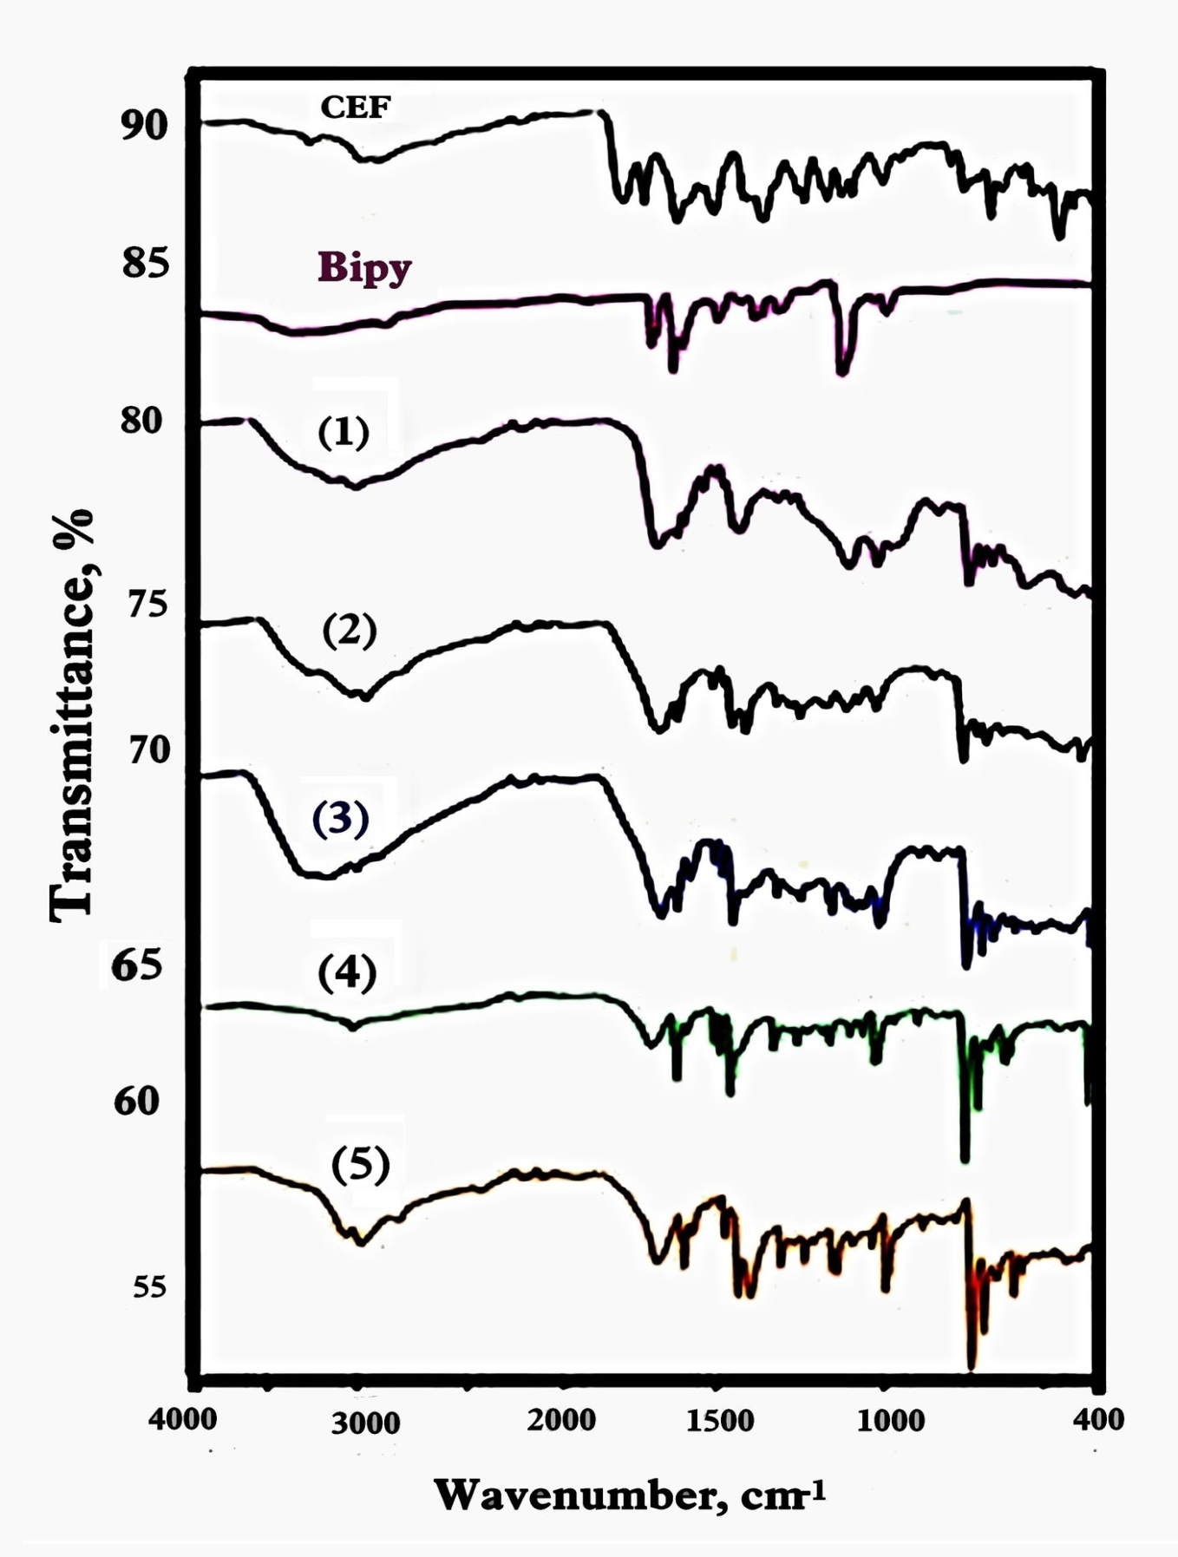

**FIGURE S1** Infrared spectra for **CEF**, **Bipy** and their metal complexes

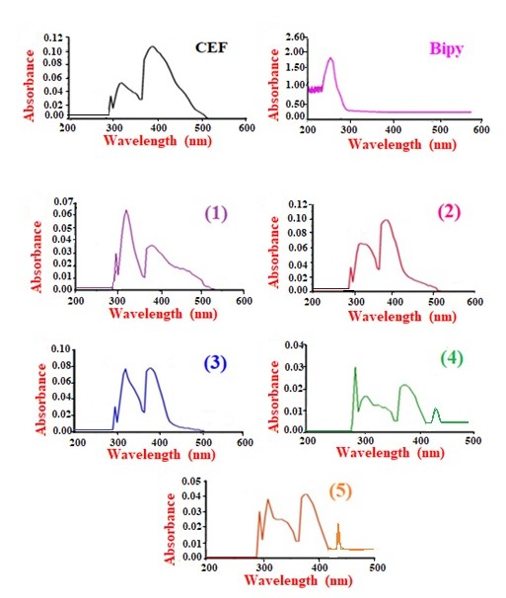

**FIGURE S2** Electronic absorption spectra for **CEF, Bipy** and their metal complexes

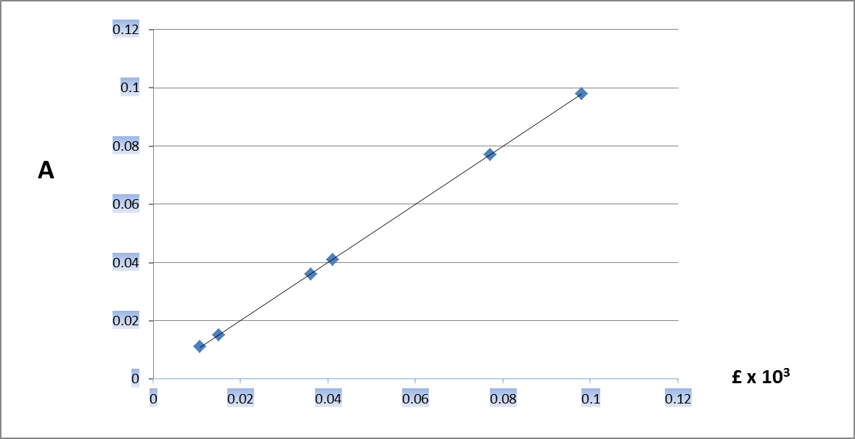

**FIGURE S3** Relation of absorbance and molar absorptivity for compounds.

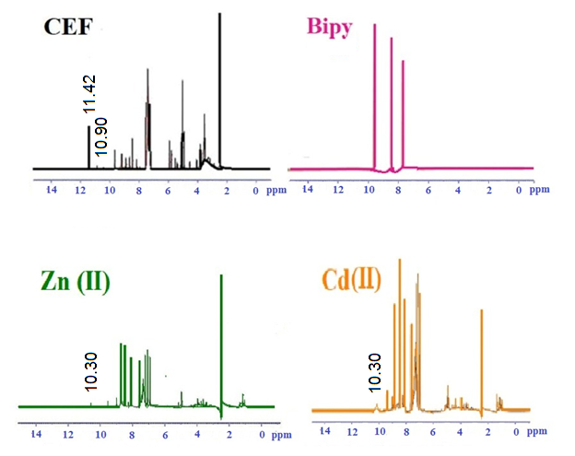

**FIGURE S4**1H NMR spectra for **CEF**, **Bipy,**Zn(II) and Cd(II) compounds

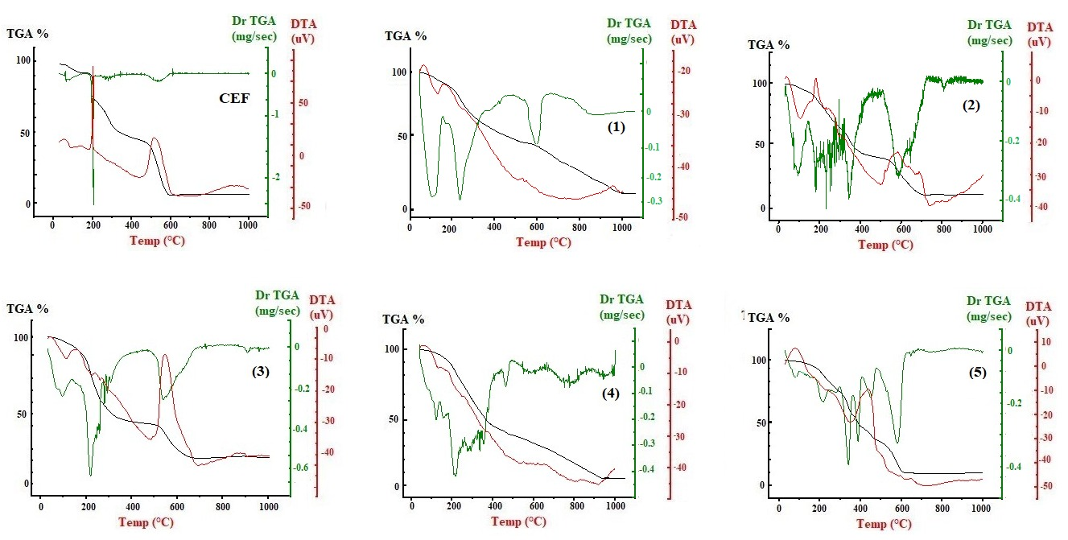

**FIGURE S5**TG,DTGand DTA diagrams for **CEF**and itsmetal complexes

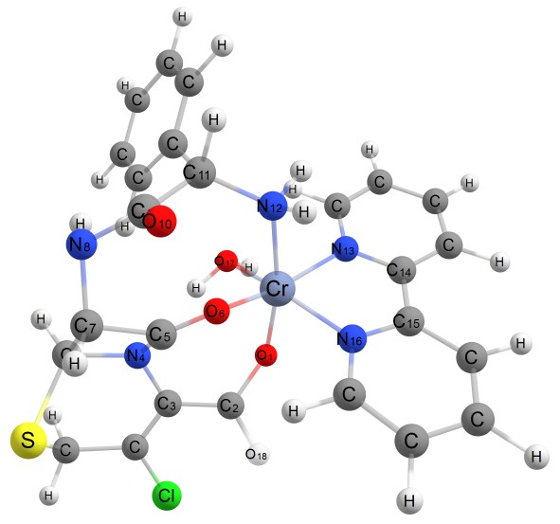

**FIGURE S6** Optimized geometrical structure of complex **(1)** by using DFT calculations

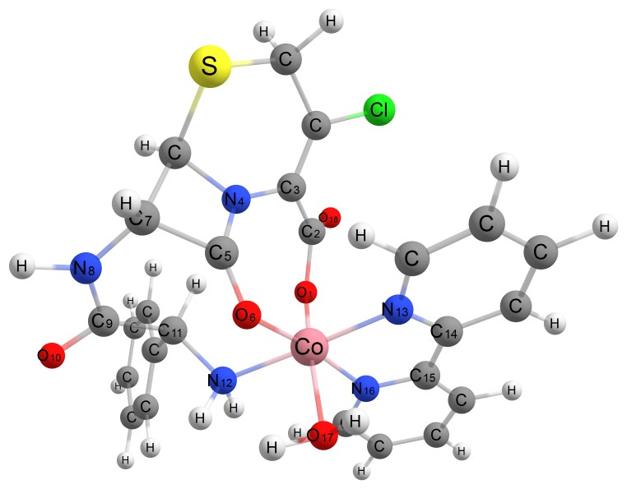

**FIGURE S7**Optimized geometrical structure of complex **(2)** by using DFT calculations

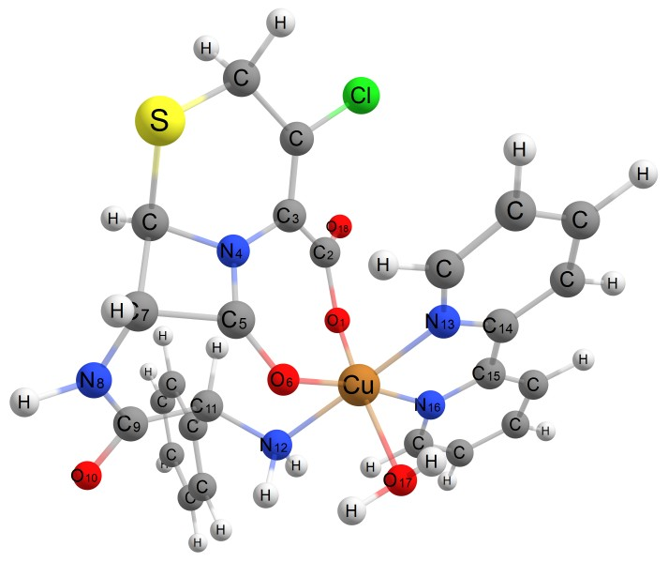

**FIGURE S8** Optimized geometrical structure of complex **(3)** by using DFT calculations

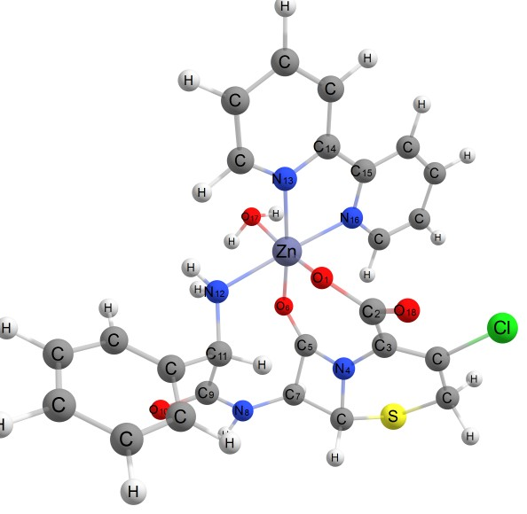

**FIGURE S9** Optimized geometry of complex **(4)** using DFT calculations

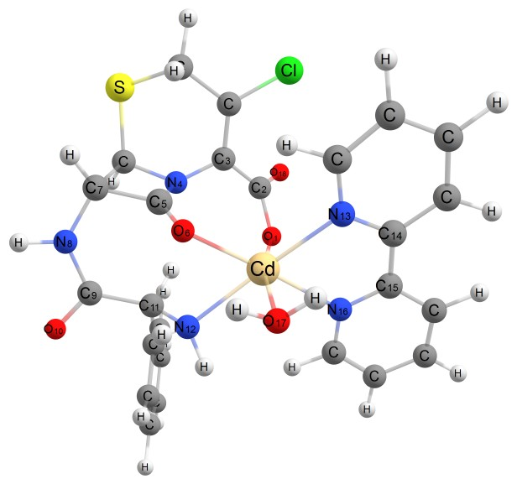

**FIGURE S10** Optimized geometry of complex **(5)** using DFT calculations

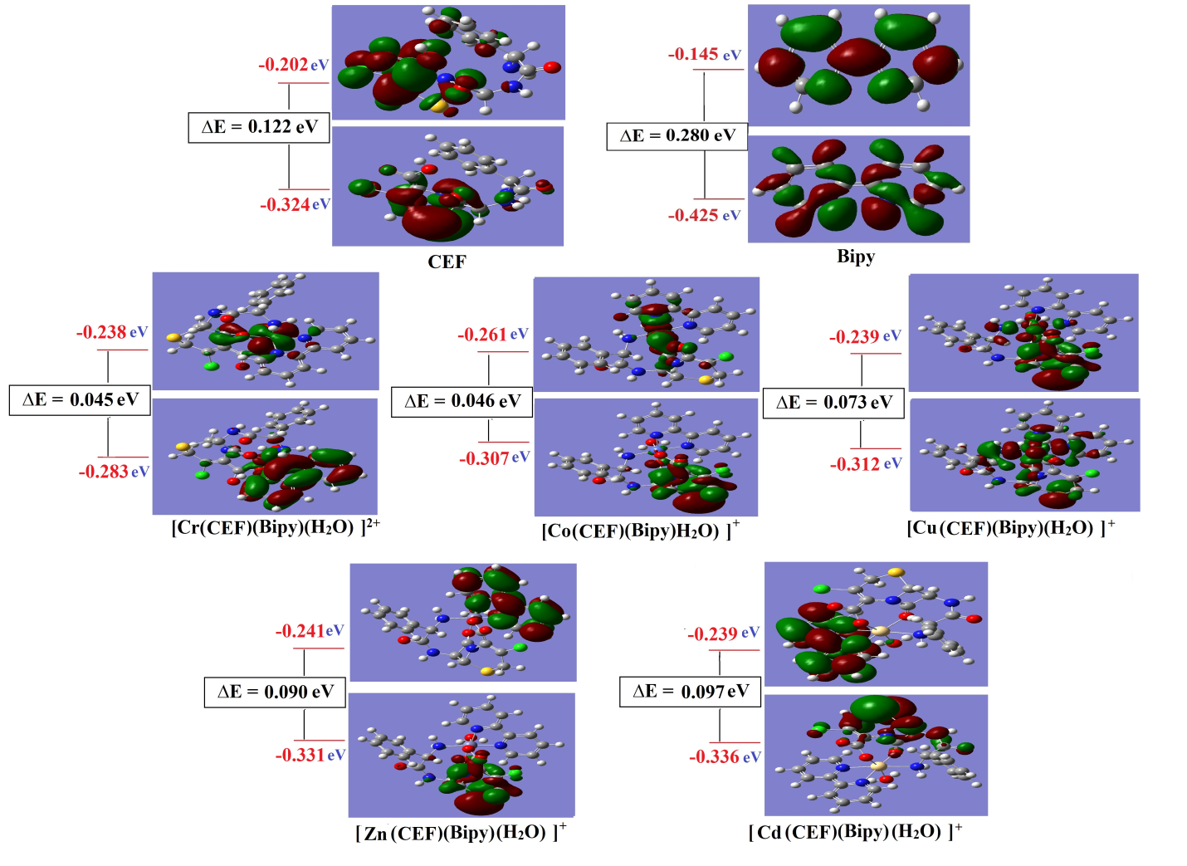

**FIGURE S11** Molecular orbital surfaces and energy levels of **CEF, Bipy** and their metal complexes

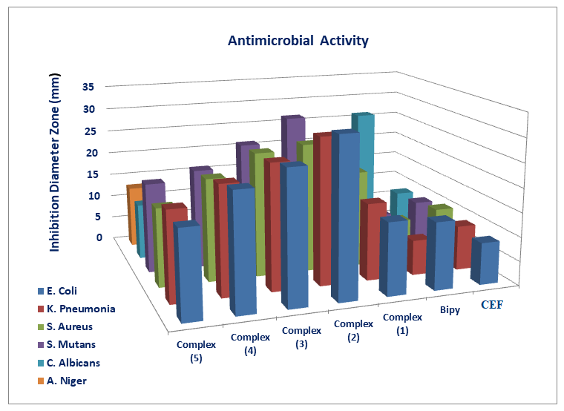

**FIGURE S12** Statistical representation of biological activity for **CEF**, **Bipy**and their metal complexes

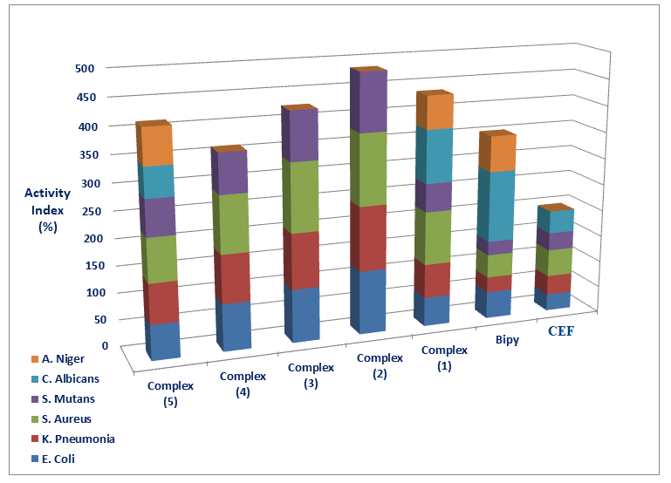

**FIGURE S13** Activity index % for CEF, Bipy and their metalcomplexes

**TABLE S1**1H NMRcalculatedvalues (ppm) for **CEF** and **Bipy**

|  |  |
| --- | --- |
| Compounds | Calculated δ (ppm) |
| **CEF**  **Bipy** |  |

**TABLE S2** Equilibrium geometric parameters, bond lengths (Å), bond angles (˚),dihedral angles (˚), total energy(E)and dipole moment(μ) of **CEF** using DFT calculations

|  |  |  |  |  |  |  |  |
| --- | --- | --- | --- | --- | --- | --- | --- |
| **Bond length (Å)** | | | | | | | |
| C1-C2  C2-C3  C3-N4  N4-C6  C6-S5  C1-S5  C6-C12  C11-C12  N4-C11  C11-O13  C2-Cl7 | 1.522  1.357  1.348  1.445  1.808  1.828  1.589  1.539  1.372  1.204  1.741 | | | C3-C8  C8-O9  C8-O10  C12-N14  N14-C15  C15-O17  C15-C18  C18-N20  C18-C23  C23-C24  C23-C28 | 1.369  1.209  1.334  1.446  1.383  1.209  1.524  1.439  1.519  1.348  1.347 | | |
| **Bond angle (˚)** | | | | | | | |
| C1S5C6  C3N4C6  C3N4C11  N4C3C8  C3C8O10  C3C8C9  O9C8O10  C6N4C11  N4C11O13  C12C11O13  N4C6C12  C11C12N14 | | 94.10  131.34  128.57  119.09  121.46  123.78  114.76  96.68  133.82  134.37  86.86  111.31 | | C6C12N14  C12N14C15  N14C15C18  N14C15O17  C18C15O17  C15C18N20  C15C18C23  N20C18C23  C18C23C24  C18C23C28  C1C2Cl7  C3C2Cl7 | | 127.08  132.08  125.76  116.64  117.57  110.61  115.78  114.66  122.16  120.22  113.62  123.47 | |
| **Dihedral angles (˚)** | | | | | | | |
| O13C11C12N14  C3N7C11O13  N4C3C8O10  N4C3C8O9  O13C11N4C6  C12N14C15O17 | | | -62.05  -9.03  2.75  -177.55  -169.75  178.31 | N20C18C23C28  N10C18C23C24  N14C15C18N20  O17C15C18N20  C23C18C15O17 | | | 162.91  -18.88  -63.51  114.07  -113.35 |
| E, kcal/mol  μ,D | | | | -145698.064  6.434 | | | |

**TABLE S3** Equilibrium geometric parameters, bond lengths (Å), bond angles (˚),dihedral angles (˚), heat of formation (Hf), total energy (E)and dipole moment (μ)of the metal complexes using DFT calculations

|  |  |  |  |  |  |
| --- | --- | --- | --- | --- | --- |
| **Bond lengths/ Å** | Cr(III) | Co(II) | Cu(II) | Zn(II) | Cd(II) |
| M-O1  M-O6  M-N13  M-N16  M-N12  M-O17  C5-O6  C9-O10  C2-O1  C11-N12 | 1.972  2.292  1.887  1.889  1.934  1.861  1.196  1.211  1.359  1.529 | 1.958  2.011  1.870  1.871  1.918  1.843  1.198  1.210  1.352  1.525 | 2.118  2.274  2.397  2.392  2.016  2.253  1.196  1.209  1.351  1.523 | 2.198  2.329  2.013  2.015  2.025  2.258  1.197  1.210  1.350  1.522 | 2.339  2.497  2.468  2.465  2.309  2.193  1.198  1209  1.351  1.513 |
| **Bond angles/(˚)** | | | | | |
| O1-M-O6  O1-M-N12  O1-M-N13  O1-M-N16  O1-M-O17  O6-M-N12  O6-M-N13  O6-M-N16  O6-M-O17  N12-M-N13  N12-M-N16  N12-M-O17  N13-M-N16  N13-M-O17  N16-M-O17 | 97.67  169.29  103.88  84.49  77.71  74.99  156.69  95.36  101.71  84.73  103.73  95.94  78.23  91.54  156.74 | 108.51  90.56  91.72  82.23  165.79  74.26  101.23  169.22  84.77  175.42  105.33  88.24  78.93  90.52  84.45 | 109.02  90.90  91.68  82.03  165.53  74.14  101.49  168.93  84.56  175.48  105.59  88.04  78.44  90.41  84.37 | 107.49  91.12  81.79  90.69  166.52  72.78  170.72  103.04  85.09  107.42  175.78  88.01  76.61  85.64  91.11 | 108.01  104.94  86.13  78.92  165.87  67.68  108.99  173.02  85.69  168.92  111.97  83.18  69.96  86.05  87.35 |
| E, kcal/mol  Hf, kcal/mol  μ, D | -219972.075  -11874.740  13.774 | -233378.349  -12282.772  10.851 | -247316.535  -12339.886  8.794 | -215069.081  -12560.809  11.360 | -214600.515  -12130.185  14.597 |

**TABLE S4** Calculated charges on donating sites and energy values (HOMO, LUMO), Energy gap ∆E (eV), hardness (η), global softness (S), electro negativity (χ), absolute softness (σ), chemical potential (Pi), global electrophilicity (ω) and additional electronic charge (∆Nmax) for**CEF,Bipy**and their metalcomplexes using DFT calculations.

|  |  |  |  |  |  |  |  |
| --- | --- | --- | --- | --- | --- | --- | --- |
| **Parameters** | **CEF** | **Bipy** | **Cr(III)** | **Co(II)** | **Cu(II)** | **Zn(II)** | **Cd(II)** |
| M  O1 carboxylate  O6 lactum  O10 amide  N12amin  N13 ­bipy  N16bipy  LUMO, L  HOMO, H  A = -L  I = -H  ∆E = L-H  η = (I-A)/2  χ = -(H-L/2)  σ = 1/ η  S = 1/2 η  Pi = - χ  ω = (Pi)2/2 η  ∆Nmax = χ/ η | -  -0.365  -0.394  -0.342  -0.352  -  -  -0.202  -0.324  0.202  0.324  0.122  0.061  0.263  16.393  8.197  -0.263  0.567  4.311 | -  -  -  -  -  -0.210  -0.212  -0.425  -0.145  0.425  0.145  0.280  0.140  0.285  7.143  3.571  -0.285  0.290  2.036 | 0.381  -0.452  -0.262  -0.310  -0.209  -0.094  -0.065  -0.238  -0.283  0.238  0.283  0.045  0.0225  0.2605  44.444  22.222  -0.2605  1.508  11.578 | -0.063  -0.459  -0.286  -0.349  -0.184  -0.066  -0.038  -0.261  -0.307  0.261  0.307  0.046  0.023  0.284  43.478  21.739  -0.284  1.753  12.348 | 0.160  -0.333  -0.294  -0.351  -0.189  -0.071  -0.057  -0.239  -0.312  0.239  0.312  0.073  0.0365  0.1755  27.397  13.698  -0.1755  0.4219  4.808 | 0.098  -0.488  -0.306  -0.349  -0.203  -0.089  -0.069  -0.241  -0.331  0.241  0.331  0.090  0.045  0.286  22.222  11.111  -0.286  0.9088  6.356 | 0.329  -0.484  -0.332  -0.348  -0.242  -0.134  -0.117  -0.239  -0.336  0.239  0.336  0.0485  0.0243  0.2875  41.152  20.576  -0.2875  1.7007  11.8313 |

(I) is an ionization energy (A) is an electron affinity

**TABLE S5:** Composition of Frontier molecular orbital formetal complexesusing DFT/B3LYP/Cep-31G.

|  |  |  |  |  |  |
| --- | --- | --- | --- | --- | --- |
|  | **(1)** | |  | **(2)** | |
| H | L | H | L |
| **Cr** | 8.4% | 66.4% | **Co** | 12.8% | 74.4% |
| **CEF** | 0.0% | 16.6% | **CEF** | 87.2% | 13.7% |
| **Bipy** | 83.7% | 4.3% | **Bipy** | 0.0% | 8.3% |
| **H2O** | 7.9% | 12.7% | **H2O** | 0.0% | 3.6% |
|  | **(3)** | |  | **(4)** | |
| H | L | H | L |
| **Cu** | 37.6% | 39.9% | **Zn** | 29.4% | 0.0% |
| **CEF** | 24.3% | 29.8% | **CEF** | 70.6% | 0.0% |
| **Bipy** | 18.8% | 12.9% | **Bipy** | 0.0% | 100% |
| **H2O** | 19.3% | 17.4% | **H2O** | 0.0% | 0.0% |
|  | **(5)** | |  |  | |
| H | L |  |  |
| **Cd** | 0.0% | 0.0% |  |  |  |
| **CEF** | 100% | 0.0% |  |  |  |
| **Bipy** | 0.0% | 98.6% |  |  |  |
| **H2O** | 0.0% | 1.4% |  |  |  |