*Egypt. J. Chem.* **Vol. 67**, No. 11 pp. 17 - 27 (2024)

**Metabolic Profiling of *Millingtonia hortensis* L.f. Leaves Using UHPLC-MS/MS and Evaluation of its Antioxidant, Cytotoxic, Anticholinesterase Activities and Molecular Docking**

**Sohila M. Elnaggara; Soumaya S. Zaghloula; Hanaa A. Kassemb; Amira K. El Motayamb\***

aDepartment of Pharmacognosy, Faculty of Pharmacy, MSA University, Cairo, Egypt

bDepartment of Pharmacognosy, Faculty of Pharmacy, Cairo University, Cairo, Egypt

**Supporting information**

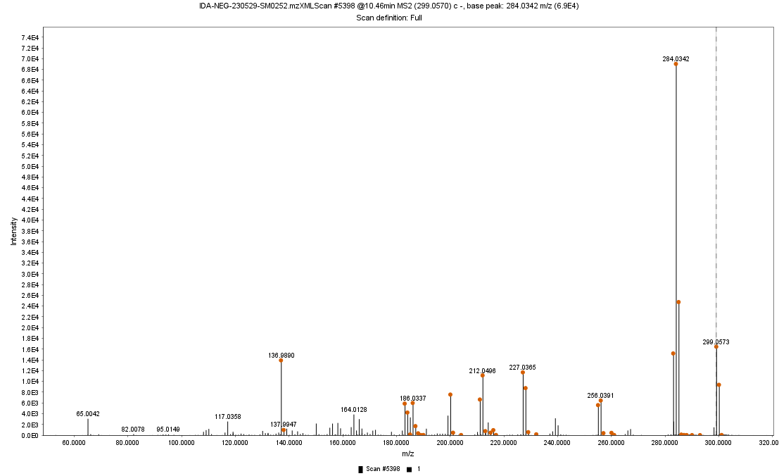

[M-H]-

M-H-Glu

M-H-284-O

M-H-CH3



**Figure (4): (-) ESI-MS spectrum of identified compound Peak 21 in the total ethanolic extract of *Millingtonia hortensis* L.f. leaves**

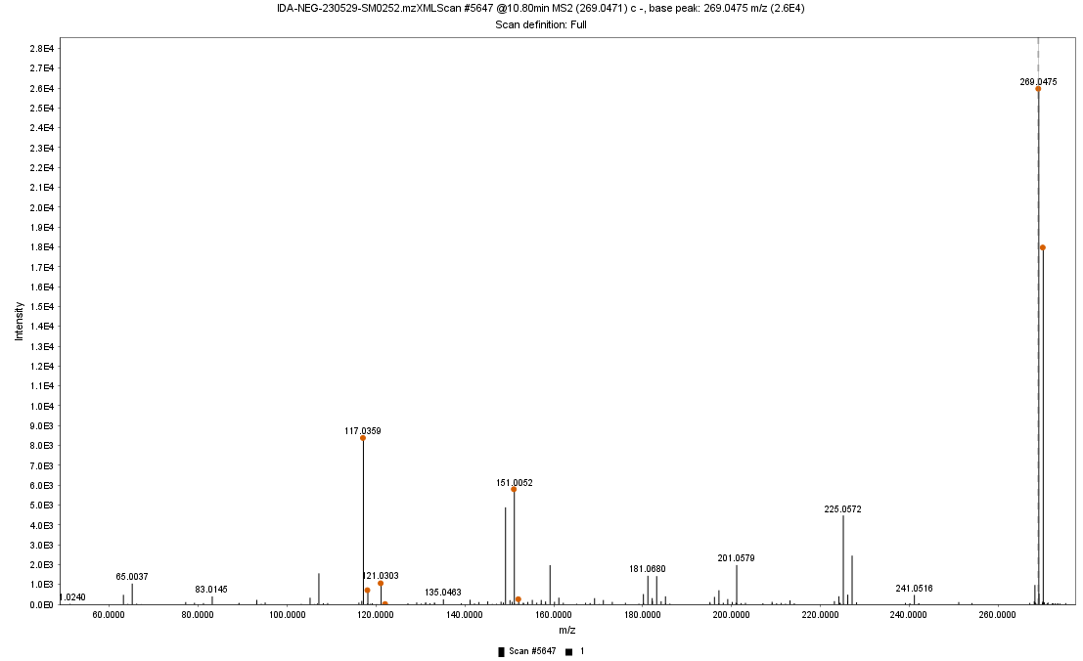**Figure (5): (-) ESI-MS spectrum of identified compound Peak 24 in the total ethanolic extract of *Millingtonia hortensis* L.f. leaves**

[M-H]-

M-H-COO-

*m/z* 117

*m/z* 151



[M-H]-



M-H-COO-

M-H-H2O

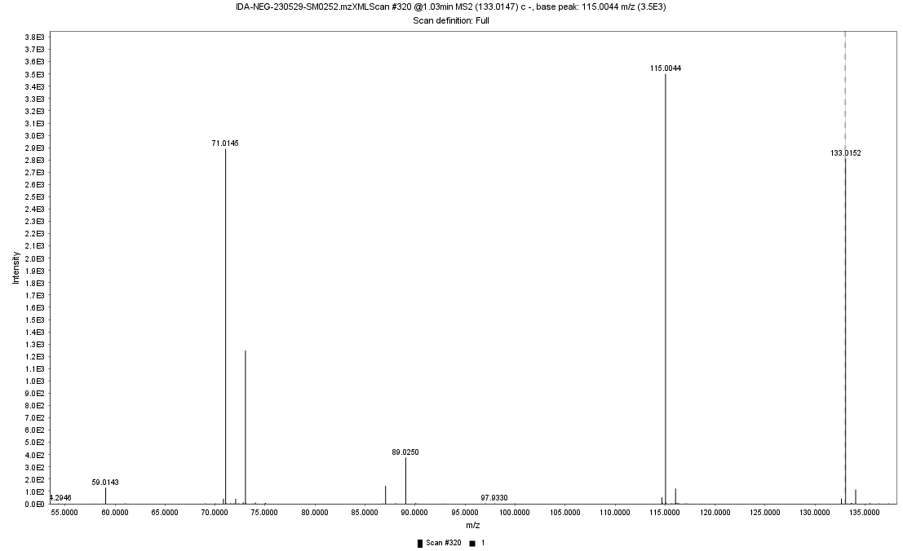**Figure (6): (-) ESI-MS spectrum of identified compound Peak 3 in the total ethanolic extract of *Millingtonia hortensis* L.f. leaves**

[M-H]-

M-H-COO-

**Figure (7): (-) ESI-MS spectrum of identified compound Peak 25 in the total ethanolic extract of *Millingtonia hortensis* L.f. leave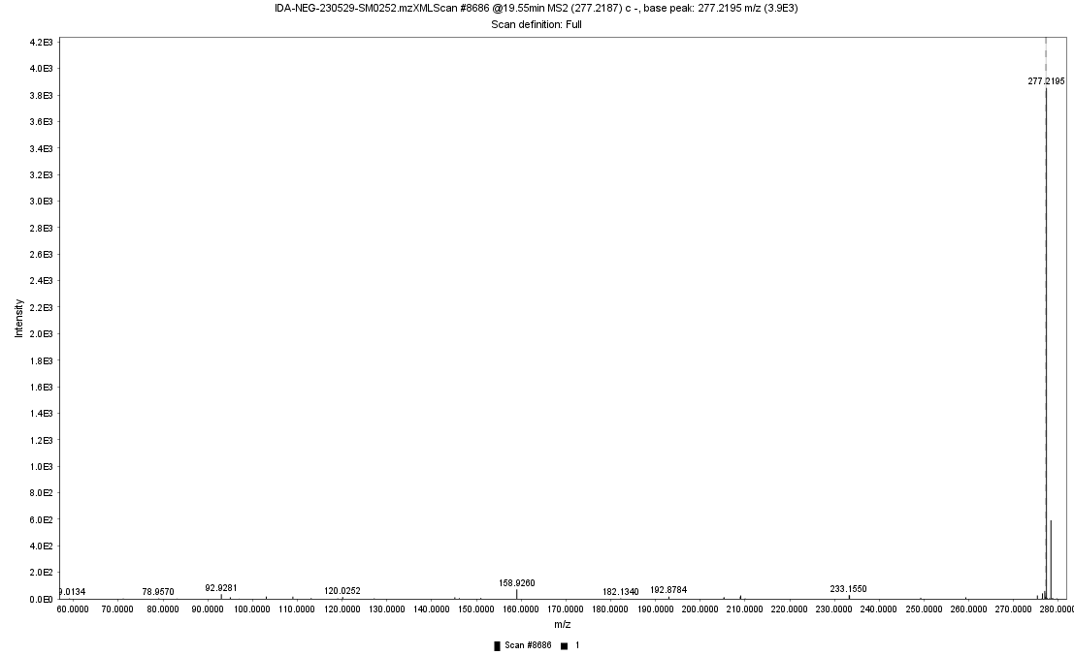s**



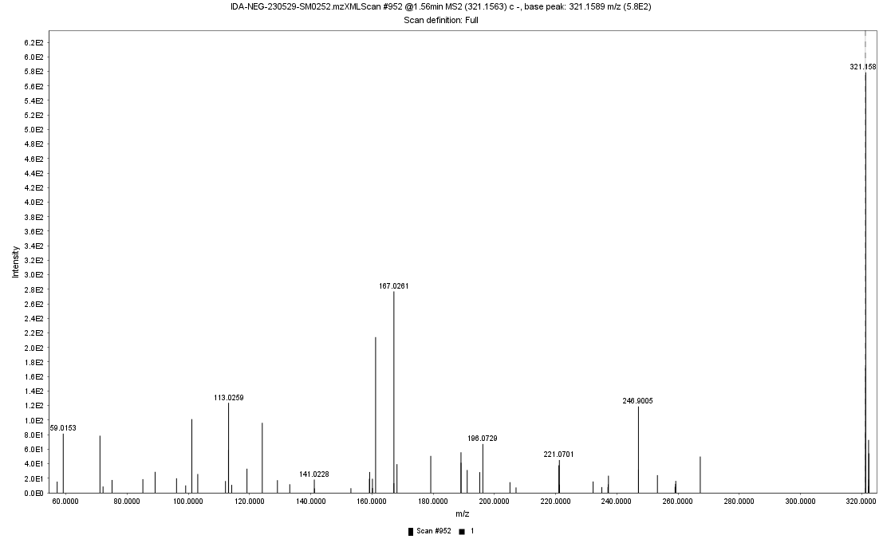**Figure (8): (-) ESI-MS spectrum of identified compound Peak 10 in the total ethanolic extract of *Millingtonia hortensis* L.f. leaves**

[M-H]-

M-H-Glu

