Supplementary file
Isolation, Taxonomical Characterization, Antimicrobial Activity and Chemical Profiling of Thirteen Marine-Derived Fungi from the Mediterranean Sea Coasts of Egypt
Eman Masoudª, Ghada E. Hegazy^{b}, Yasser El-Halmouch^{c}, Mohammad M El-Metwallyª, Mohamed Shaaban^{d*}
ª Botany and Microbiology Department, Faculty of Science, Damanhour University, Damanhour, Egypt.
^{b} National Institute of Oceanography & Fisheries, NIOF-Egypt.
^{c} Botany and Microbiology Department, Faculty of Sciences, Kfrelsheikh University, Egypt. Kafr El Sheikh
^{d} Chemistry of Natural Compounds Department, Division of Pharmaceutical Industries, National Research Centre, El-Behoos St. 33, Dokki-Cairo 12622, Egypt.
Contents | Page
Figure S1 : Antimicrobial activity assaying of the supernatants of thirteen fungal strain (Nr. 2-13,15) using well difusion method against seven diverse pathogenic microorganisms (a-g) | S2
Figure S2: Antimicrobial activity assaying of five fungal strains supernatants (Nr. 8,9,12,13,15) dissolved in DMSO using well difusion method against six diverse pathogenic microorganisms (a-f). | S3
Table S1: Tentatively identified compounds by GC-MS produced by fungal strain 8 optimized at four different conditions | S4
Figure S3: Chemical structures of tentatively identified compounds by GC-MS from fungal strain EM-8 | S7
Figure S4: Chemical structures of tentatively identified compounds by GC-MS from fungal strain EMRH-8 | S8
Figure S5:Chemical structures of tentatively identified compounds by GC-MS from fungal strain EMRS-8 | S10
Figure S6: Chemical structures of tentatively identified compounds by GC-MS from fungal strain EMWB-8. | S11
Figure S7: Chemical structures of tentatively identified compounds by GC-MS from fungal strain EMWS-8 | S11
Table S2: Tentatively identified compounds by GC-MS produced by fungal strain 13 optimized at four different conditions | S12
Figure S8: Chemical structures of tentatively identified compounds by GC-MS from fungal strain EM-13 | S15
Figure S9: Chemical structures of tentatively identified compounds by GC-MS from fungal strain EMRH-13. | S16
Figure S10: Chemical structures of tentatively identified compounds by GC-MS from fungal strain EMRS-13 | S17
Figure S11: Chemical structures of tentatively identified compounds by GC-MS from fungal strain EMWB-13. | S18
Figure S12: Chemical structures of tentatively identified compounds by GC-MS from fungal strain EMWS-13 | S19
Figure S13: pure cultures of different morphological fungal isolates (1, 13, 14,15) | S20

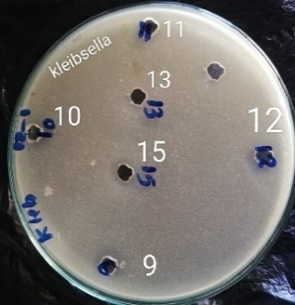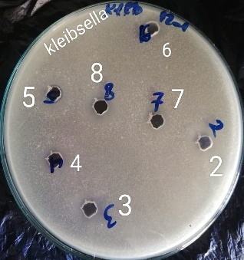  b: .Kleibsella | 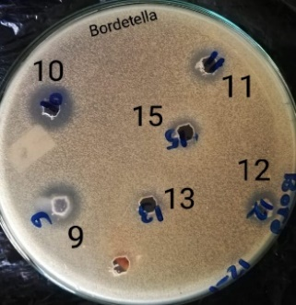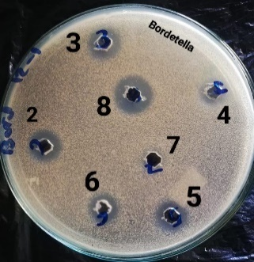  a: Bordetella sp
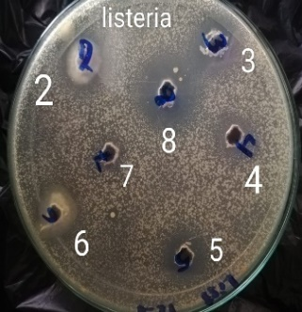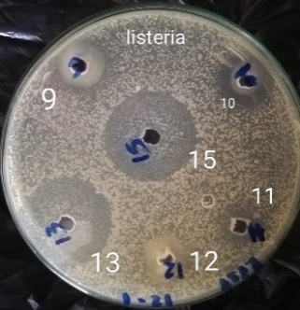  d: .Listeria | 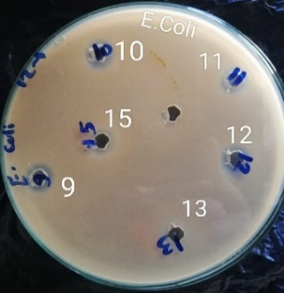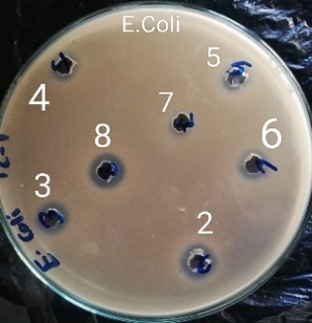  c: E.coli
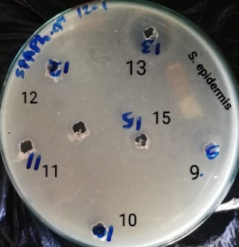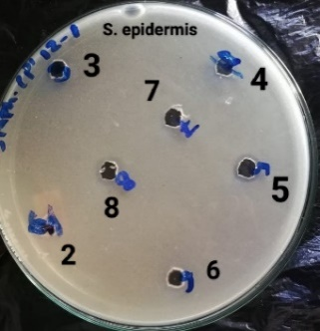  f: Staphyllococcus epidermidis | 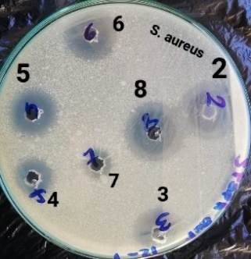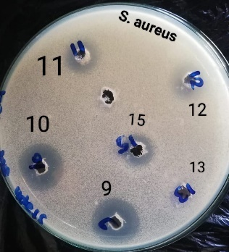  e: Staphylociccus aureus
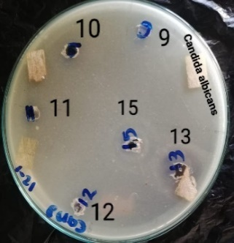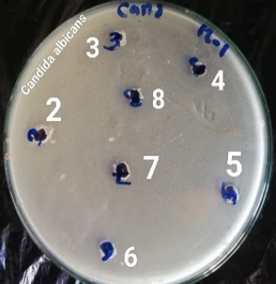
g: Candida albicans
Figure S1: Antimicrobial activity assaying of the supernatants of thirteen fungal strain (Nr. 2-13,15) using well difusion method against seven diverse pathogenic microorganisms (a-g).

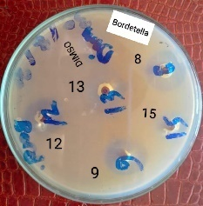 | 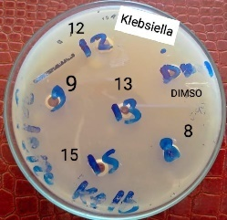 | 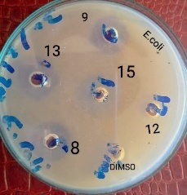
a: Bordetellasp | b: klebsiella | c: E.coli
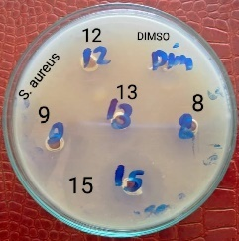 | 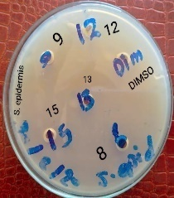 | 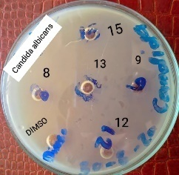
d: Staphylococcus aureus | e: Staphylococcus epidermidis | f:Candida albicans
Figure S2: Antimicrobial activity assaying of five fungal strains supernatants (Nr. 8,9,12,13,15) dissolved in DMSO using well difusion method against six diverse pathogenic microorganisms (a-f).

Table S1: Tentatively identified compounds by GC-MS produced by fungal strain 8 optimized at four different conditions
Optimized Strain | Compound Name | Rt (min) | A (%) |  | MF | MWt
A: EM8 | 9,17-Di-O-acetyl-26,32di-O-methylkijanolide (1) | 21.45 | 0.46 |  | C₃₉H₅₂O₉ | 664
 | Hexadecane, 7,9-dimethyl (2) | 21.74 | 0.53 |  | C₁₈H₃₈ | 254
 | Phenol,2,5-bis(1,1-dimethylethyl) (3) | 22.34 | 0.70 |  | C₁₄H₂₂O | 206
 | Pentadecane | 24.05 | 0.81 |  | C₁₅H₃₂ | 212
 | Benzene, (1-ethyloctadecyl) (4) | 25.59 | 0.91 |  | C₂₆H₄₆ | 358
 | Heptane, 2,2,3,3,4,4,5,5,6,6,-heptamethyl (5) | 26.23 | 1.31 |  | C₁₄H₃₀ | 198
 | Ethanol, 2,2’-iminobis (6) | 26.38 | 0.82 |  | C₄H₁₁NO₂ | 105
 | 2-Propenoic acid, (1methyl1,2ethanediyl) bis[oxy(methyl2,1ethanediyl)] ester (7) | 27.55-28.0 | 7.95 |  | C₁₅H₂₄O₆ | 300
 | Oxalic acid, allyl nonylester (8) | 28.31 | 1.97 |  | C₁₄H₂₄O₄ | 256
 | Benzeneacetonitrile,àmethyl (9) | 28.53 | 1.55 |  | C₉H₉N | 131
 | Docosane | 30.29 | 1.88 |  | C₂₂H₄₆ | 310
 | (R)6,6'Di naphthalene-1-,4dione2yl)2,2'dimethoxy1,1'binaphthyl (10) | 30.58 | 0.86 |  | C₄₂H₂₆O₆ | 626
 | Hexadecanoic acid methyl ester | 30.90 | 6.52 |  | C₁₇H₃₄O₂ | 270
 | Cucurbitacin B, dihydro (11) | 31.49 | 0.46 |  | C₃₂H₄₈O₈ | 560
 | Colchifoleine (12) | 31.78 | 0.67 |  | C₂₁H₂₃NO₇ | 401
 | Humulane-1,6-dien-3-ol (13) | 32.97 | 1.00 |  | C₁₅H₂₆O | 222
 | 9,12-octadecadienoic acid methyl ester (14) | 34.03 | 25.03 |  | C₁₉H₃₄O₂ | 294
 | 9-octadecenoic acid methyl ester | 34.12 | 14.12 |  | C₁₉H₃₆O₂ | 296
 | Octadecanoic acid methyl ester | 34.59 | 1.52 |  | C₁₉H₃₈O₂ | 298
 | Heneincosane | 35.74 | 1.08 |  | C₂₁H₄₄ | 296
 | Decanoicacid,1,1a,1b,4,4a,5,7a,7b,8,9decahydro4a,7bdihydroxy1,1,6,8tetramethyl5oxo3[[(1oxodecyl)oxy]methyl]9aHcyclopropa[3,4]benz[1,2e]azulene9,9adiylester (15) | 37.12 | 0.65 |  | C₅₀H₈₂O₉ | 826
 | 2Chloro-2'-hydroxy3',4'dimethoxy5'chloromethylacetophenone (16) | 51.69 | 0.45 |  | C₁₁H₁₂Cl₂O₄ | 678
 | Pyrrolidine | 52.84 | 0.51 |  | C₄H₉N | 71
 | Cantaxanthin (17) | 54.41 | 0.94 |  | C₄₀H₅₃O₂ | 564
 | Total sum. |  | 72.7
B. EMRH-8 | (4Bromophenyl) bis(2,4dibromophenyl) amine (1) | 5.09 | 5.06 |  | C₁₈H₁₀Br₅N | 635
 | Benzene, 1,2dimethyl (2) | 5.17 | 2.43 |  | C₈H₁₀ | 106
 | 3Amino-s-triazole (3) | 5.63 | 3.55 |  | C₂H₄N₄ | 84
 | (4S,6S)4,6Dihydroxy4, 6dimethylnona1,8dien5one (4) | 5.79 | 1.42 |  | C₁₁H₁₈O₃ | 198
 | 1,3,6,8tetrabromo9(4'iodophenyl) carbazole (5) | 6.12 | 1.71 |  | C₁₈H₈Br₄IN | 681
 | 3Methylcis2,3epoxycy clohexan1ol (6) | 6.93 | 1.54 |  | C₇H₁₂O₂ | 128
 | 4H1,2,4Triazol4amine (7) | 7.05 | 1.68 |  | C₂H₄N₄ | 84
 | Hydroxy tetracosane (8) | 7.33 | 2.30 |  | C₂₄H₅₀O | 354
 | 1Acetamido3,4,4,8,8pentamethylbicyclo [3.2.2]non2enanti7ol (9) | 7.39 | 1.20 |  | C₁₆H₂₇NO2 | 265
 | Octanal (10) | 8.34 | 2.08 |  | C₈H₁₆O | 128
 | 5Chloro2,2'dithienyldisulfide (11) | 8.41 | 2.47 |  | C₈H₅ClS₄ | 264
 | Ethanol, 2chloro (12) | 8.47 | 1.94 |  | C₂H₅ClO | 80
 | Olean12en28oic Acid, 3,16dioxo,methyl ester (13) | 19.84 | 1.52 |  | C₃₁H₄₆O₄ | 482
 | Ether, hexyl pentyl (14) | 21.65 | 1.37 |  | C₁₁H₂₄O | 172
 | (1S,3S)8Hydroxy6methoxyNmethyl1,3dimethyl1,2,3,4tetrahydroisoquinoline (15) | 22.35 | 5.56 |  | C₁₃H₁₉NO₂ | 221
 | 1Buten3yne (16) | 23.67 | 1.23 |  | C₄H₄ | 52
 | 3O(2Bromo4,5dimethoxybenzyl)1,2:  5,6diOisopropylideneà,Dglucofuranoside (17) | 25.10 | 1.65 |  | C₂₁H₂₉BrO₈ | 488
 | Docosane (18) | 26.45 | 1.40 |  | C₂₂H₄₆ | 310
 | Hexadecanoic acid,methyl ester (19) | 30.93 | 2.88 |  | C₁₇H₃₄O₂ | 270
 | Z,Z)1Iodo9,12octadecadiene (20) | 34.06 | 1.52 |  | C₁₈H₃₃I | 376
 | 9Octadecenoic acid, methyl ester, (E) (21) | 34.14 | 4.45 |  | C₁₉H₃₆O₂ | 296
 | 5"(1,1Dimethylethyl) 2,2',2",2"',2""pentamethoxy[1,1':3',1":3",1''':3"'.1""quinquephenyl] 3,3""dimethanol (22) | 47.64 | 1.22 |  | C₄₁H₄₄O₇ | 648
 | Total sum. |  | 50.18
C: EMRS8 | 2(Difluoromethyl)2methyloxazolidine (1) | 5.13 | 1.42 |  | C₅H₉F₂NO | 137
 | (Z)2,4Dihydro4[(hydroxyamino)methylene]5methyl2phenyl3Hpyraz  ol3one (2) | 5.29 | 2.26 |  | C₁₁H₁₁N₃O₂ | 217
 | 2-Amino1,2diphenylethanol (3) | 5.37 | 0.94 |  | C₁₄H₁₅NO | 213
 | 1,3-Propanediol, 2,2bis(hydroxymethyl (4) | 8.25 | 0.71 |  | C₅H₁₂O₄ | 136
 | 2Methylpent4en1ol (5) | 8.36 | 0.70 |  | C₆H₁₂O | 100
 | 7,22bis(Chloroacetyl)7,14,15,22tetraaza[7.2.7.1.](1,3)(1,3)(1,4)(1,4)cyclophan14-ene (6) | 9.32 | 0.70 |  | C₄₁H₄₆Cl₂N₄O₂ | 696
 | 3-Penten-2-one (7) | 9.41 | 0.67 |  | C₅H₈O | 84
 | Cyanamide, [2(1bromo6a,7,7a,10a,11,11ahexahydro4hydro  xy6oxo6H[1,3]benzodioxolo[5,6c][1]benzopyran2yl)ethyl]methyl (9) | 14.86 | 0.61 |  | C₁₈H₁₉BrN₂O₅ | 422
 | n-Butyl6[3,4dichlorophenyl]-N-methyl-1,2,4,5-tetrazin-3-amine (10) | 15.82 | 0.70 |  | C₁₃H₁₅Cl₂N₅ | 311
 | 1-Octanol | 15.97 | 1.10 |  | C₈H₁₈O | 130
 | 5"(1,1Dimethylethyl)2,2',2",2"',2""pentamethoxy[1,1':3',1":3",1''':3"'.1""quinquephenyl]3,3""dicarboxylic acid (11) | 16.23 | 1.01 |  | C₄₁H₄₀O₉ | 676
 | Methyl1{4Methoxy3chloro6[2[3(2'methoxy3'chloro5'(1,3dioxan2yl) phenyl)4methoxyphenyl]ethyl]phenyl}2methoxybenzene4carboxylate (12) | 16.46 | 1.40 |  | C₃₆H₃₆Cl₂O₈ | 666
 | N-Isopentyl-N-nitrosopentylamine (13) | 16.68 | 0.53 |  | C₁₀H₂₂N₂O | 186
 | 2,2Bis[4[[4chloro6(3ethynylphenoxy)1,3,5triazin2yl]oxy]phenyl]propane (14) | 17.76 | 0.75 |  | C₃₇H₂₄Cl₂N₆O₄ | 686
 | 2,6Bis[5cyano6(4bromophenyl)1,2,4triazin3yl]pyridine (15) | 18.18 | 0.88 |  | C₂₅H₁₁Br₂N₉ | 595
 | Z-7-Hexadecenal (16) | 18.58 | 2.52 |  | C₁₆H₃₀O | 238
 | 7{4'[4"(5"'Chloro2"'methoxybenzoyl)amino]phenyl}2(thienylmethylene)3oxo5(pfluorophenyl)2,3dihydro5Hthiazolo[3,2a]pyrimidine (17) | 19.43 | 0.57 |  | C₃₁H₂₁ClFN₃O₃S₂ | 601
 | Dodecane, 4,6-dimethyl (18) | 21.66 | 0.65 |  | C₁₄H₃₀ | 198
 | Nonadecane | 21.76 | 1.15 |  | C₁₉H₄₀ | 268
 | 2-tert-Butyl-4-isopropyl-5-methylphenol (20) | 22.36 | 3.71 |  | C₁₄H₂₂O | 206
 | Dodecane, 2,6,11-trimethyl (21) | 24.07 | 1.07 |  | C₁₅H₃₂ | 212
 | Nonane, 3-methyl-5-propyl (22) | 26.25 | 4.59 |  | C₁₃H₂₈ | 184
 | 1HImidazole2methanol (23) | 26.99 | 0.89 |  | C₄H₆N₂O | 98
 | Undecane, 2,10-dimethyl | 28.34 | 1.66 |  | C₁₃H₂₈ | 184
 | 7-Hexadecane | 29.84 | 4.20 |  | C₁₆H₃₂ | 224
 | Nonadecane | 30.33 | 19.24 |  | C₁₉H₄₀ | 268
 | Hexadecanoic acid, methyl ester | 30.92 | 8.98 |  | C₁₇H₃₄O₂ | 270
 | Sulfurous acid, hexylpentyl ester (24) | 32.22 | 2.14 |  | C₁₁H₂₄O₃S | 236
 | 9,12-Octadecadienoic acid (Z,Z), methyl ester | 34.05 | 10.11 |  | C₁₉H₃₄O₂ | 294
 | 9-Octadecenoic acid (Z),methyl ester | 34.16 | 4.97 |  | C₁₉H₃₆O₂ | 296
 | Hexane,2,2,3,4,5,5-hexamethyl (25) | 35.77 | 0.65 |  | C₁₂H₂₆ | 170
 | Eicosane, 7-hexyl (26) | 37.43 | 0.77 |  | C₂₆H₅₄ | 366
 | 1,2Benzenedicarboxylicacid, bis(2-ethylhexyl)ester (27) | 41.52 | 5.54 |  | C₂₄H₃₈O₄ | 390
 | Total sum. |  | 87.79
D: EMWB-8 | Methanethiol (1) | 5.12 | 4.49 | CH4S |  | 48
 | Chloromethyl chloroacetate (2) | 5.16 | 3.43 | C₃H₄Cl₂O₂ |  | 142
 | Octadecane (3) | 5.51 | 1.26 | C₁₈H₃₈ |  | 254
 | pyrrolidin1propionic acid (4) | 6.86 | 1.16 | C₇H₁₃NO₂ |  | 143
 | Nonane, 3-methylene (5) | 7.17 | 1.48 | C₁₀H₂₀ |  | 140
 | Docosane (6) | 8.32 | 12.19 | C₂₂H₄₆ |  | 310
 | (6Bromopyridin2yl)phenylmethanol (7) | 10.35 | 1.43 | C₁₂H₁₀BrNO |  | 263
 | Octane, 4methyl (8) | 11.21 | 2.94 | C₉H₂₀ |  | 128
 | Chloromethyl propanoate (9) | 11.29 | 1.17 | C₄H₇ClO₂ |  | 122
 | 3-Nonanone,2methyl (10) | 16.21 | 2.07 | C₁₀H₂₀O |  | 156
 | (4S,6S)4,6Dihydroxy4,6dimethylnona1,8dien5one (11) | 18.36 | 1.44 | C₁₁H₁₈O₃ |  | 198
 | (trans)3Ethoxy1vinylcyclobutanol (12) | 19.10 | 1.58 | C₈H₁₄O₂ |  | 142
 | 1[10[3(dimethylamino)propyl]10Hphenothiazin2yl] (13) | 21.60 | 1.32 | C₁₉H₂₂N₂OS |  | 326
 | (1à,4à,4aà,10aà)1,4,4a,5,6,7,8,9,10,10adecahydro1,4,11,11tetramethyl1,4-methanocycloocta[d]pyridazine (14) | 22.34 | 5.37 | C₁₅H₂₆N₂ |  | 234
 | 2,2Dimethyl1,3propan ediol isobutanoate (15) | 22.73 | 1.18 | C₉H₁₈O₃ |  | 174
 | 1Hexadecene (16) | 23.92 | 1.16 | C₁₆H₃₂ |  | 224
 | 4,5-dihydrofuran-3-carbaldehyde (17) | 27.50 | 2.88 | C₅H₆O₂ |  | 98
 | Total sum. |  | 46.55
E: EMWS-8 | S-Methyl propanethioate (1) | 5.86 | 2.32 |  | C₄H₈OS | 104
 | OH-Spirilloxanthin (2) | 6.81 | 2.08 |  | C₄₁H₅₈O₂ | 582
 | Cyclopropene (3) | 7.62 | 1.43 |  | C₃H₄ | 40
 | Dichloroacetaldehyde (4) | 8.50 | 2.01 |  | C₂H₂Cl₂O | 112
 | 1,5-Dimethyl3,7dithiabicyclo[3.3.1]nonan9one Hydrazone (5) | 13.41 | 1.48 |  | C₉H₁₆N₂S2 | 216
 | 5(1H)Indolizinone, hexahydro (6) | 15.46 | 2.42 |  | C₈H₁₃NO | 139
 | (3Thienyl) butadiyne (7) | 19.33 | 2.21 |  | C₈H₄S | 132
 | N(aminocarbonyl)2ethyl (8) | 21.35 | 1.73 |  | C₇H₁₄N₂O₂ | 158
 | 2,2dimethyl1,3dithiolane (9) | 34.36 | 1.43 |  | C₅H₁₀S₂ | 134
 | (E)NMethyl4,8dimeth yl3,7nonadien1amine (10) | 38.16 | 1.59 |  | C₁₂H₂₃N | 181
 | 3Aminocrotonamide (11) | 45.26 | 1.82 |  | C₄H₈N₂O | 100
 | Total sum. |  | 20.52

Figure S3: Chemical structures of tentatively identified compounds by GC-MS from fungal strain EM-8

Figure S4: Chemical structures of tentatively identified compounds by GC-MS from fungal strain EMRH-8

1 2 3 4 5 6
7 9 10 11
12 13 14
15 16
17 19 20
21 22 23 24
25 26 27
Figure S5: Chemical structures of tentatively identified compounds by GC-MS from fungal strain EMRS-8
Figure S6: Chemical structures of tentatively identified compounds by GC-MS from fungal strain EMWB-8

Figure S7: Chemical structures of tentatively identified compounds by GC-MS from fungal strain EMWS-8

Table S2: Tentatively identified compounds by GC-MS produced by fungal strain 13 optimized at four different conditions
Optimized Strain | Compound Name | Rt (min) | A (%) | MF | MWt
A: EM-13 | Tetramethoxybazzanin J (1) | 7.50 | 0.44 | C₃₂H₃₀Cl₂O₆ | 548
 | 1,2-Propadiene | 7.63 | 0.50 | C₃H₄ | 260
 | Nitrosyl chloride | 8.41 | 0.58 | ClNO | 65
 | 2-Methyl-2-aminopropanenitrile (2) | 8.46 | 0.60 | C₄H₈N₂ | 84
 | Ohioensin A (3) | 9.31 | 0.45 | C₂₃H₁₆O₅ | 372
 | 1,11,12,13,14,14-Hexachloro-5,7di(pchlorophenyl)5,6-diazapentacyclo[9.2.1.2(3,9).0(2,10).0(4,8)]hexadeca6,12diene (4) | 11.19 | 0.53 | C₂₆H₁₈Cl₈N₂ | 638
 | 5,5"-Dibromo3,3'',4,4''-tetrabutyl2,2':5',2"terthiophene (5) | 12.17 | 0.42 | C₂₈H₃₈Br₂S | 628
 | 6,6"Bis(chloromethyl)[4,4':6',4"terdibenzofuran] (6) | 14.86 | 0.47 | C₃₈H₂₂Cl₂O₃ | 596
 | 2,5-Bis(5-benzyloxycarbonyl4-methyl-2-pyrrolylmethyl)-3,4-diethylpyrrole (7) | 16.02 | 0.47 | C₃₆H₃₉N₃O₄ | 577
 | 3-Acetamidobutan-2-one (8) | 17.80 | 0.50 | C₆H₁₁NO₂ | 129
 | Cyclobutane, methylene (9) | 18.62 | 0.46 | C₅H₈ | 68
 | 3,4-Dihydro2H1,5(3"tbutyl)benzodioxepine (10) | 22.35 | 0.99 | C₁₃H₁₈O₂ | 206
 | Pentadecanoic acid,14-methyl,methyl ester (11) | 30.90 | 14.83 | C₁₇H₃₄O₂ | 270
 | 9,12-Octadecadienoic acid (Z,Z), methyl ester (12) | 34.03 | 34.81 | C₁₉H₃₄O₂ | 294
 | 9-Octadecenoic acid (Z), methyl ester (13) | 34.12 | 20.86 | C₁₉H₃₆O₂ | 296
 | Octadecanoic acid,methyl ester (14) | 34.59 | 1.81 | C₁₉H₃₈O₂ | 298
 | 2,2',5,5'Tetrabromo-4,4'-ditertbutylbiphenyl (15) | 37.01 | 0.45 | C₂₀H₂₂Br₄ | 578
 | Ursa-9(11),12dien28oic acid, 3-(acetyloxy),methyl ester, (3á)2 (16) | 46.59 | 0.47 | C₃₃H₅₀O₄ | 510
 | 1,12-Dibromo4,9diisopropyl2,3,10,11tetramethoxy14oxo 6,7-(  methanoxymethano)dinaphtho[1,2b:2',1'd]furan (17) | 48.52 | 0.44 | C₃₂H₃₀Br₂O₇ | 684
 | 1',1'-Dicarboethoxy1á,2ádihydro3'Hcycloprop[1,2]cholesta1,4,6trien-3-one (18) | 48.98 | 0.59 | C₃₄H₅₀O₅ | 538
 | Salmoxanthin (19) | 50.34 | 0.48 | C₄₀H₅₆O₄ | 600
 | 5à-Cholestan7àyl4(àHydroxyphenylmethyl)phenylacetate25, àether (20) | 51.18 | 0.52 | C₄₂H₅₈O₃ | 610
 | 2,5-Dibromo1,4-dinhex Adecylbenzene (21) | 51.75 | 0.86 | C₃₈H₆₈Br₂ | 682
 | 3',4'didehydro1',2'dihydro1',2'dihydroxy (22) | 51.82 | 0.56 | C₄₀H₅₆O₂ | 568
 | 2-Methyl2pentyl1,3dithiolane 1oxide (23) | 52.15 | 0.46 | C₉H₁₈OS₂ | 206
 | Ethylenediamine,N,N,N',N'tetraethyl1,2bis(p-methoxyphenyl) (24) | 52.58 | 0.50 | C₂₄H₃₄N₂O₂ | 380
 | 5"(1,1Dimethylethyl)2,2',2",2"',2""pentamethoxy[1,1':3',1":3",1''':3"'.1""quinquephenyl]3,3""dicarboxylic acid (25) | 52.91 | 0.67 | C₄₁H₄₀O₉ | 676
 | 3,4-Diphenyl 7-styrylpyridazino [4',3':4,5] thieno[3,2b][1,8] naphthyridine (26) | 53.31 | 0.48 | C₃₂H₂₀N₄S | 492
 | Total sum. | 92.43%
B: EMRH-13 | Nephthoside 1,2',3',4'-tetraacetate (1) | 5.15 | 5.42 | C₄₀H₅₆O₁₀ | 696
 | Benzeneethanamine (2) | 5.28 | 1.47 | C₈H₁₁N | 121
 | Dimethyl 5"(1,1Dimethylethyl) 2,2',2",2"',2""pentamethoxy  [1,1':3',1":3",1''':3"'.1""quinquephenyl]3,3""dicarboxylate (3) | 5.33 | 1.45 | C₄₃H₄₄O₉ | 704
 | 1-Acetyl4,4bis[4(3bromopropoxy) 3,5dimethoxyphenyl] piperidine (4) | 5.36 | 2.39 | C₂₉H₃₉Br₂NO₇ | 671
 | Pyrrolidinone (5) | 5.76 | 1.30 | C₄H₇NO | 85
 | 5-[4,5Bis(methoxycarbonyl)1,3dithiole2ylidene ]3[p(N,Ndiethylamino)phenylimino]1,2dithiole4thione (6) | 6.45 | 4.17 | C₂₀H₂₀N₂O₄S₅ | 512
 | DL-Leucine, N-acetyl (7) | 6.92 | 1.41 | C₈H₁₅NO₃ | 173
 | 2(Dibromomethyl)2hydroxytetrahydrofuran (8) | 7.18 | 1.37 | C₅H₈Br₂O₂ | 258
 | 3,5-cyclo5 (N-methylamino) 2,7,8,12,13,17,18 heptapropyl 3 ethyl21H,23 Hporphrin | 7.14 | 1.34 | C₄₆H₆₃N₅ | 685
 | 2,7,12,17 tetrabromo cyclotetrathiophen (2,7,12,17tetrabromcycloocta[1,2b:4,3b':5,6b":8,7b"']tetrathiophen (9) | 7.72 | 1.76 | C₁₆H₄Br₄S₄ | 640
 | 2-Butyne1,4diol (10) | 8.37 | 1.95 | C₄H₆O₂ | 86
 | 2,2',7,7'-Tetrabromo-9,9'-spirobifluorenone (11) | 11.61 | 1.45 | C₂₅H₁₂Br₄ | 628
 | 1(2Bromobenzoyl)3,5,7triphenyl1H1,2diazepine (13) | 12.46 | 1.36 | C₃₀H₂₁BrN₂O | 504
 | 2,5-Dibromo1,4dinhexadecylbenzene (14) | 19.28 | 1.64 | C₃₈H₆₈Br₂ | 682
 | Docosane | 21.64 | 2.42 | C₂₂H₄₆ | 310
 | Allyl-5-t-butylhydroquinone (15) | 22.34 | 10.84 | C₁₃H₁₈O₂ | 206
 | Nonane,2,2,4,4,6,8,8heptamethyl (16) | 22.69 | 2.64 | C₁₆H₃₄ | 226
 | 4Acetyl-4-(benzenesulfonyl)-1,2-Dimethyl1cyclohexene (17) | 24.42 | 1.84 | C₁₆H₂₀O₃S | 292
 | N-valerylcarnitine oxylactone (18) | 26.45 | 2.16 | C₉H₁₄O₄ | 186
 | (R)6,6'Di(naphthalene1,4dione2yl)2,2'-dimethoxy1,1'-binaphthyl (19) | 27.72 | 1.45 | C₄₂H₂₆O₆ | 626
 | Pentadecane | 30.76 | 1.55 | C₁₅H₃₂ | 212
 | Tetratetracontane | 31.56 | 1.33 | C₄₄H₉₀ | 618
 | 1,1Dibromo2(3,3",4,4"tetrabutyl2,2':5',2"terthiophene5yl)  Ethylene (20) | 32.34 | 1.39 | C₃₀H₄₀Br₂S₃ | 654
 | 2R)8,13epoxy2,2(8',13'epoxy2'bmethoxy3'oxolabdane1'a,2'adiyldioxy)1ahydroxylabdan3one (21) | 36.27 | 1.27 | C₄₁H₆₆O₈ | 686
 | Acetic acid, 1,1',4'triacetoxy5,5'diisopropyl-6,7,6',7'-tetrameth  oxy3,3'dimethyl[2,2']binaphthalenyl4ylester (22) | 45.52 | 1.42 | C₄₀H₄₆O₁₂ | 718
 | 3,4,5,6-Tetrakis(pchlorophenoxy)1,2-dicyanobenzene (23) | 46.92 | 1.86 | C₃₂H₁₆Cl₄N₂O₄ | 632
 | 2-Pyridinepropanoic acid, àmethyláoxo, ethyl ester (24) | 49.36 | 1.40 | C₁₁H₁₃NO₃ | 207
 | Anodendrosidea (25) | 50.38 | 2.10 | C₃₀H₃₆O₁₁ | 572
 | Hexahydroferrginin A (26) | 51.72 | 1.59 | C₃₀H₄₂O₄ | 466
 | Spherodenon (27) | 51.86 | 1.67 | C₄₁H₅₈O₂ | 588
 | 25-Norisopropyl-9,19-cyclolanostan-22-en-24-one,3-acetoxy-24-phenyl 3 (28) | 51.97 | 2.69 | C₃₅H₄₈O₃ | 516
 | .psi.,.psi.Carotene, 1,1',2,2'tetrahydro1,1'dimethoxy2 (29) | 52.31 | 2.02 | C₄₂H₆₄O₂ | 600
 | Stearic acid,3(octadecyloxy)propylester (30) | 53.09 | 1.28 | C₃₉H₇₈O₃ | 594
 | NPhenylthiocarbamoyldiethoxyacetamidine (31) | 54.81 | 1.33 | C₁₃H₁₉N₃O₂S | 281
 | Total sum. |  | 98.01%
C: EMRS-13 | bicyclo[3.3.0]oct2ene4à,6àcarbolactone (1) | 5.11 | 7.57 | C₉H₁₀O₂ | 150
 | Benzene, eicosyl (2) | 5.54 | 1.25 | C₂₆H₄₆ | 358
 | Propanethioic acid, Spentyl ester (3) | 5.64 | 1.18 | C₈H₁₆OS | 160
 | 1Hexene, 3,5,5trimethyl (4) | 8.33 | 0.90 | C₉H₁₈ | 126
 | 1Propanone,2methyl1phenyl (5) | 9.14 | 0.73 | C₁₀H₁₂O | 148
 | 1,3,5triazine2,4,6(1H,3H,5H)trione (6) | 9.96 | 0.89 | C₃H₃N₃O₃ | 129
 | Dichloroacetaldehyde (7) | 10.19 | 0.74 | C₂H₂Cl₂O | 112
 | (22E)3àBromostigmasta5,22diene (8) | 22.14 | 0.71 | C₂₉H₄₇Br | 474
 | 3-(2Oxocyclohexylcarboxamido)2,3-dihydro1H,5H [1] benzopyran (9) | 22.35 | 1.52 | C₁₀H₉NO₃ | 191
 | Hexadecanoic acid, methyl ester (10) | 30.90 | 17.15 | C₁₇H₃₄O₂ | 270
 | 9Octadecenoic acid, methyl ester (11) | 32.54 | 2.77 | C₁₉H₃₆O₂ | 296
 | 9,12Octadecadienoic acid, methyl ester (12) | 34.04 | 15.63 | C₁₉H₃₄O₂ | 294
 | 9Octadecenoic acid (Z),methyl ester (13 | 34.13 | 6.33 | C₁₉H₃₆O₂ | 296
 | Octadecanoic acid, methyl ester (14) | 34.59 | 1.92 | C₁₉H₃₈O₂ | 298
 | cis10Nonadecenoic acid, methyl ester (15) | 36.11 | 4.77 | C₂₀H₃₈O₂ | 310
 | 1,2Benzenedicarboxylic acid, dioctyl ester (16) | 41.49 | 12.46 | C₂₄H₃₈O₄ | 390
 | 3,5cyclo6methoxyà (Iodotetradecyl)pregnanoic acid ethyl ester (17) | 42.95 | 0.73 | C₃₈H₆₅IO₃ | 696
 | 3methylfuro[2,3b]pyridine (18) | 48.00 | 0.61 | C₈H₇NO | 133
 | Total sum |  | 77.86
D: EMWB-13 | Undecane, 5methyl (1) | 5.63 | 1.91 | C₁₂H₂₆ | 170
 | Pyrrolidine (2) | 6.51 | 1.77 | C₄H₉N | 71
 | Chloromethyl chloroacetate (3) | 8.33 | 3.55 | C₃H₄Cl₂O₂ | 142
 | LAlanine, 1,1dimethylethyl ester, hydrochloride (4) | 9.51 | 1.85 | C₇H₁₅NO₂ | 145
 | (2E)3Methyl4oxo2pentenal (5) | 10.69 | 1.98 | C₆H₈O₂ | 112
 | Butanal, 3methyl (6) | 11.27 | 1.67 | C₅H₁₀O | 86
 | (E,E)1,10bis(1,3Dioxolan2yl)3,7decadiene (7) | 11.49 | 2.21 | C₁₆H₂₆O₄ | 282
 | Pentane,3ethyl2,4dimethyl (8) | 15.21 | 1.25 | C₉H₂₀ | 128
 | Decane (9) | 16.21 | 1.99 | C₁₀H₂₂ | 142
 | Octacosane (10) | 21.64 | 1.74 | C₂₈H₅₈ | 394
 | 3,4Dihydro2H1,5(3"tbutyl)benzodioxepine (11) | 22.34 | 12.09 | C₁₃H₁₈O₂ | 206
 | 3Methoxy6oxaestra1,3,5(10),7tetraen17one (12) | 22.72 | 1.70 | C₁₈H₂₀O₃ | 140
 | methacrylic acid hexadecanyl ester (13) | 23.90 | 2.53 | C₂₀H₃₈O₂ | 310
 | Heptadecane (14) | 26.45 | 2.09 | C₁₇H₃₆ | 240
 | Decane, 3ethyl3methyl (15) | 30.75 | 2.52 | C₁₃H₂₈ | 184
 | 7Ethyl2,2,3trimethyl5 methylidenenonane3,7diol (16) | 30.89 | 1.84 | C₁₅H₃₀O₂ | 242
 | Spherodenon (17) | 45.36 | 1.90 | C₄₁H₅₈O₂ | 582
 | Total sum |  | 44.59
E: EMWS13 | Methane, thiobis (1) | 5.94 | 3.49 | C2H6S | 62
 | Cyanoacetylene (2) | 14.41 | 1.34 | C3HN | 51
 | Benzenemethanol,à(1aminoethyl) (3) | 14.49 | 1.41 | C9H13NO | 151
 | 1,3Butadiyn (4) | 15.28 | 1.16 | C4H2 | 50
 | Tetradecane, 4ethyl (5) | 21.64 | 1.68 | C16H34 | 226
 | (1à,4à,4aà,10aà)1,4,4a,5,6,7,8,9,10,10adecahydro1,4,11,11tetramethyl1 ,4methanocycloocta[d]pyridazine (6) | 22.34 | 5.97 | C15H26N2 | 234
 | 7,8Epoxylanostan11ol,3acetoxy3 (7) | 28.92 | 1.20 | C32H54O4 | 502
 | Eicosanoic acid, methylester (8) | 30.92 | 2.10 | C21H42O2 | 326
 | Methyl 9cis,11transoctadecadienoate (9) | 34.05 | 6.14 | C19H34O2 | 294
 | 10Octadecenoic acid, methyl ester (10) | 34.13 | 5.31 | C19H36O2 | 296
 | Rhodopin (11) | 45.49 | 1.47 | C40H58O | 554
 | Rhodoxanthin (12) | 50.59 | 1.25 | C40H50O2 | 562
 | Total sum |  | 32.52

Figure S8: Chemical structures of tentatively identified compounds by GC-MS from fungal strain EM-13

1 2 3 4 5
6 7 8 9 10 11
13 14 15
16 17 18 19 20 21
22 23 24 25 26
27 28
29
30 31
Figure S9: Chemical structures of tentatively identified compounds by GC-MS from fungal strain EMRH-13
Figure S10: Chemical structures of tentatively identified compounds by GC-MS from fungal strain EMRS-13
Figure S11: Chemical structures of tentatively identified compounds by GC-MS from fungal strain EMWB-13
Figure S12: Chemical structures of tentatively identified compounds by GC-MS from fungal strain EMWS-13

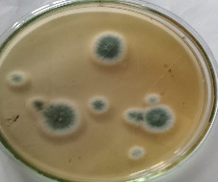  Isolate Nr.1  On potato dextrose agar  After 48 hr | 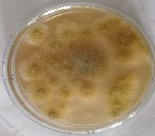  Isolate Nr. 13  On potato dextrose agar  After 48 hr
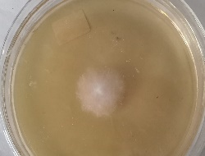  Isolate Nr.14  On potato dextrose agar  After 48 hr | 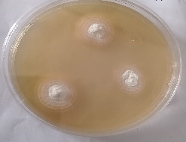  Isolate Nr.15  On nutrient agar  After 10 days
Figure S13: Pure cultures of different morphological fungal isolates (1, 13, 14 , 15 )

