*Egypt. J. Chem.* **Vol. 67**, No. 12 pp. 365 - 377 (2024)

**LC-MS/MS chemical profiling of *Chrysopogon zizanioides* *in vitro* shoots propagated on different elicitors**

**Mahmoud A. M. Arafata,*, Mohammed N. A. Khalilb, Engy A. Mahrousb,c, Essam M. Abd El-kaderd and Seham El-Hawaryb**

a Pharmacognosy Department, Faculty of Pharmacy, Heliopolis University, 11361, Egypt

b Pharmacognosy Department, Faculty of Pharmacy, Cairo University, Cairo, 11562, Egypt

c Pharmacognosy Department, Faculty of Pharmacy, Ahram Canadian University, Giza, 12451, Egypt

d Timber Tree Research department, Horticulture Research Institute, Agriculture Research Center, Cairo, 12619, Egypt

**Supplementary material**

**Table S1:** Constituents of CE, ProE and PheSAE identified using LC-ESI-MS/MS

|  |  |  |  |  |  |  |  |  |
| --- | --- | --- | --- | --- | --- | --- | --- | --- |
|  | **Rt** | ***m/z*** | **Mol Formula** | **Possibility** | **Occurrence** | | | **Reference** |
| **CE** | **ProE** | **PheSAE** |
| **Flavonoids** | | | | | | | | |
| 1 | 3.88 | 549.0 | C25H25O14- | Luteolin-6,8-*di*-*C*-pentoside | + | + | + | (Arafat et al. 2023) |
| 2 | 3.99 | 562.9 | C26H27O14- | Apigenin-6-*C*-hexoside-8-*C*-pentoside | + | + | + | (Roriz et al. 2014) |
| 3 | 6.68 | 592.9 | C27H29O15- | Chrysoeriol-*C*-arabinoside-*C*-glucopyranoside | + | + | - | (Arafat et al. 2023) |
| 4 | 7.17 | 533.0 | C25H25O13- | Apigenin-*C*,*C*-di-pentoside | + | + | + | (Arafat et al. 2023) |
| 5 | 7.22 | 579.0 | C26H27O15- | Luteolin 6-*C*-arabinoside 8-*C*-glucoside (Isocarlinoside) | + | + | - | (Champagnat et al. 2008) |
| 6 | 7.29 | 666.9 | C29H31O18- | Tricin-*O*-hexouronic acid -hexoside | + | + | + | (Arafat et al. 2023) |
| 7 | 7.93 | 491.0 | C23H23O12- | Tricin-*O*-hexoside | + | + | + | (Hussein et al. 2018) |
| 8 | 9.35 | 636.9 | C29H33O16- | Tricin-*O*-rutinoside | + | - | + | (Yang et al. 2014) |
| 9 | 11.13 | 329.1 | C17H13O7- | Tricin aglycone | + | + | + | (Arafat et al. 2023) |
| **Lignans & flavolignans** | | | | | | | | |
| 10 | 11.74 | 494.9 | C26H23O10- | Aegicin | + | + | - | (Cooper et al. 1977)**,** (Cooper 2015) |
| 11 | 12.09 | 524.9 | C27H25O11- | Tricin 4'-*O*-( guaiacylglyceryl) ether | + | - | + | (Mohanlal et al. 2011) |
| 12 | 12.73 | 443.0 | C23H23O9- | 2,7'-Cyclo-3',4,4',5,5',6,7-heptahydroxy-8,8'-lignan-9',9-olide-4,5-Methylene, 3',4',5',6-tetra-Me ether | - | - | + | (Arafat et al. 2023) |
| **Phenolics** | | | | | | | | |
| 13 | 2.50 | 367.0 | C17H19O9- | Feruloylquinic acid | - | - | + | (Ao et al. 2022) |
| 14 | 2.81 | 211.0 | C10H11O5 - | Vanillactic acid | + | + | + | (Arafat et al. 2023) |
| 15 | 8.54 | 163.0 | C9H7O3- | 4-Hydroxycinnamic acid | + | + | + | (De Oliveira et al. 2017) |
| 16 | 11.06 | 355.1 | C16H19O9- | [1-*O*-Feruloylhexose](https://pubchem.ncbi.nlm.nih.gov/compound/13962927) | + | + | + | (Arafat et al. 2023) |
| **Carboxylic acids** | | | | | | | | |
| 17 | 2.59 | 191.0 | C7H11O6- | Quinic acid | + | + | + | (Arafat et al. 2023) |
| 18 | 2.83 | 195.0 | C6H11O7- | gluconic acid | + | + | + | (Akbari et al. 2015) |
| 19 | 3.16 | 173.1 | C7H9O5- | Shikimic acid | + | + | + | (Nurazah et al. 2017) |
| **Fatty acids** | | | | | | | | |
| 20 | 11.67 | 327.1 | C18H31O5- | Trihydroxyoctadecenoic acid | + | + | + | (Arafat et al. 2023) |
| 21 | 14.04 | 293.1 | C18H29O3- | Hydroxyoctadecatrienoic acid | + | + | + | (Arafat et al. 2023) |
| 22 | 14.82 | 295.1 | C18H31O3- | Hydroxyoctadecadienoic acid | + | + | + | (Han et al. 2020) |

+ present; -, absent

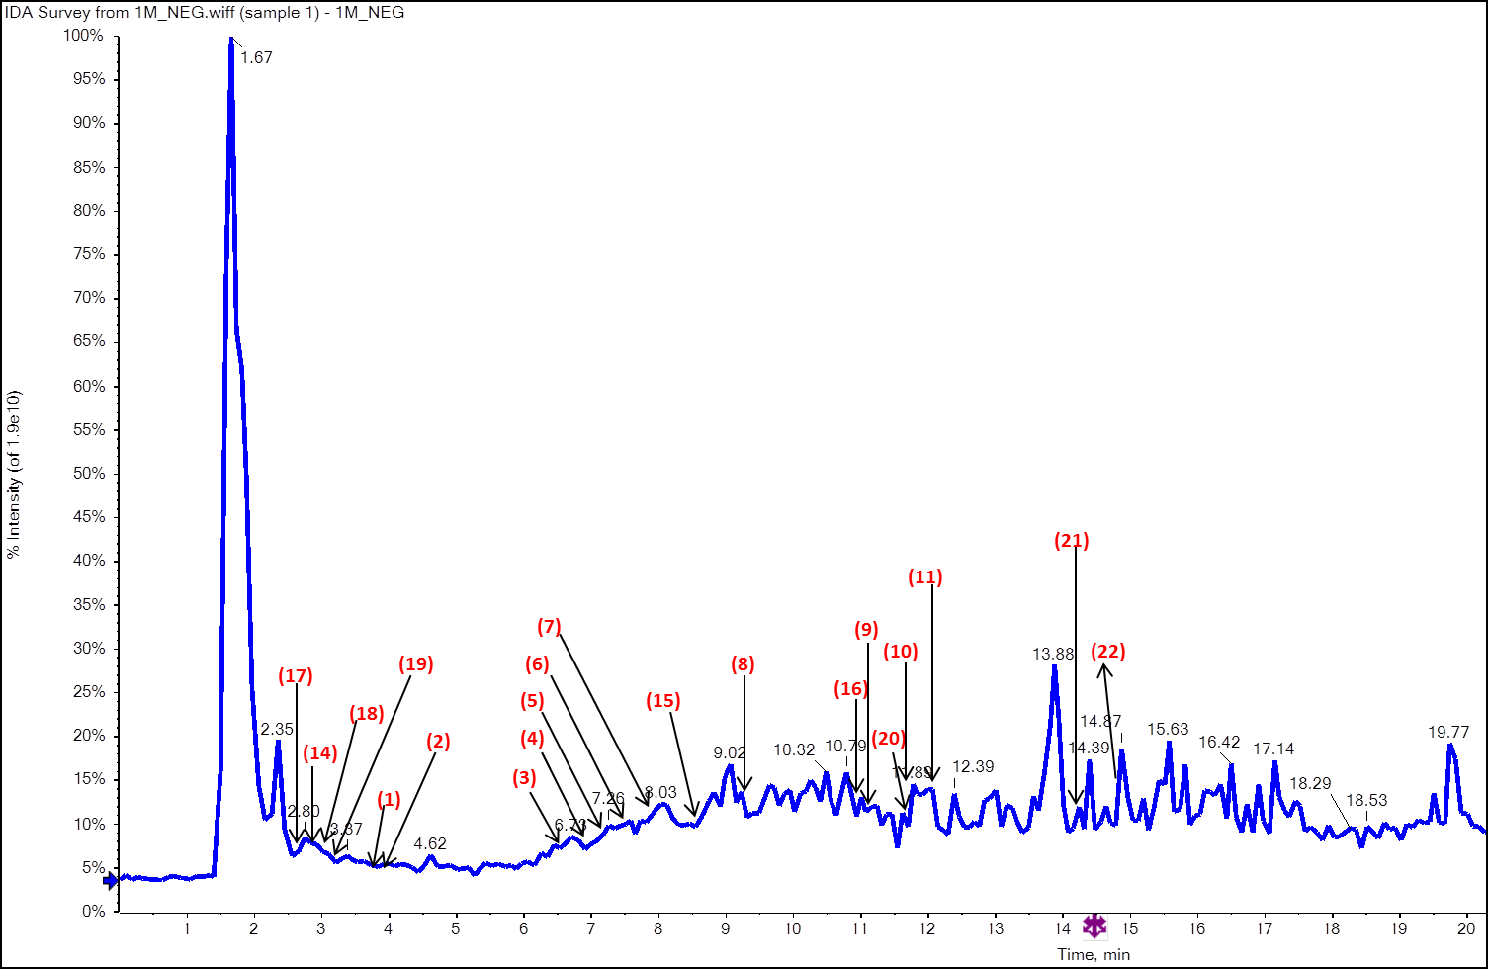

**Fig (S1.1):** Base peak chromatograms of ethanolic extract of *C. zizanioides* *in vitro* shoots cultured on MS medium supplemented IAA at 0.5 mg L-1 only (control group). Numbers refer to identified compounds listed in Table S1.

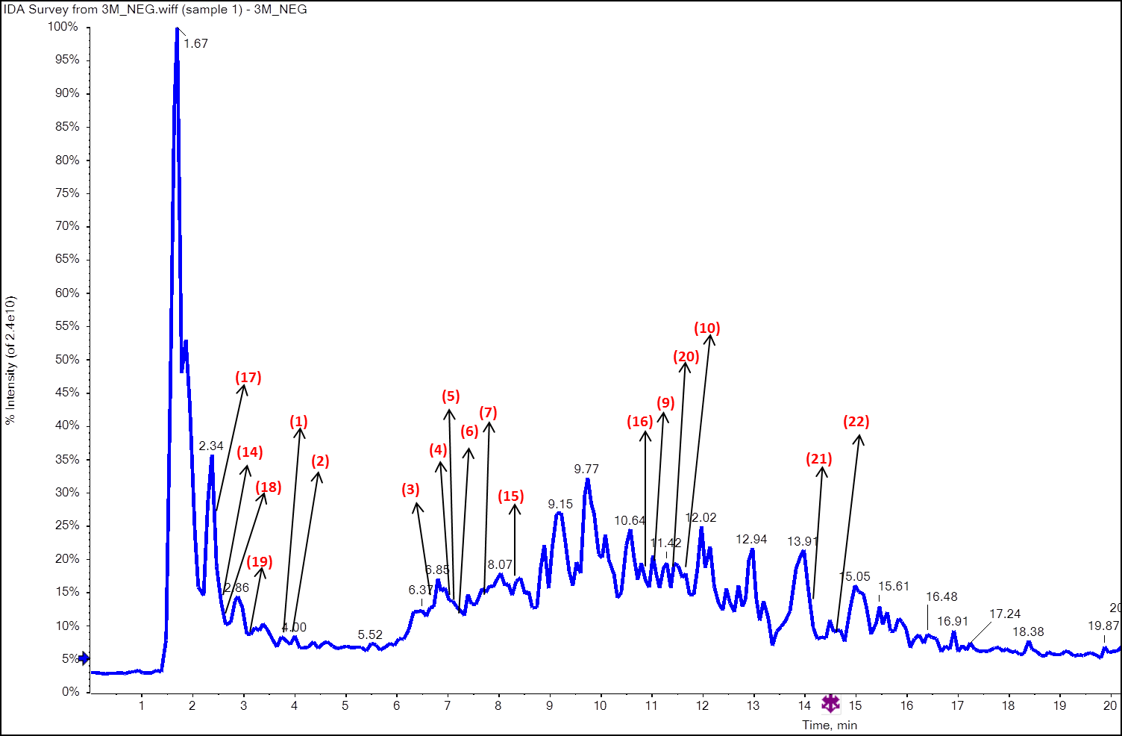

**Fig (S1.2):** Base peak chromatograms of ethanolic extract of *C. zizanioides in vitro* shoots cultured on MS medium supplemented IAA at 0.5 mg L-1 and Pro at 50 mg L-1. Numbers refer to identified compounds listed in Table S1.

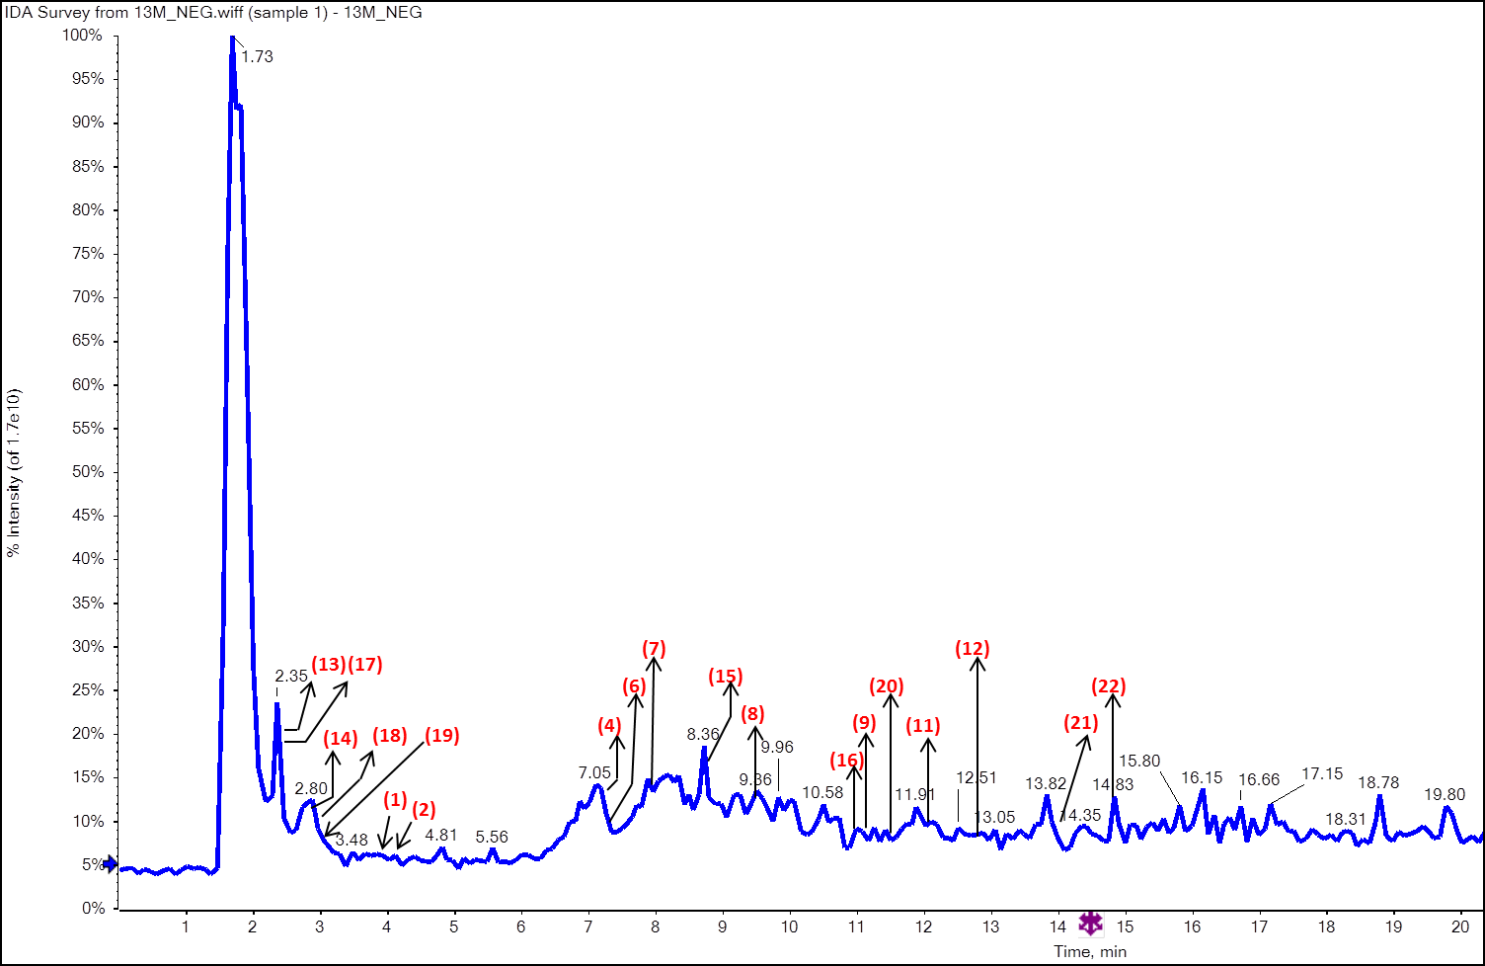

**Fig (S1.3):** Base peak chromatograms of ethanolic extract of *C. zizanioides* *in vitro* shoots cultured on MS medium supplemented IAA at 0.5 mg L-1 and combination between Phe (100 mg L-1)and SA (100 mg L-1). Numbers refer to identified compounds listed in Table S1.

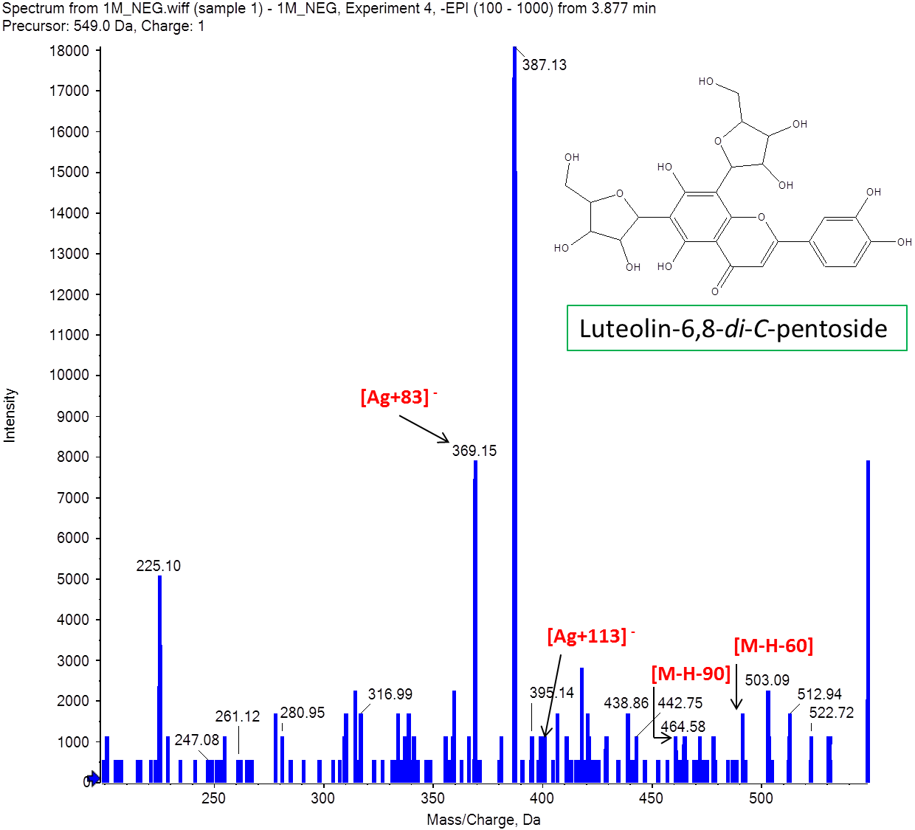

**Fig (S1.4):** Mass spectrum of luteolin-di-*C*-pentoside.

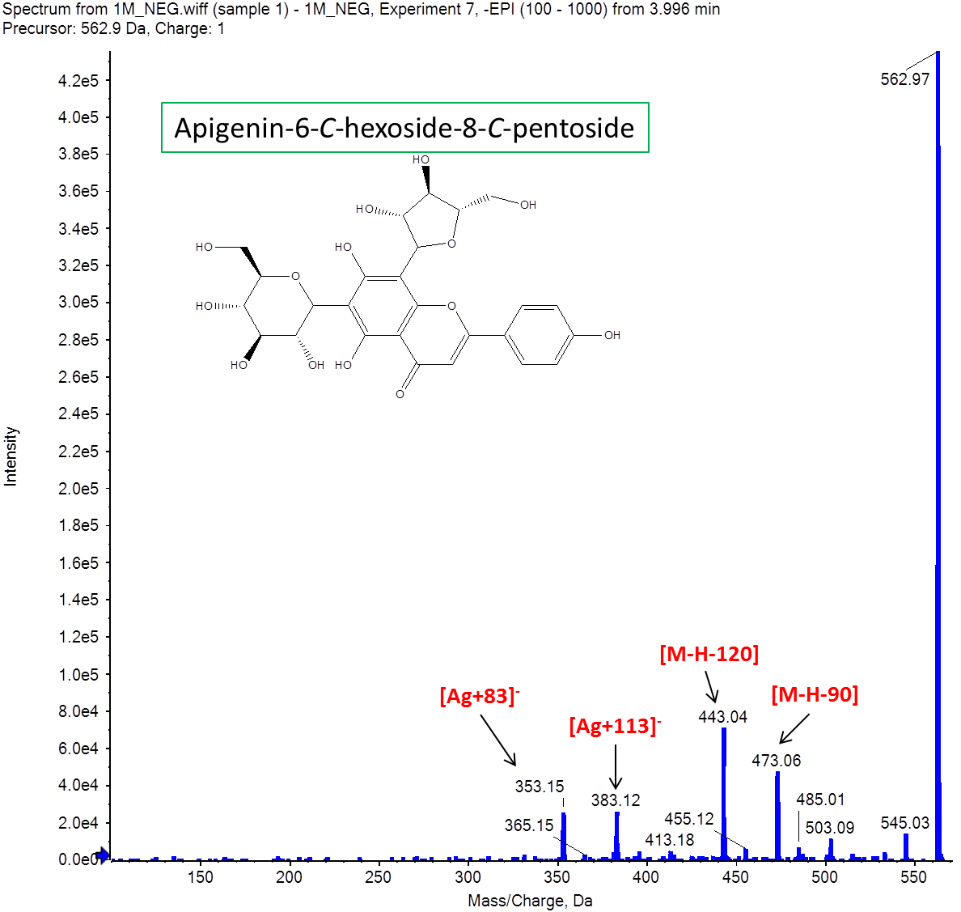

**Fig (S1.5):** Mass spectrum of apigenin-6-*C*-hexoside-8-*C*-pentoside.

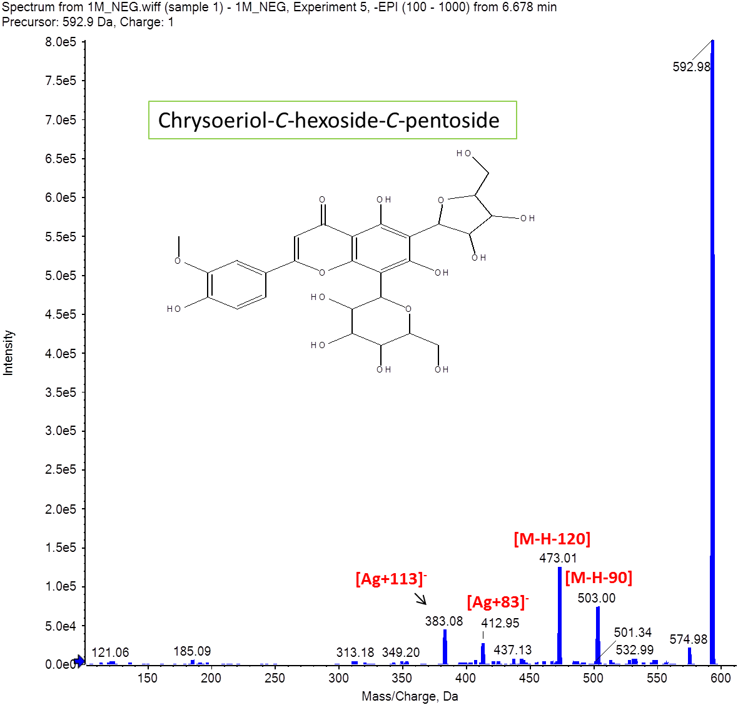

**Fig (S1.6):** Mass spectrum of chrysoeriol-*C*-hexoside-*C*-pentoside.

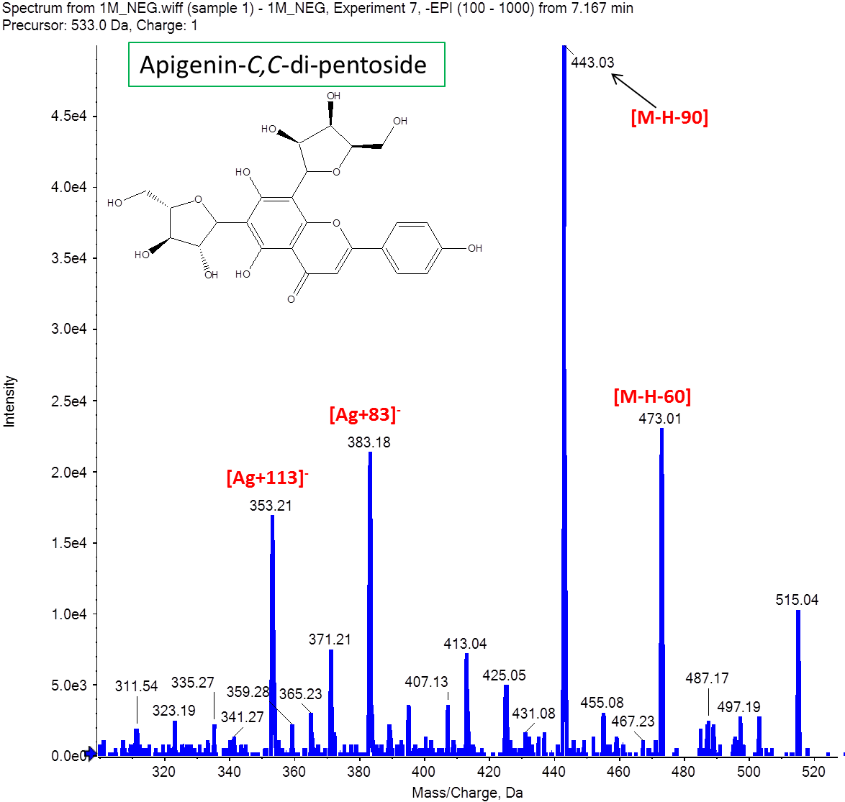

**Fig (S1.7):** Mass spectrum of apigenin-*C*,*C*-di-pentoside.

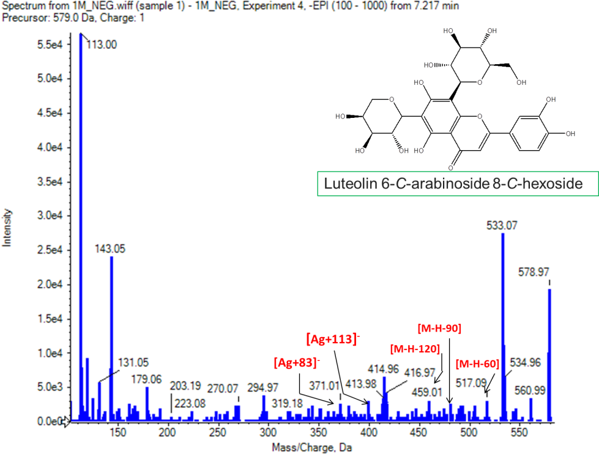

**Fig (S1.8):** Mass spectrum of luteolin 6-*C*-arabinoside-8-*C*-hexoside.

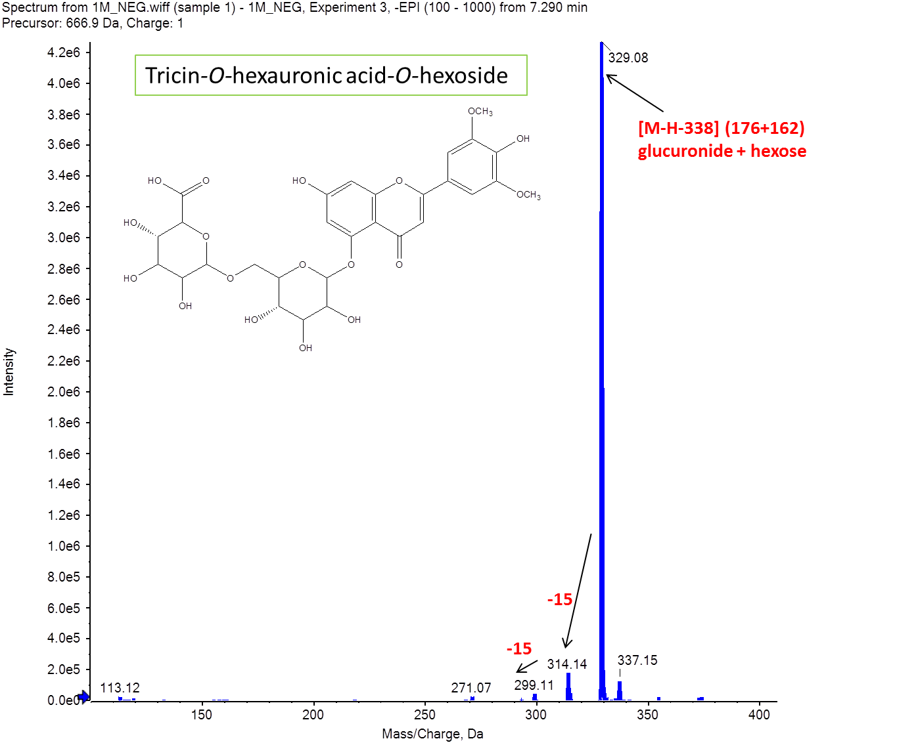

**Fig (S1.9):** Mass spectrum of tricin-*O*-(hexauronic acid-*O*-hexoside).

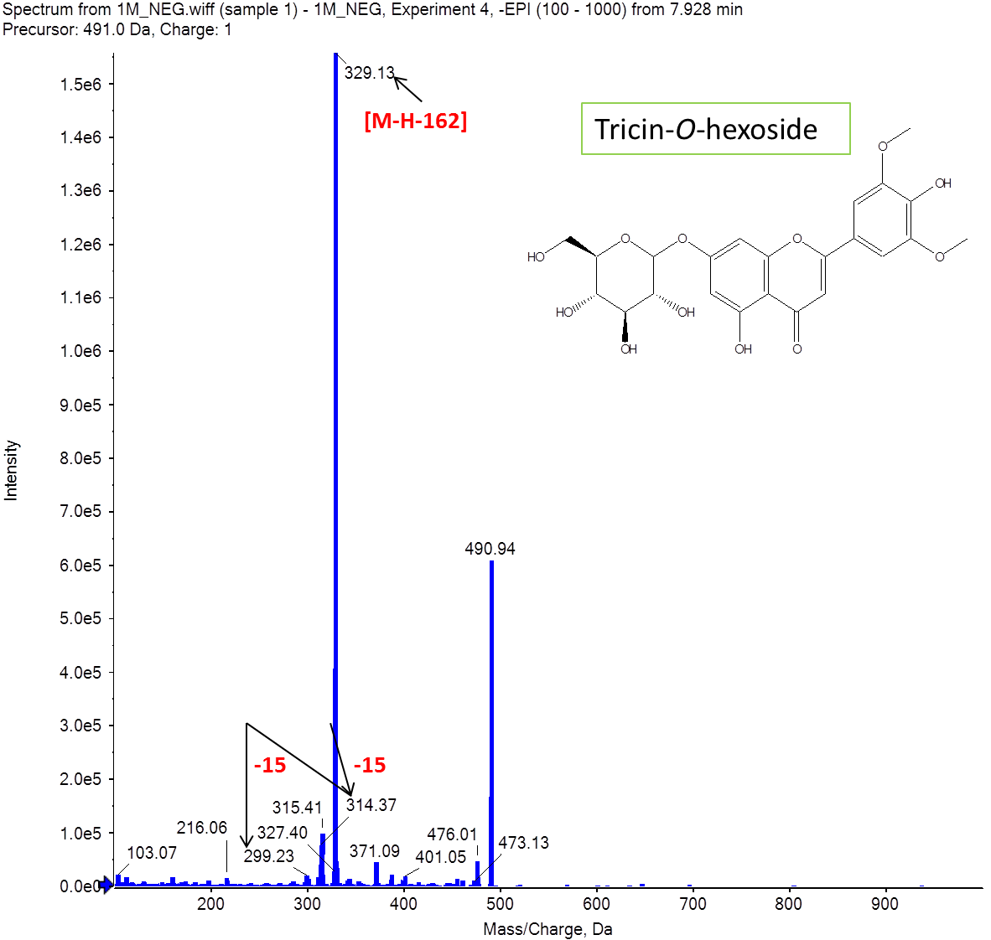

**Fig (S1.10):** Mass spectrum of tricin hexoside.

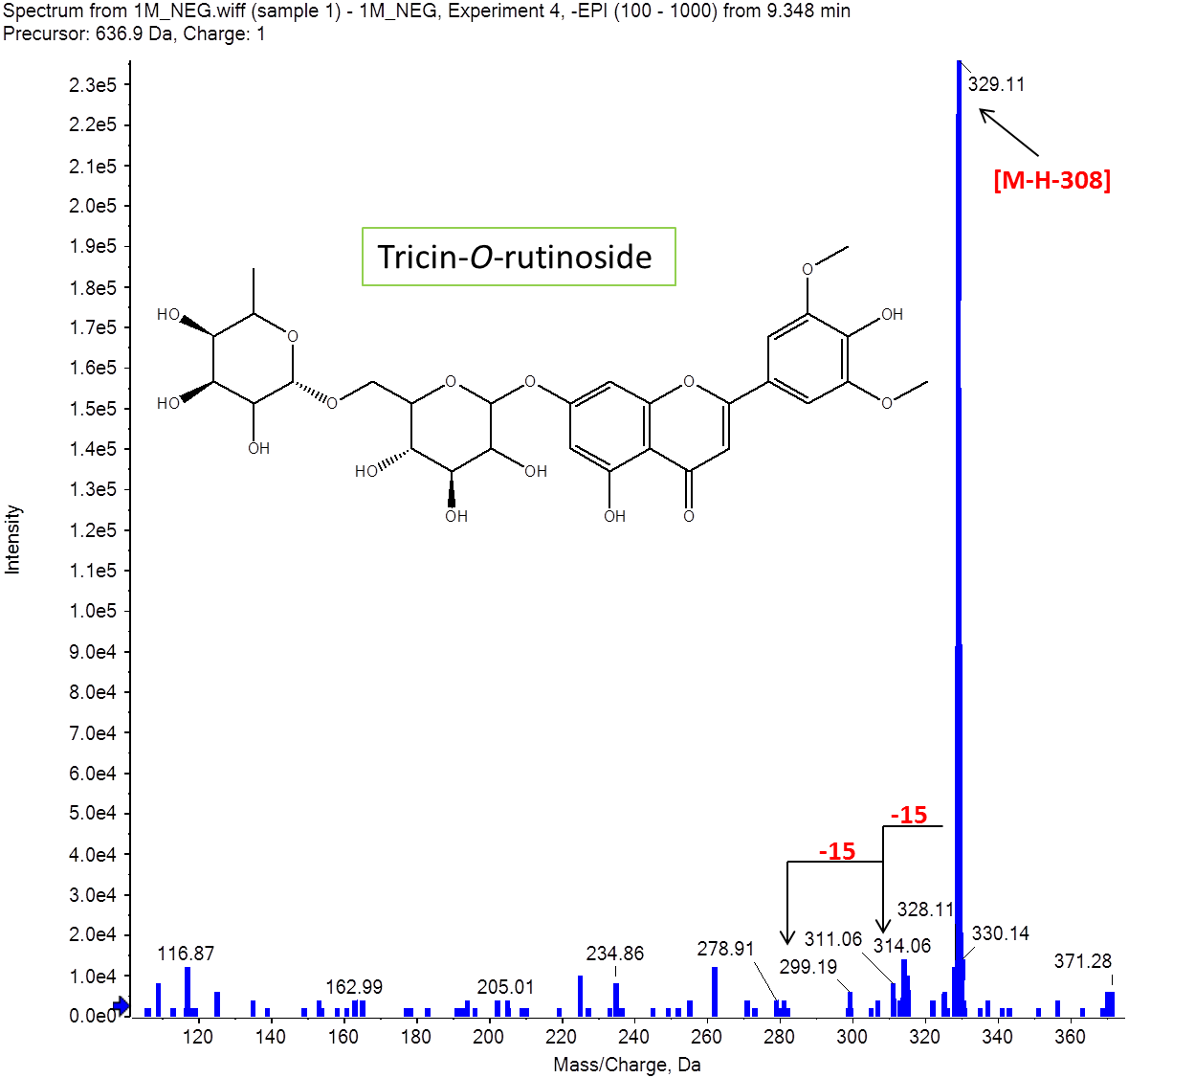

**Fig (S1.11):** Mass spectrum of tricin-*O*-rutinoside.

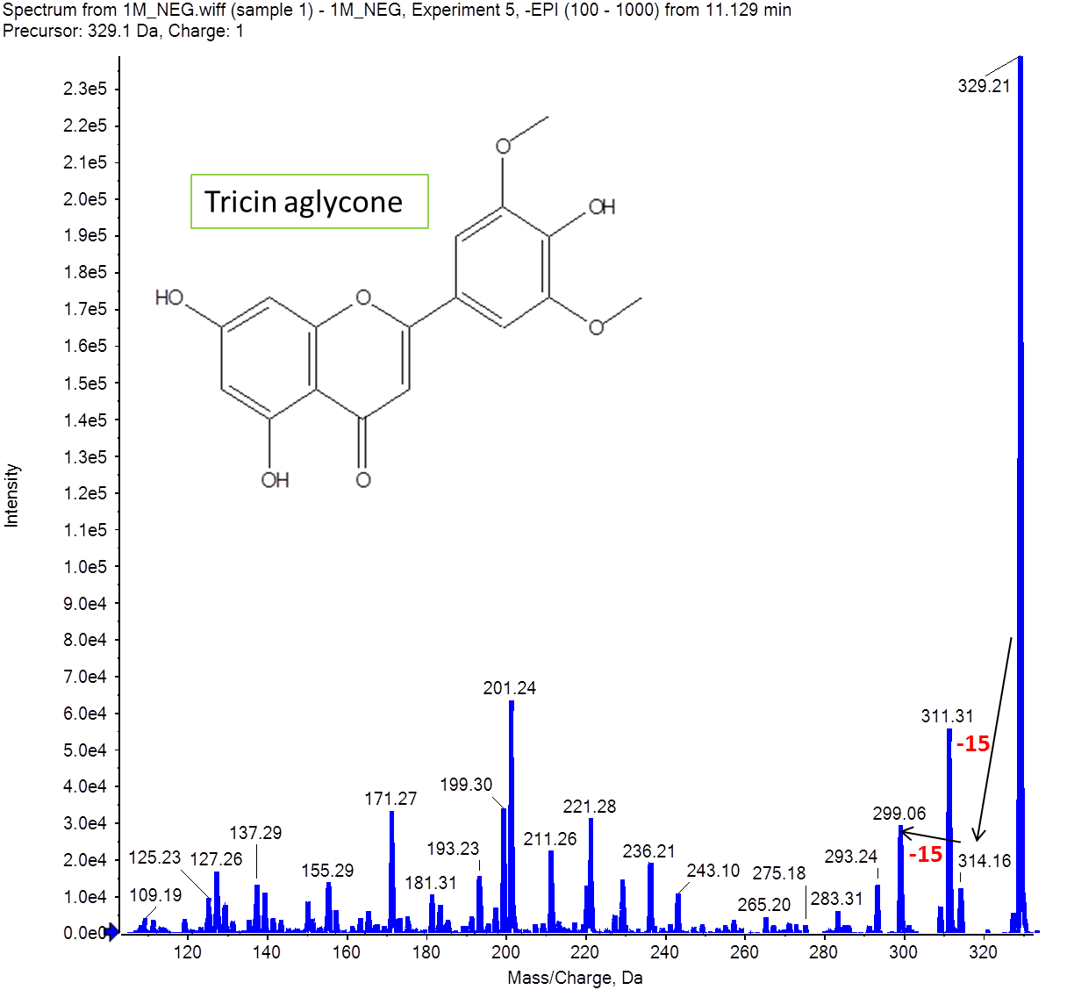

**Fig (S1.12):** Mass spectrum of tricin-aglycon.

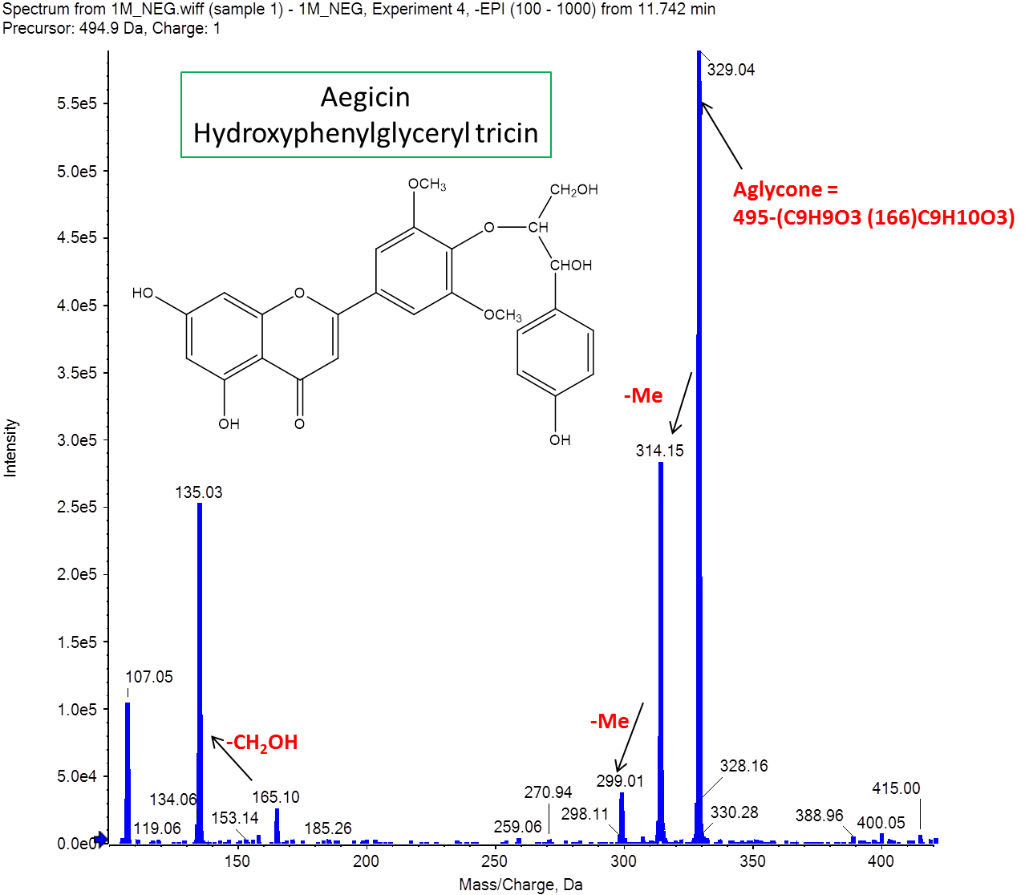

**Fig (S1.13):** Mass spectrum of aegicin.

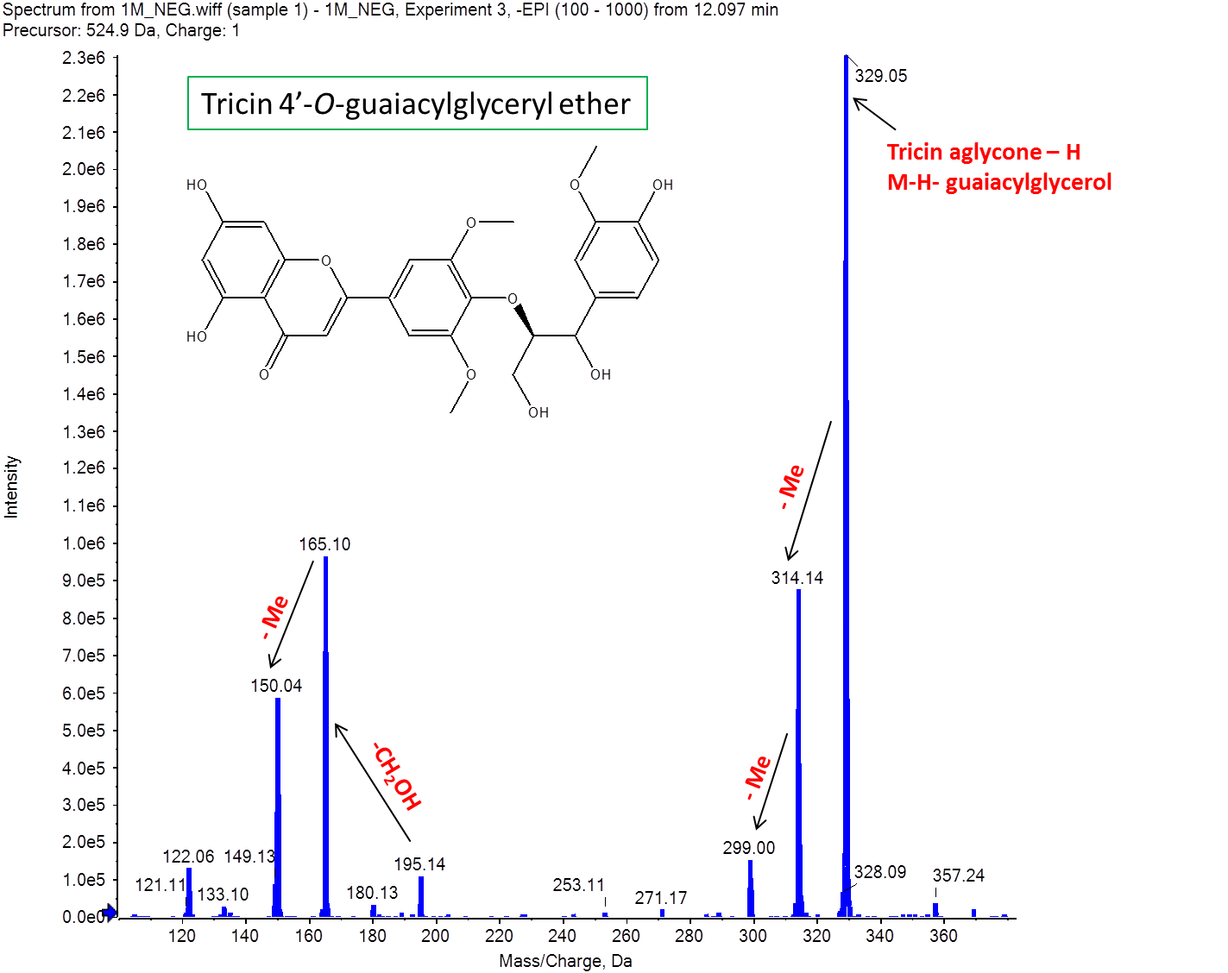

**Fig (S1.14):** Mass spectrum of tricin 4'-*O*-(guaiacylglyceryl) ether.

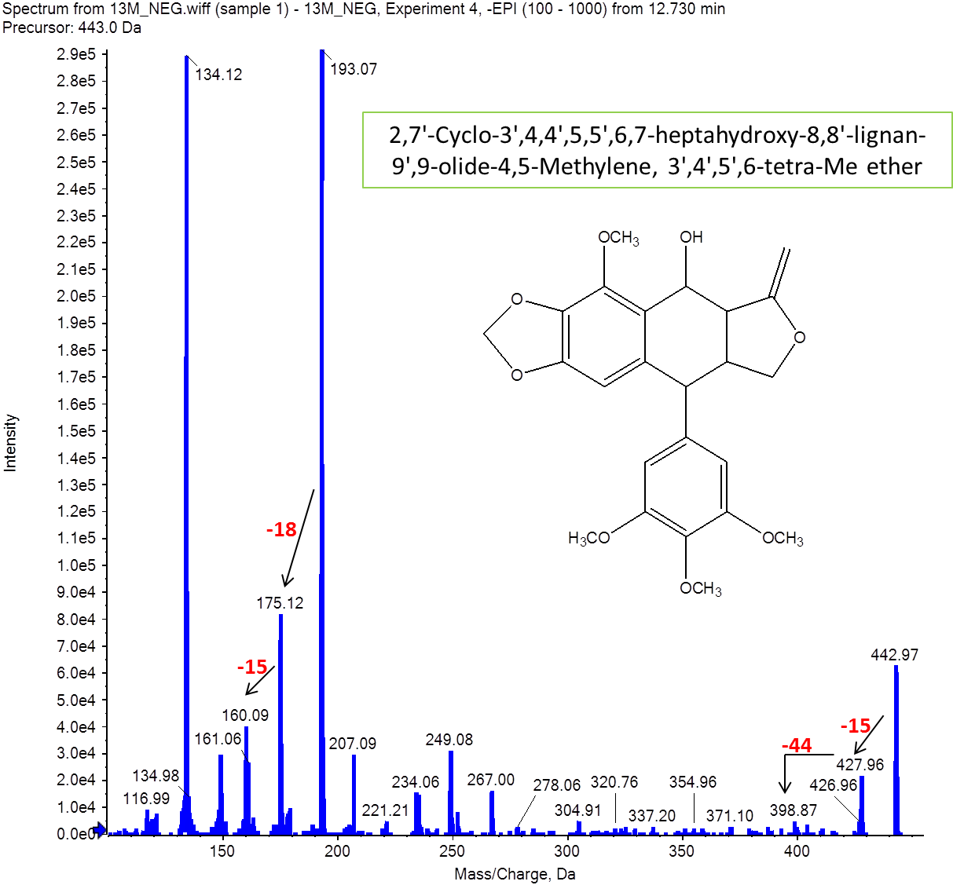

**Fig (S1.15):** Mass spectrum of 2,7'-Cyclo-3',4,4',5,5',6,7-heptahydroxy-8,8'-lignan-9',9-olide-4,5-Methylene, 3',4',5',6-tetra-Me ether.

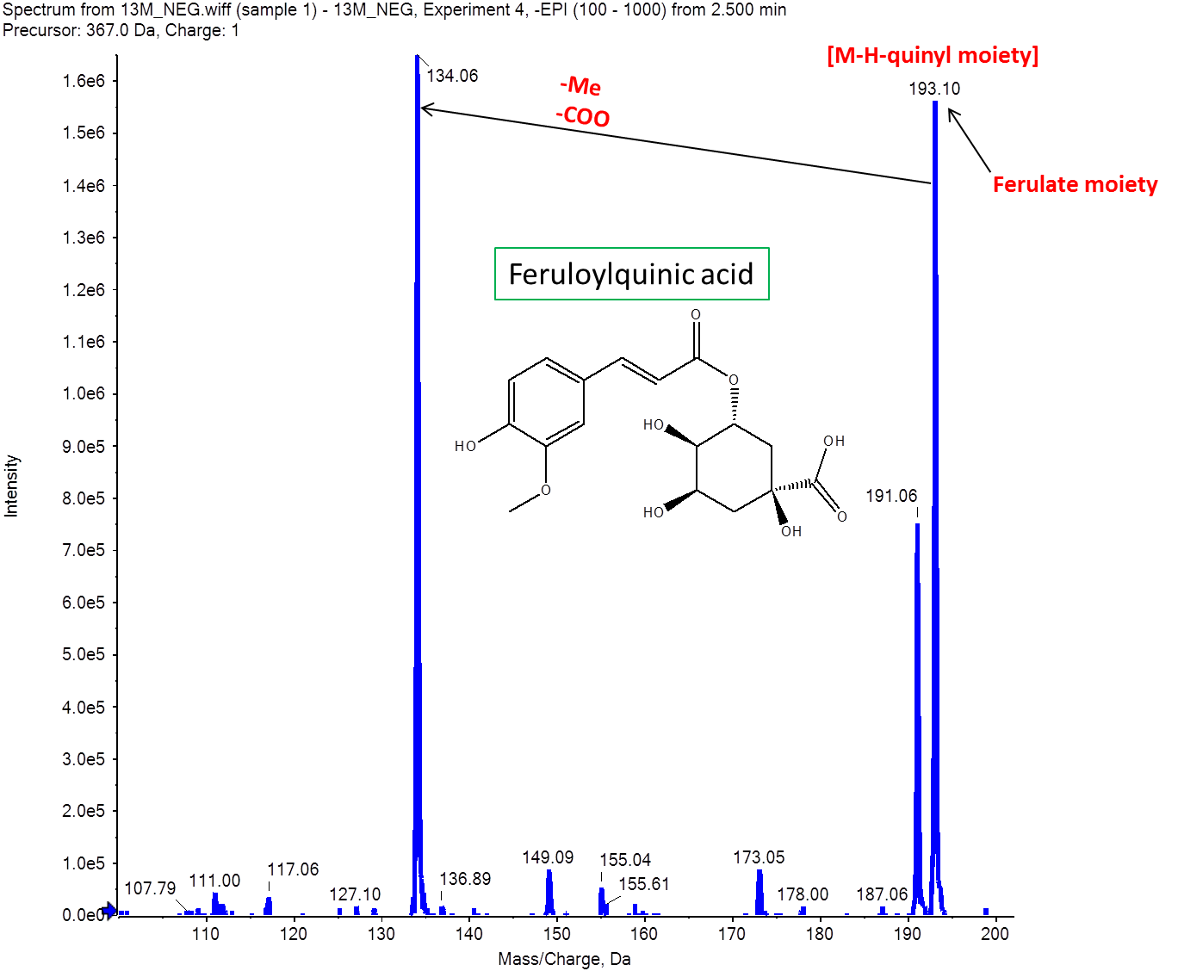

**Fig (S1.16):** Mass spectrum of feruloylquinic acid.

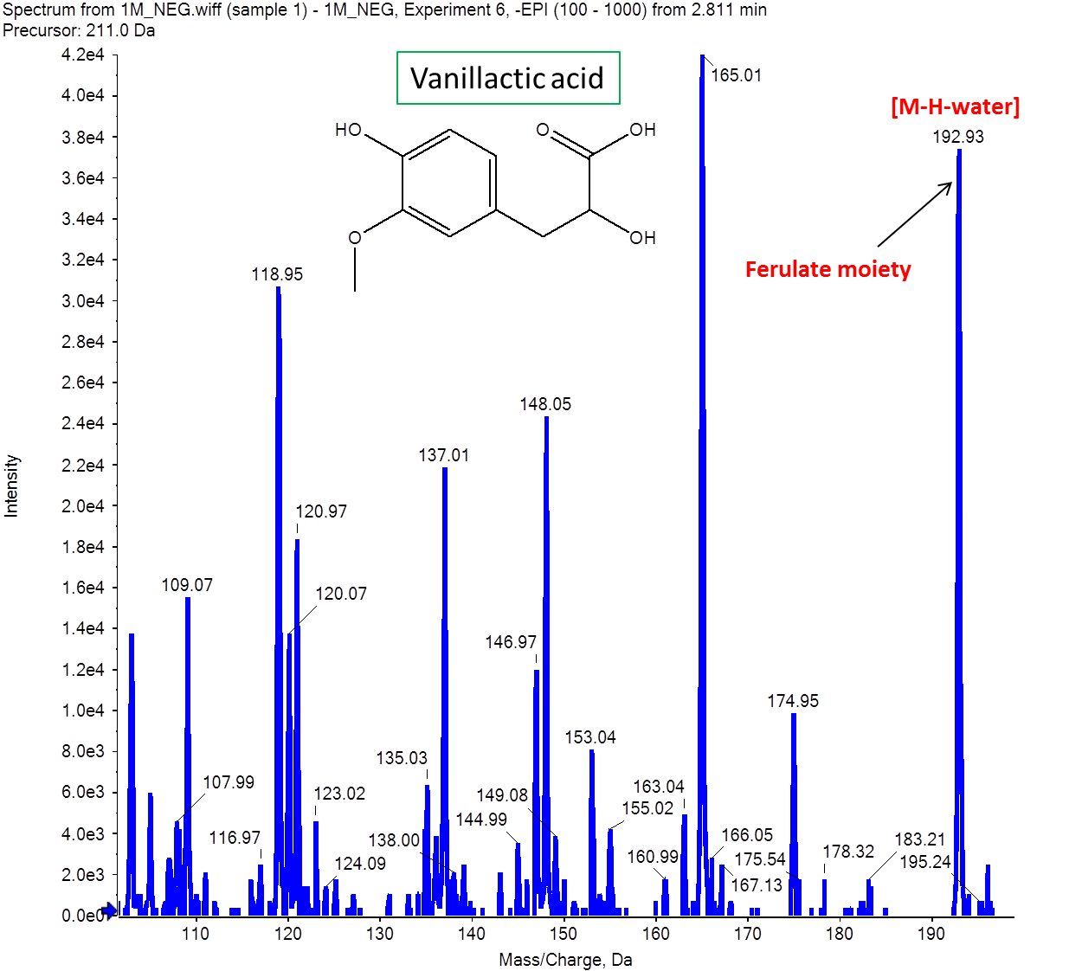

**Fig (S1.17):** Mass spectrum of vanillactic acid.

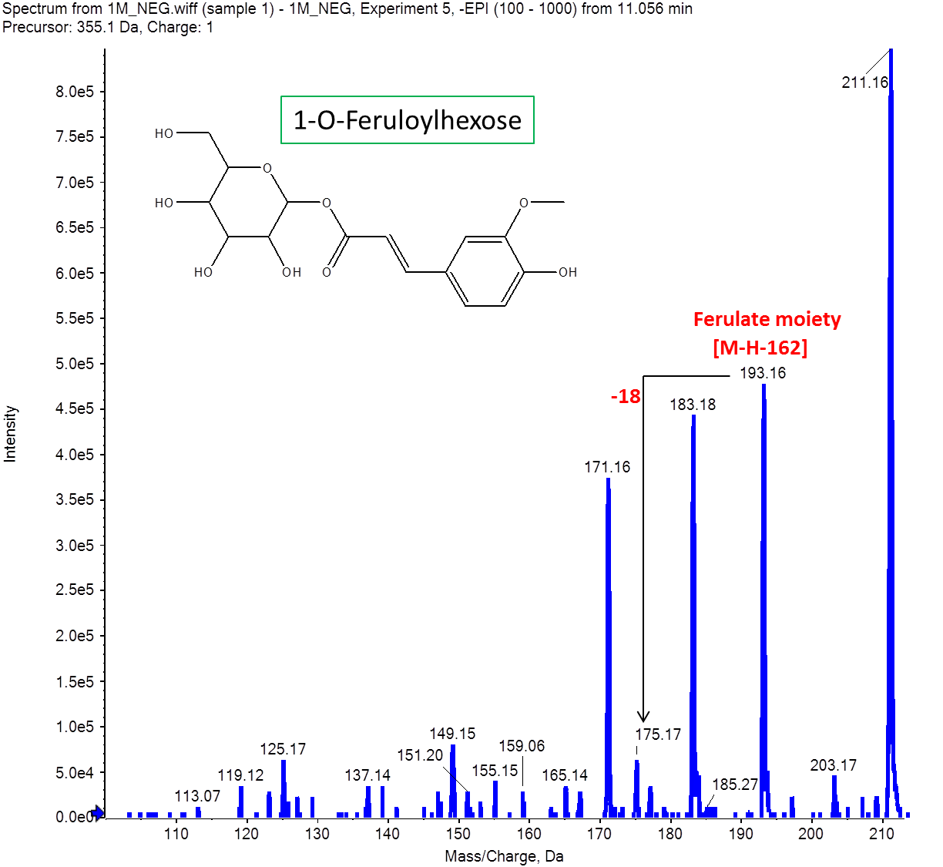

**Fig (S1.18):** Mass spectrum of feruloylhexose.

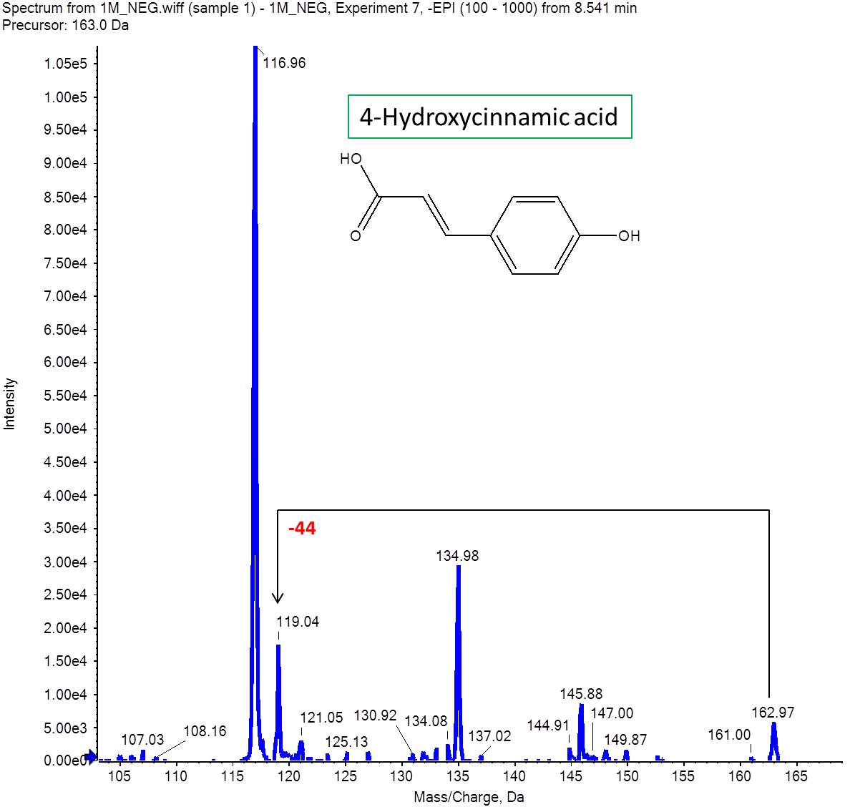

**Fig (S1.19):** Mass spectrum of 4-hydroxycinnamic acid.

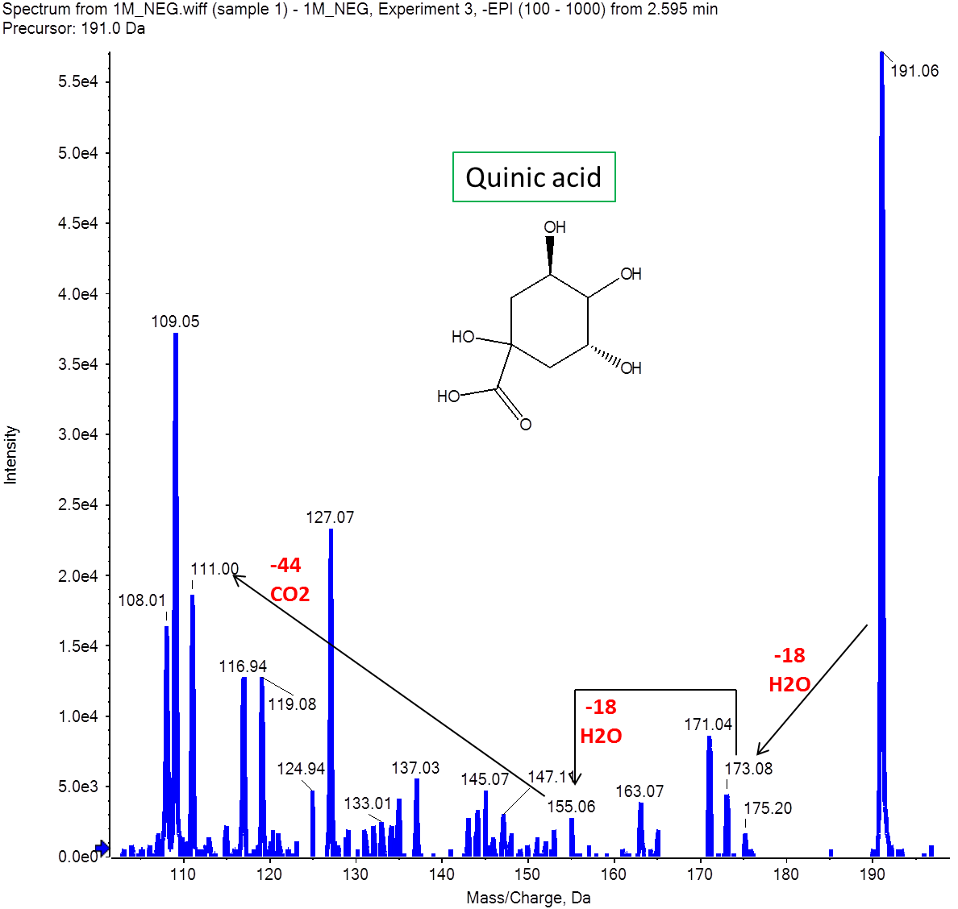

**Fig (S1.20):** Mass spectrum of quinic acid.

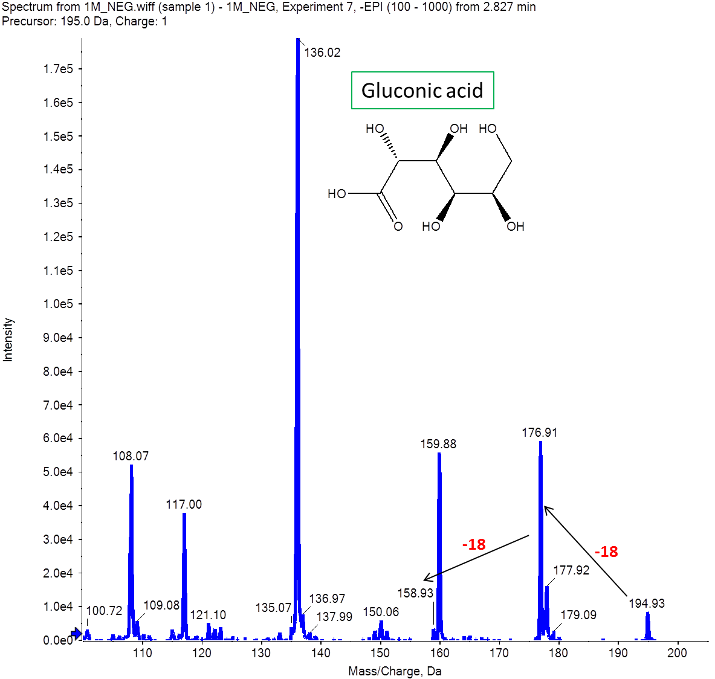

**Fig (S1.21):** Mass spectrum of gluconic acid.

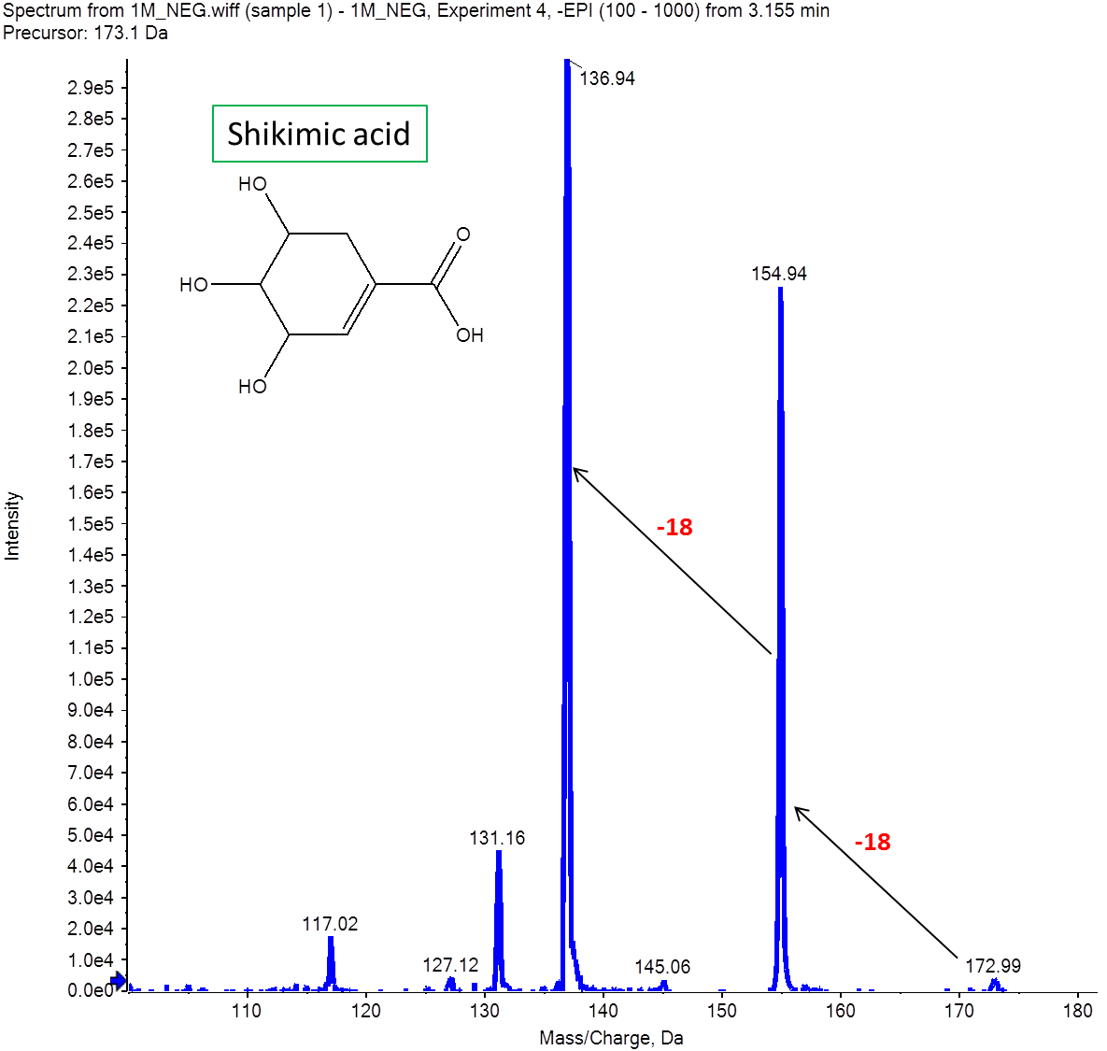

**Fig (S1.22):** Mass spectrum of shikimic acid.