Egypt. J. Chem. Vol. 68, No. 5 pp. 69 - 75 (2025)

Composition and Bronchodilator activity of the fruits of Trachyspermumammi L. Essential oil

Mariam K. Alamoudi^{a*}, Najeeb Ur Rehmanª, Mohammad Ayman A. Salkini^{b}, Abdulaziz S. Saeedanª, Omar K. M. Al-Rahimi^{c}, Maged S. Abdel-Kader^{b,d}

ªDepartment of Pharmacology and Toxicology, College of Pharmacy, Prince Sattam Bin Abdulaziz University, P.O. Box 173, Al-Kharj 11942, Saudi Arabia
^{b} Department of Pharmacognosy, College of Pharmacy, Prince Sattam Bin Abdulaziz University, P.O. Box 173, Al-Kharj 11942, Saudi Arabia
^{c}College of Pharmacy, Prince Sattam Bin Abdulaziz University, P.O. Box 173, Al-Kharj 11942, Saudi Arabia
^{d}Department of Pharmacognosy, Faculty of Pharmacy, Alexandria University, Alexandria 21215, Egypt

Supporting information

A | B
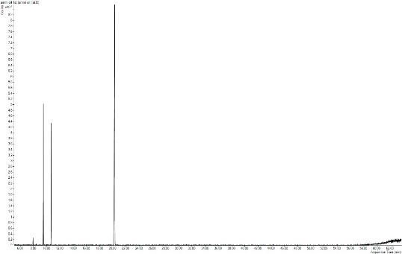 | 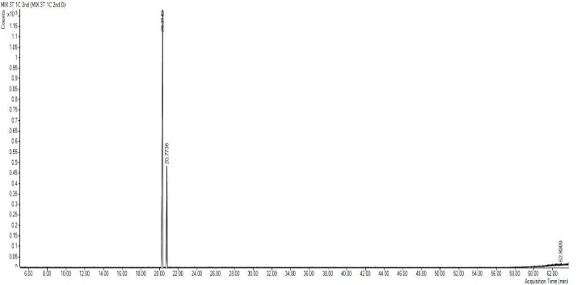
Figure S1.GC chromatogram of Trachyspermumammioil (A), Thymol and Carvacrol (B).

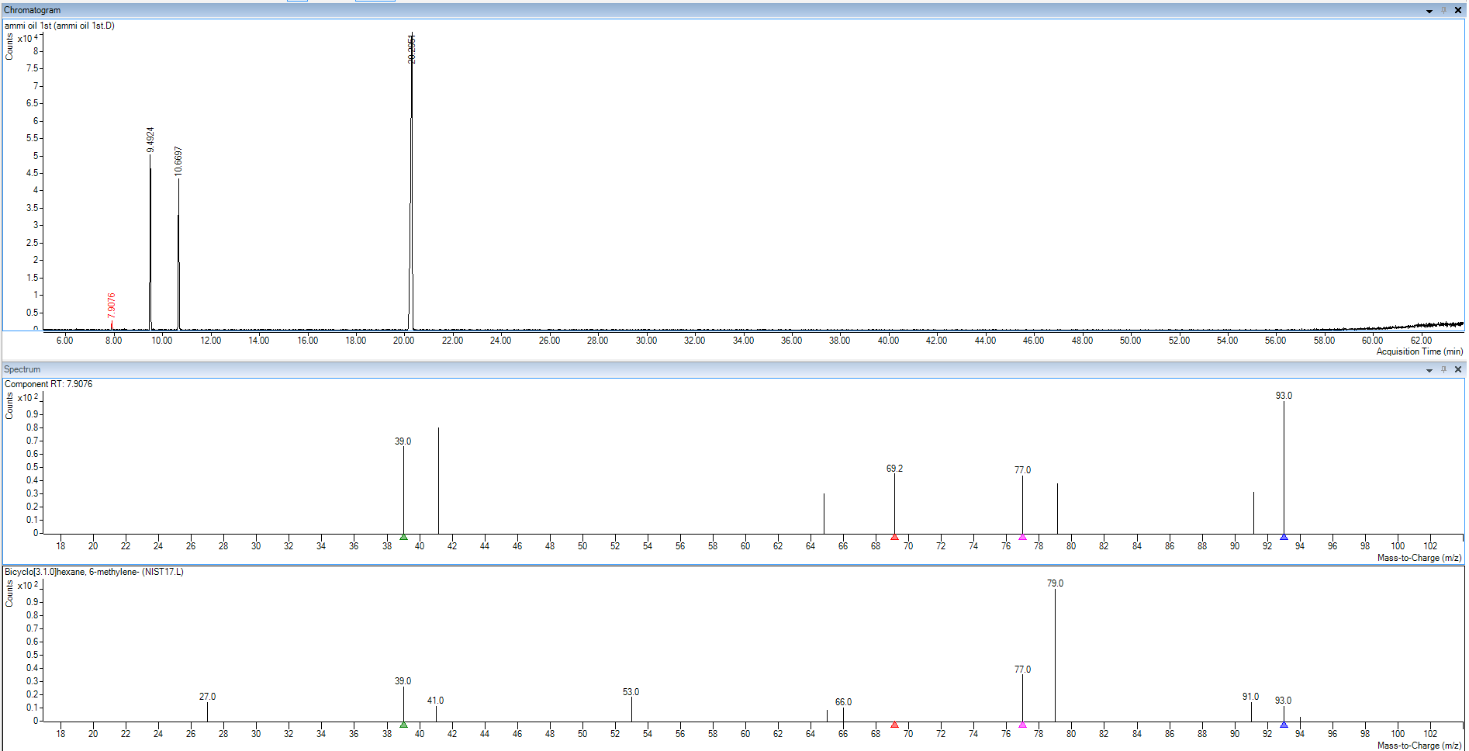 | 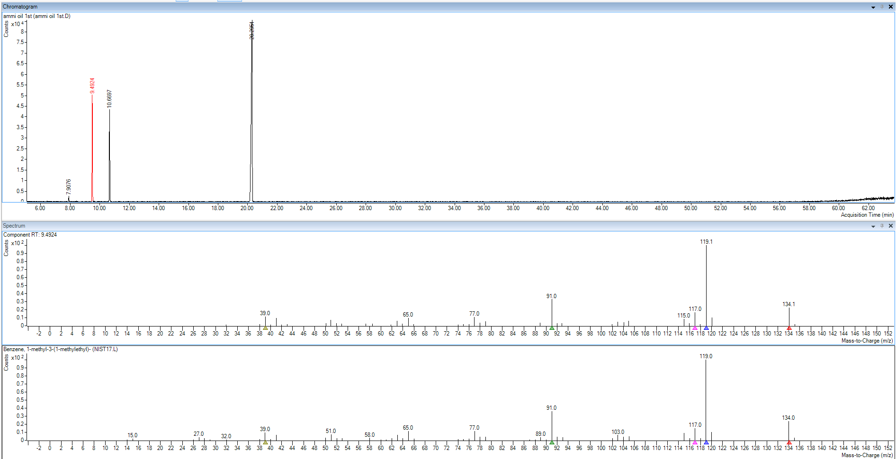
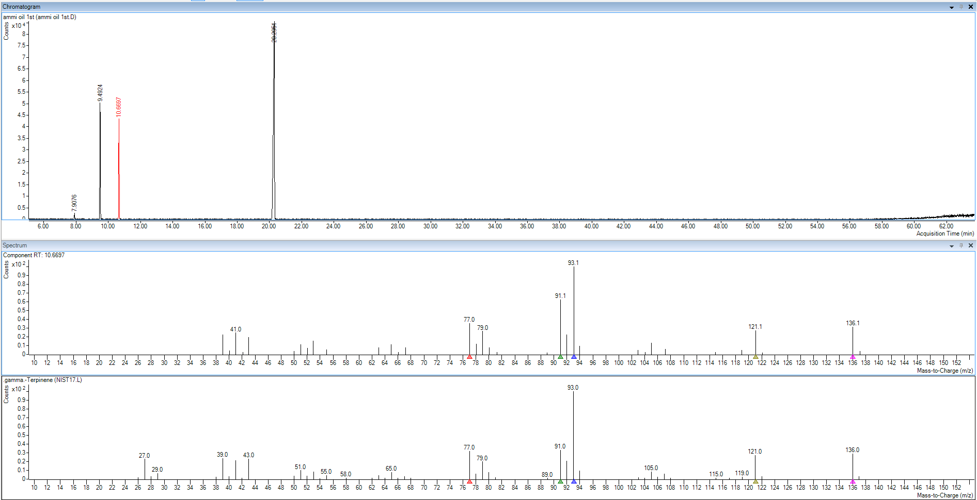 | 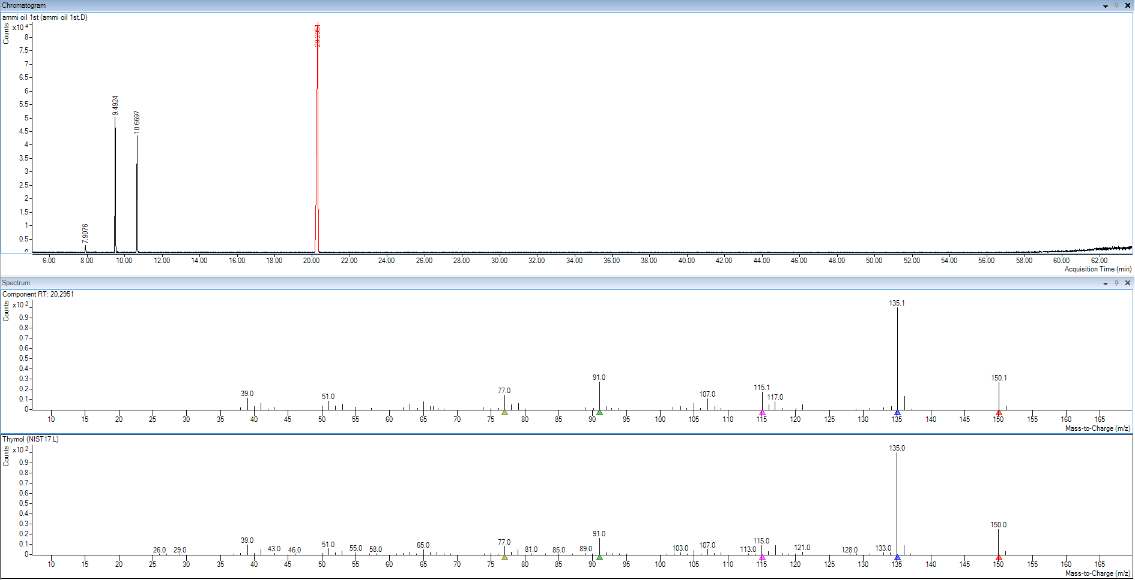
Figure S2.GC chromatogram of Trachyspermumammioil with measured and reported MS spectra of the four components

