*Egypt. J. Chem.* **Vol. 68**, No. 12 pp. 641 - 669 (2025)

**Revealing the Antiviral Activity of Certain Volatile Oils against Respiratory RNA and DNA Viruses Supported by Molecular Dynamics Analysis**

Mohamed S. Refaey1,2,*, Omnia Kutkat3,Yassmin Moatasim3, Nahla Sameh Tolba4, Anis Zaid5, Ahmed M. Elshorbagy1, Khloud Nassar6,Ahmed A. El-Rashedy7,10**,** Mohamed F. El-Badawy8, Khaled A. M. Abouzid9, Marwa A. A. Fayed1 and Yaseen A. M. M. Elshaier10

1*Department of Pharmacognosy, Faculty of Pharmacy, University of Sadat City, Menoufia 32897, Egypt*

*2Department of Pharmacognosy and natural products, Faculty of Pharmacy, Menoufia National University, km Cairo-Alexandria Agricultural Road, Menoufia, Egypt*

3*Center of Scientific Excellence for Influenza Viruses, National Research Centre (NRC), Giza 12622, Egypt*

4*Department of Pharmaceutics, Faculty of Pharmacy, University of Sadat City, Menoufia 32897, Egypt*

5*Department of Pathology, faculty of Veterinary Medicine, University of Sadat City, Egypt*

6*Department of biochemistry, Faculty of Pharmacy, University of Sadat City, Menoufia 32897, Egypt*

7 *Department of The Chemistry of Natural and Microbial Products, Pharmaceutical and Drug Industries Institute, National Research Centre (NRC), 33 El-Behouth St., Dokki, Giza, 12622, Egypt.*

8*Microbiology and immunology Department, Faculty of Pharmacy, University of Sadat City, Menoufia 32897, Egypt*

9*Pharmaceutical Chemistry Department, Faculty of Pharmacy, Ain Shams University, Abbassia 11566, Cairo, Egypt*

10*Department of Organic and Medicinal Chemistry, Faculty of Pharmacy, University of Sadat City, Menoufia 32897, Egypt*

\***Corresponding authors**: Mohamed S. Refaey

E-mail address: mohamed.said@fop.usc.edu.eg

**Content**

|  |  |  |
| --- | --- | --- |
| **No.** | **Contents** | **Page** |
| **Fig. S1** | Total ion chromatogram of *Coriandrum sativum* essential oil | S3 |
| **Fig. S2** | Total ion chromatogram of *Rosmarinus officinalis* essential oil | S3 |
| **Fig. S3** | Total ion chromatogram of *Pimpinella anisum* essential oil | S3 |

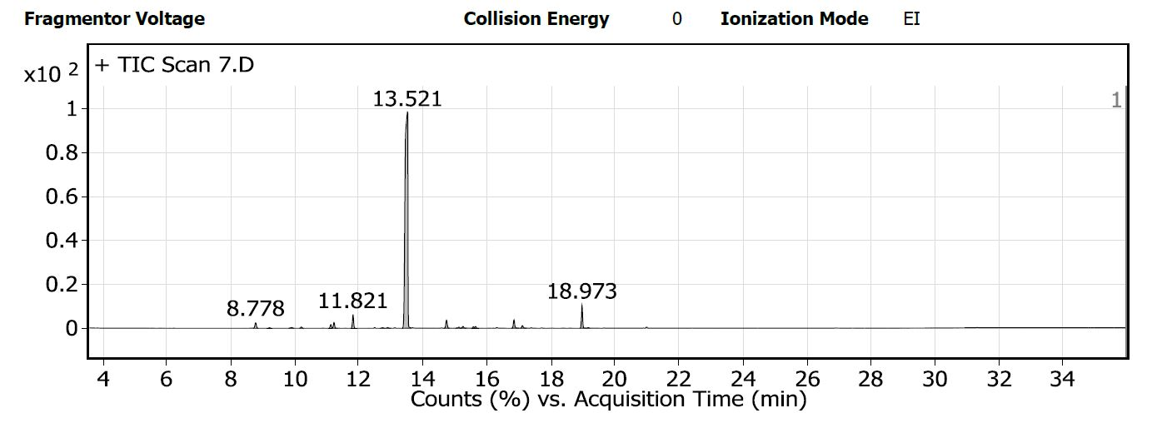

Fig. **S1**: Total ion chromatogram of *Coriandrum sativum* essential oil

Fig. **S2**: Total ion chromatogram of *Rosmarinus officinalis* essential oil

Fig. **S3**: Total ion chromatogram of *Pimpinella anisum* essential oil