Egypt. J. Chem. Vol. 67, No. 11 pp. 1 - 7 (2024)

Chemical characterization of two Egyptian Melilotus species to reveal their anti-inflammatory properties

Nermin A. Ragabª, Salma A. El Sawiª, Elsayed A. Aboutabl^{b}, Ali M. El Halawany^{b}, Amany A. Sleem^{c}, Mona M. Marzouk^{d}
ª Pharmacognosy Department, National Research Centre, 33El Bohouth St., Dokki, Giza 12622, Egypt
^{b} Faculty of Pharmacy, Cairo University, Kasr-el-Aini Street, 11562, Cairo, Egypt
^{c} Pharmacology Department, National Research Centre, 33El Bohouth St., Dokki, Giza 12622, Egypt.
^{d} Phytochemistry and Plant Systematics Department, National Research Centre, 33 El Bohouth St., Dokki, Giza 12622, Egypt

Supporting information

Table S1: Components identified by GC/MS of the unsaponifiable matter of M. messanensis and M. indicus
Area % |  | M.Wt | M.F | R_{t} | Compound | BP | No
Mi | Mm
0.7 | 1.22 | 236 | C₁₅H₂₄O₂ | 10.83 | 2,5-cyclohexadien-1-one, 2,6-bis(1,1-dimethylethyl)-4-hydroxy-4-methyl- | 165 | 1
- | 0.28 | 220 | C₁₅H₂₄O | 11.34 | Butylated hydroxyl toluene | 205 | 2
0.57 | 1.73 | 218 | C₁₆H₂₆ | 11.61 | (1-butylhexyl) Benzene | 91 | 3
0.68 | 1.62 | 218 | C₁₆H₂₆ | 11.72 | Benzene, (1-propylheptyl)- | 91 | 4
0.55 | 1.89 | 218 | C₁₆H₂₆ | 11.95 | Benzene, (1-ethyloctyl)- | 91 | 5
0.88 | 2.84 | 218 | C₁₆H₂₆ | 12.38 | Benzene, (1-methylnonyl)- | 105 | 6
0.80 | 2.38 | 232 | C₁₇H₂₈ | 12.72 | Benzene, (1-pentylhexyl)- | 91 | 7
1.99 | 6.26 | 232 | C₁₇H₂₈ | 12.76 | Benzene, (1-butylheptyl)- | 91 | 8
1.69 | 5.25 | 232 | C₁₇H₂₈ | 12.87 | Benzene, (1-propyloctyl)- | 91 | 9
2.23 | 5.99 | 232 | C₁₇H₂₈ | 13.12 | Benzene, (1-ethylnonyl)- | 91 | 10
2.80 | 8.69 | 232 | C₁₇H₂₈ | 13.54 | Benzene, (1-methyldecyl)- | 105 | 11
1.52 | 4.64 | 246 | C₁₈H₃₀ | 13.80 | Benzene, (1-pentylheptyl)- | 91 | 12
1.69 | 4.97 | 246 | C₁₈H₃₀ | 13.86 | Benzene, (1-butyloctyl)- | 91 | 13
1.29 | 4.27 | 246 | C₁₈H₃₀ | 13.99 | Benzene, (1-propylnonyl)- | 91 | 14
1.48 | 4.83 | 246 | C₁₈H₃₀ | 14.23 | Benzene, (1-ethyldecyl)- | 91 | 15
2.51 | 7.02 | 246 | C₁₈H₃₀ | 14.64 | Benzene, (1-methylundecyl)- | 105 | 16
1.96 | 4.88 | 260 | C₁₉H₃₂ | 14.85 | Benzene, (1-pentyloctyl)- | 91 | 17
1.27 | 3.33 | 260 | C₁₉H₃₂ | 14.92 | Benzene, (1-butylnonyl)- | 91 | 18
2.09 | - | 268 | C₁₈H₃₆O | 15.01 | 2-Pentadecanone, 6,10,14-trimethyl- | 43 | 19
1.62 | 3.2 | 260 | C₁₉H₃₂ | 15.05 | Benzene, (1-propyldecyl)- | 91 | 20
1.34 | 3.61 | 260 | C₁₉H₃₂ | 15.30 | Benzene, (1-ethylundecyl)- | 91 | 21
1.93 | 5.31 | 260 | C₁₉H₃₂ | 15.70 | Benzene, (1-methyldodecyl)- | 105 | 22
1.54 | 1.62 | 296 | C₂₀H₄₀O | 17.62 | Phytol | 71 | 23
4.44 | 2.78 | 281 | C₁₈H₃₅NO | 19.84 | 9-Octadecenamide, (Z)- | 59 | 24
1.19 | - | 326 | C₂₂H₄₆O | 20.78 | Behenic alcohol | 83 | 25
0.98 | - | 256 | C₁₇H₃₆O | 20.83 | 1-Hexadecanol, 2-methyl- | 57 | 26
5.63 | - | 380 | C₂₇H₅₆ | 22.33 | Heptacosane | 57 | 27
- | 0.68 | 416 | C₂₇H₄₄O₃ | 23.09 | 9,10-Secocholesta-5,7,10(19)-triene-3,24,25-triol, (3.beta.,5Z,7E)- | 207 | 28
- | 1.07 | 490 | C₃₅H₇₀ | 23.95 | 17-Pentatriacontene | 57 | 29
36.34 | - | 298 | C₂₀H₄₂O | 23.99 | 1-Dodecanol, 2-octyl- | 57 | 30
 | 0.91 |  | C₂₆H₄₄O₅ | 28.31 | Ethyl iso-allocholate | 207 | 31
1.65 | - | 400 | C₂₈H₄₈O | 28.32 | Campesterol | 43 | 32
1.52 | 0.77 | 412 | C₂₉H₄₈O | 28.86 | Stigmasterol | 207 | 33
12.26 | 6.39 | 432 | C₂₉H₅₀O | 29.95 | gamma-Sitosterol | 207 | 34
0.48 | 0.3 | 426 | C₃₀H₅₀O | 30.62 | α -Amyrin | 207 | 35
1.95 | 1.21 | 426 | C₃₀H₅₀O | 31.57 | Lupeol | 207 | 36
98.8 | 99.9 |  | Total identified compounds
BP; base peak, R_{t;} retention time, MF; molecular formula and M.Wt; molecular weight, Mm; Melilotus messanensis, Mi; Melilotus indicus , data represented in table according to [16,17,19,20]

Table S2: Components identified by GC/MS of the fatty acid methyl esters of M. messanensis and M. indicus
Area % |  | M. Wt | M.F | R_{t} | Compound | BP | No
Mi | Mm
- | 0.44 | 214 | C₁₃H₂₆O₂ | 7.79 | Undecanoic acid, 10-methyl-, methyl ester | 74 | 1
- | 2.63 | 242 | C₁₅H₃₀O₂ | 8.99 | Tetradecanoic acid, methyl ester | 74 | 2
- | 4.38 | 256 | C₁₆H₃₂O₂ | 9.73 | Pentadecanoic acid, methyl ester | 74 | 3
- | 1.46 | 268 | C₁₇H₃₂O₂ | 10.57 | 9-Hexadecenoic acid, methyl ester, (Z)- | 55 | 4
21.07 | 50.17 | 270 | C₁₇H₃₄O₂ | 10.68 | Hexadecanoic acid, methyl ester | 74 | 5
- | 1.99 | 268 | C₁₇H₃₂O₂ | 11.30 | 2-Hexadecenoic acid, methyl ester, (E)- | 41 | 6
- | 1.41 | 284 | C₁₈H₃₆O₂ | 11.49 | Hexadecanoic acid, ethyl ester | 88 | 7
- | 1.26 | 284 | C₁₈H₃₆O₂ | 11.95 | Hexadecanoic acid, 15-methyl-, methyl ester | 74 | 8
- | 6.47 | 294 | C₁₉H₃₄O₂ | 13.09 | 9,12-Octadecadienoic acid (Z,Z)-, methyl ester | 67 | 9
19.40 | - | 294 | C₁₉H₃₄O₂ | 13.10 | 9,12-Octadecadienoic acid, methyl ester, (E,E)- | 67 | 10
59.53 | 15.31 | 292 | C₁₉H₃₂O₂ | 13.22 | 9,12,15-Octadecatrienoic acid, methyl ester, (Z,Z,Z)- | 79 | 11
- | 10.94 | 298 | C₁₉H₃₈O₂ | 13.69 | Octadecanoic acid, methyl ester | 74 | 12
- | 1.22 | 340 | C₂₂H₄₄O₂ | 20.49 | Heneicosanoic acid, methyl ester | 74 | 13
- | 1.02 | 354 | C₂₃H₄₆O₂ | 22.90 | Docosanoic acid, methyl ester | 74 | 14
- | 1.31 | 368 | C₂₄H₄₈O₂ | 25.46 | Tricosanoic acid, methyl ester | 74 | 15
100 | 100 |  | Total identified compounds

BP; base peak, R_{t;} retention time, MF; molecular formula and M.Wt; molecular weight, Mm; Melilotus messanensis, Mi; Melilotus indicus, data represented in table according to [16,17,19,20]

Table S3: Comparative LC/ESI/MS analysis of M. messanensis and M. indicus
Peak no. (Isolate no.) | Rt (min) | [M-H]⁻ | m/z fragments | Tentative identification | Mm | Mi
1 | 2.01 | 131 | 113, 87,70 | Asparagine | + | +
2 | 2.54 | 293 | 131, 113, 87 | Asparagine-hexoside | + | +
3 | 3.47 | 317 | 273, 225, 165,131 | Unknown | + | -
4 | 4.48 | 191 | 129,111, 85 | Quinic acid ^{b} | + | +
5 | 8.28 | 371 | 195,99, 80 | Unknown | + | -
6 | 14.82 | 329 | 167,153, 109 | Vanillic acid-O-glucoside ^{b,c} | + | -
7(21) | 16.15 | 327 | 193, 176, 147, 133, 109 | Melimessanol B ^{a,b} | + | +
8 | 20.43 | 337 | 191, 173, 163, 119 | Coumaroyl quinic acid | + | -
9(3) | 20.82 | 353 | 191, 179, 161, 109 | Chlorogenic acid ^{a,b} | + | -
10(1) | 21.7 | 136.9 | 92.9 | p-Hydroxy benzoic acid ª | + | -
11(2) | 22.91 | 325 | 163, 119 | trans p-Coumaric acid-O-glucoside ^{a,b} | + | +
12 | 25.23 | 801 | 639, 477, 315 | Isorhamnetin O-dihexoside-O-hexoside | + | -
13 | 25.36 | 771 | 609, 463, 301 | Quercetin 3-O-(rhamnosyl hexoside)-7-O-hexoside | - | +
14 | 27.2 | 755 | 593, 447, 285 | Kaempferol 3-O-(rhamnosyl hexoside)-7-O-hexoside | - | +
15(10) | 28.4 | 885 | 739,593, 431, 285 | Kaempferol 3-O-(2՛՛,6՛՛ di α-rhamno-pyranosyl)-O-β-galactopyranoside-7-O-α-rhamnopyranoside ^{a,b} | + | +
16 | 30.97 | 325 | 163, 119 | Coumaroyl glucoside isomer | + | +
17(15) | 32.18 | 755 | 609, 447, 301 | Quercetin 3-O-(6՛՛-α-rhamnopyranosyl)-O-β-galactopyranoside-7-O-α-rhamno-pyranoside ^{a,b} | + | +
18(19) | 32.84 | 447 | 429,357,327 | Isoorientin ^{a,b} | + | -
19(20) | 33.25 | 447 | 357,327 | Orientin ^{a,b} | + | -
20(9) | 34.8 | 739 | 593, 285 | Kaempferol 3-O-(2՛՛,6՛՛ di α-rhamno-pyranosyl)-O-β-galactopyranoside ^{a,b} | + | +
21(18) | 36.18 | 769 | 315, 314 | Isorhamnetin 3-O-(2՛՛,6՛՛ di α-rhamno-pyranosyl)-O-β-galactopyranoside ^{a,b} | + | +
22(14) | 36.18 | 609 | 301, 300 | Quercetin 3-O-rutinoside ^{a,b} | + | -
23(13) | 37.25 | 463 | 301, 300 | Quercetin 3-O-glucoside ^{a,b,c} | + | +
24 | 38.85 | 927 | 781, 473, 431, 430, 285 | Kaempferol 3-O-(di-rhamnosyl)-O-hexoside-7-O-acetyl-rhamnoside | + | +
25 | 39.38 | 461 | 285 | Kaempferol 7-O-glucuronide ^{b} | + | -
26(8) | 39.95 | 593 | 285 | Kaempferol 3-O-rutinoside ^{a,b} | - | +
27(12) | 40.7 | 447 | 301, 285 | Quercetin 3-O-rhamnoside ^{a,b} | + | -
28(17) | 41.25 | 623 | 315 | Isorhamnetin 3-O-rutinoside ^{a,b,c} | + | +
29(7) | 42.08 | 447 | 285, 284 | Kaempferol 3-O-glucoside ^{a,b} | - | +
30(16) | 42.45 | 477 | 315, 314 | Isorhamnetin 3-O-glucoside ^{a,b,c} | - | +
31(5) | 42.99 | 431 | 285 | Kaempferol 7-O-rhamnoside ^{a,b} | + | +
32 | 43.79 | 445 | 269, 225, 171, 151, 117 | Medicarpin-O-glucuronide | + | -
33(6) | 44.17 | 431 | 285, 284 | Kaempferol 3-O-rhamnoside ^{a,b} | + | +
34 | 44.46 | 295 | 281, 267, 167, 145, 117 | Coumesterol dimethyl ether ^{c} | + | -
35 | 45.52 | 447 | 285 | Kaempferol 7-O-glucoside ^{b} | +
36(4) | 45.9 | 285 | 151, 145, 117 | Kaempferol ^{a,b,c} | - | +
37(11) | 48.2 | 301 | 179, 151,121 | Quercetin ^{a,b,c} | - | +
38 | 48.79 | 267 | 167, 145, 117 | Coumesterol ^{c} | + | -
39 | 53.81 | 583 | 463, 436, 343, 316 | Peptide derivative | + | -
40 | 56.48 | 269 | 225, 171, 151, 117 | Medicarpin ^{c} | + | -
41 | 60.75 | 753 | 281, 253, 245, 227, 153 | Acylphosphatidylglycerol(18:1/16:1) derivative | + | -

ª: Compounds isolated and identified in the present study, ^{b}: Compounds identified by comparing their retention times and mass spectrum with the authentic, ^{c}: Compounds isolated previously from Melilotus messanensis and Melilotus indicus; Mm: M. messanensis; Mi: M. indicus, data represented in table according [16,17,19,20]

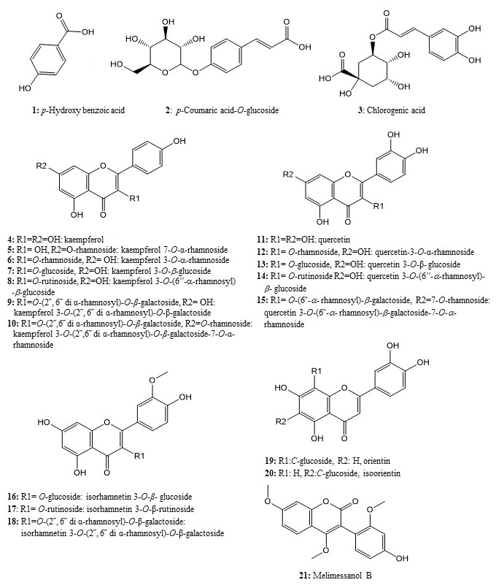Figure S1. Isolated compounds of Melilotus indicus and Melilotus messanensis [16,17,19]

