Egypt. J. Chem. Vol. 67, No. 12 pp. 143 - 156 (2024)

Seasonal Variations in the Composition, Antioxidant and Antimicrobial Activities of Zanthoxylum piperitum (L.) DC. 'Odorum' LeavesEssential Oil
Nermin S. El Tayeb¹, Nermin A. Younis¹, Ahmed A. Al‐Karmalawy^{2,3}, Amany Belal⁴, Samar M Mouneir⁵, Azza R. Abdel Monem⁶, Nesrin M. Fayek^{6*}
¹ Pharmacognosy Department, Faculty of Pharmacy, Ahram Canadian University, 6th of October City, Giza, Egypt.
² Department of Pharmaceutical Chemistry, Faculty of Pharmacy, Horus University-Egypt, New Damietta 34518, Egypt.
³Pharmaceutical Chemistry Department, Faculty of Pharmacy, Ahram Canadian University, 6th of October City, Giza, Egypt.
⁴Medicinal Chemistry Department, Faculty of Pharmacy, Beni-Suef University, Beni-Suef, city, Egypt.
⁵Pharmacology Department, Faculty of Veterinary Medicine, Cairo University, Cairo, Egypt.
⁶Pharmacognosy Department, College of Pharmacy, Cairo University, Kasr El Aini St, Cairo, Egypt.
*Corresponding author: Nesrin M. Fayek, email: nesrin.fayek@pharma.cu.edu.eg, (https://orcid.org/0000-0001-5932-6257), Tel: +201006362792.

Supporting information

Suppl. Table 1: The docking scores (-kcal/mol) of the essential oil of the Odorum components.
Peak No. | Target protein  Compound  Name (Ligand  compound) | Docking Scores (kcal/mol)
 |  | 1) DNA gyrase B kinase (6F86) | 2) Topoisomerase IV (5YIG) | 3) Penicillin-binding protein (1MWT) | 4) Dihydrofolate Reductase (4LAE) | 5) Dihydropteroate Synthase (2VEG) | 6) D-alanine D-alanine ligase (1EHI) | 7) Isoleucyl-tRNA synthetase (1JZS) | 8) RNA Polymerase enzyme (5UAH) | 9) Urease enzyme (1E9Z) | 10) Secretory aspartate protease (5JWG) | 11) β-1,3-glucan synthase (6PAL)
Monoterpene Hydrocarbons
1 | β-Myrcene | -5.749 | -5.190 | -5.033 | -5.131 | -4.685 | -6.176 | -4.583 | -5.070 | -4.723 | -5.473 | -4.087
2 | (-)-β-Pinene | -4.214 | -4.184 | -4.901 | -4.784 | -4.184 | -5.407 | -4.654 | -4.132 | -3.735 | -5.260 | -3.639
3 | D-Limonene | -4.404 | -4.825 | -4.886 | -4.939 | -4.167 | -5.748 | -4.695 | -4.623 | -3.973 | -5.342 | -3.891
4 | Terpinolene | -4.297 | -5.080 | -5.080 | -4.946 | -4.343 | -6.354 | -4.556 | -4.755 | -4.054 | -5.328 | -3.990
Oxygenated Monoterpenes
5 | Linalool | -5.858 | -4.986 | -5.185 | -5.663 | -4.893 | -6.665 | -4.861 | -4.851 | -4.667 | -5.667 | -4.540
6 | Cis-β-Terpineol | -4.397 | -4.725 | -5.321 | -5.515 | -4.464 | -6.338 | -4.754 | -4.293 | -4.036 | -5.488 | -4.081
7 | Isopulegol | -4.444 | -4.931 | -5.293 | -5.420 | -4.343 | -6.101 | -4.771 | -4.488 | -4.224 | -5.525 | -4.213
8 | Citronellal | -5.641 | -5.567 | -5.518 | -5.697 | -5.308 | -6.563 | -4.906 | -5.026 | -4.866 | -5.531 | -4.323
9 | Cis-4-Thujanol | -4.520 | -4.475 | -5.208 | -5.205 | -4.213 | -6.563 | -4.692 | -4.321 | -4.041 | -5.506 | -3.792
10 | Terpinen-4-ol | -4.673 | -4.940 | -5.295 | -5.428 | -4.440 | -6.737 | -4.731 | -4.410 | -4.369 | -5.346 | -3.760
11 | α –Terpineol | -4.846 | -4.679 | -4.994 | -5.198 | -4.467 | -6.093 | -4.714 | -4.415 | -4.668 | -5.763 | -4.010
12 | (Z)-Piperitol | -4.190 | -5.026 | -5.149 | -5.342 | -4.598 | -6.400 | -4.846 | -4.581 | -3.981 | -5.571 | -3.974
13 | trans- Piperitol | -4.672 | -4.945 | -5.276 | -5.373 | -4.708 | -6.629 | -5.019 | -4.667 | -4.168 | -5.447 | -4.075
14 | Citronellol | -5.899 | -5.661 | -5.629 | -5.858 | -5.157 | -6.616 | -5.102 | -5.469 | -4.649 | -5.932 | -4.315
15 | Methyl Citronellate | -5.937 | -5.946 | -5.730 | -6.147 | -5.805 | -6.771 | -5.289 | -5.373 | -5.149 | -6.554 | -4.541
16 | exo-2-Hydroxycineole acetate | -5.122 | -5.436 | -5.203 | -5.892 | -4.786 | -6.211 | -4.771 | -4.978 | -4.812 | -6.269 | -4.428
17 | α-Terpinyl acetate | -5.160 | -5.395 | -5.958 | -6.065 | -4.997 | -6.736 | -5.190 | -5.035 | -4.906 | -6.438 | -4.526
Sesquiterpene hydrocarbons
18 | β-caryophyllene | -4.825 | -4.510 | -4.995 | -5.481 | -4.576 | -6.235 | -5.406 | -4.503 | -4.341 | -4.215 | -4.138
19 | γ –Elemene | -5.055 | -5.437 | -6.076 | -5.684 | -4.675 | -6.734 | -5.266 | -5.166 | -4.806 | -5.665 | -4.436
20 | α-Humelene | -4.296 | -4.566 | -5.373 | -5.952 | -4.434 | -6.027 | -5.122 | -4.808 | -4.430 | -4.717 | -4.097
21 | γ-Gurjunene | -4.969 | -5.262 | -5.509 | -5.977 | -4.881 | -6.462 | -5.141 | -4.836 | -4.653 | -5.394 | -4.530
22 | Germacrene D | -4.771 | -4.987 | -5.530 | -5.992 | -4.671 | -6.716 | -5.193 | -5.046 | -4.533 | -4.685 | -4.109
23 | Germacrene B | -4.913 | -4.704 | -5.996 | -6.009 | -4.409 | -6.977 | -4.977 | -4.579 | -4.758 | -4.982 | -4.092
Oxygenated Sesquiterpenes
24 | Elemol | -5.059 | -5.225 | -5.602 | -6.245 | -4.743 | -5.750 | -4.997 | -4.960 | -4.600 | -4.636 | -4.437
25 | Dehydronerolidol | -7.019 | -5.928 | -6.409 | -6.842 | -6.366 | -8.074 | -5.965 | -5.633 | -5.376 | -7.341 | -5.366
26 | d-nerolidol | -6.688 | -6.117 | -6.192 | -6.499 | -6.105 | -8.429 | -5.803 | -5.972 | -5.362 | -6.848 | -5.558
27 | Cis-Eudesm-6-en-11-ol | -4.865 | -5.083 | -5.687 | -6.216 | -5.129 | -5.249 | -5.222 | -4.967 | -4.428 | -4.941 | -4.633
28 | Caryophyllene oxide | -4.865 | -5.120 | -5.465 | -6.278 | -5.128 | -5.873 | -5.238 | -5.149 | -4.343 | -5.453 | -4.555
29 | Humulene epoxide II | -4.573 | -5.337 | -5.491 | -6.125 | -4.866 | -6.547 | -5.169 | -4.675 | -4.511 | -4.214 | -4.245
30 | γ- eudesmol | -4.920 | -5.625 | -6.055 | -6.083 | -4.925 | -5.750 | -5.162 | -4.768 | -4.709 | -4.818 | -4.545
31 | β-Eudesmol | -4.638 | -5.267 | -5.914 | -6.224 | -4.856 | -7.210 | -5.232 | -5.095 | -4.383 | -4.522 | -4.437
32 | α-eudesmol | -4.994 | -5.400 | -5.609 | -6.151 | -4.574 | -5.819 | -5.064 | -4.922 | -4.532 | -5.059 | -4.545
Cinnamic acid derivatives
33 | (E)- Methyl Cinnamate | -5.355 | -5.329 | -4.876 | -5.170 | -4.817 | -5.932 | -4.407 | -5.081 | -4.556 | -5.565 | -4.397
Oxygenated Diterpenes
34 | Sandaracopimaradiene | -5.236 | -5.417 | -5.425 | -6.473 | -4.994 | -3.703 | -6.255 | -5.097 | -4.329 | -5.297 | -4.578
35 | Phytol | -6.840 | -6.447 | -6.969 | -7.657 | -6.499 | -8.809 | -6.972 | -6.848 | -5.648 | -7.496 | -5.515
Acyl Chlorides
36 | Linoleoyl Chloride | -6.704 | -6.944 | -6.764 | -7.812 | -6.160 | -9.083 | -6.604 | -7.188 | -5.757 | -7.906 | -5.621
Alkanes
37 | Heptacosane | -7.753 | -7.537 | -7.686 | -8.704 | -7.492 | -6.657 | -8.831 | -8.615 | -6.673 | -9.654 | -6.377
Total Fatty Acid Methyl Esters
38 | Methyl caprylate | -6.027 | -6.062 | -5.483 | -5.882 | -5.361 | -6.342 | -4.854 | -6.143 | -4.832 | -6.095 | -4.418
39 | Methyl nonanoate | -5.988 | -5.997 | -5.550 | -5.885 | -5.622 | -7.107 | -5.286 | -6.290 | -5.047 | -6.581 | -4.644
40 | Methyl 8-methyl-nonanoate | -6.104 | -6.340 | -5.708 | -6.171 | -5.803 | -7.036 | -5.459 | -6.265 | -4.983 | -6.802 | -4.558
41 | Methyl hexadecanoate | -7.074 | -7.346 | -7.144 | -7.669 | -6.509 | -8.769 | -6.994 | -7.017 | -5.512 | -8.376 | -5.375
42 | Oleic acid, methyl ester | -7.328 | -7.614 | -7.111 | -7.747 | -6.432 | -8.824 | -6.937 | -8.119 | -5.795 | -8.497 | -5.746
43 | 9,12-Octadecadienoic acid, methyl ester | -7.785 | -7.231 | -7.229 | -7.855 | -6.605 | -9.550 | -6.759 | -7.286 | -6.180 | -8.052 | -5.773
44 | 9,12-Octadecadienoic acid, methyl ester, (E,E)- |  | -7.256 | -6.987 | -7.794 | -6.346 | -9.390 | -6.695 | -7.867 | -5.783 | -8.204 | -5.543
45 | Methyl octadecanoate | -6.884 | -7.663 | -6.961 | -8.267 | -6.346 | -9.137 | -7.170 | -8.556 | -5.928 | -8.882 | -5.842
Fatty Acids
46 | Linolein, 1-mono | -7.499 | -7.040 | -7.573 | -8.400 | -6.903 | -9.945 | -7.875 | -7.695 | -6.382 | -8.636 | -6.038
47 | Linolein, 2-mono | -7.609 | -7.146 | -7.502 | -8.243 | -7.479 | -9.342 | -7.485 | -8.162 | -6.217 | -8.970 | -6.071
Gentamycin |  | -6.058 | -6.580 | -7.645 | -7.626 | -5.768 | -7.267 | -6.760 | -6.671 | -6.056 | -6.644 | -6.546
Fluconazole |  | -5.938 | -5.851 | -6.265 | -7.229 | -6.040 | -5.937 | -5.321 | -5.502 | -4.910 | -6.194 | -4.788
Amoxicillin |  | -5.821 | -5.925 | -7.143 | -6.832 | -6.319 | -9.231 | -6.269 | -5.735 | -6.025 | -8.546 | -5.513
Clarithromycin |  | -6.944 | -6.292 | -7.980 | -7.643 | -7.953 |  | -9.822 | -7.676 | -6.230 | -8.596 | -7.393
Metronidazole |  | -5.040 | -4.772 | -5.022 | -5.250 | -5.164 | -6.120 | -4.445 | -4.726 | -4.881 | -5.497 | -4.062
Co-crystal |  | -8.724 | -10.482 | -7.337 | -7.511 | -7.790 | -9.223 | -9.194 | -10.497 |  | -9.995 | -2.826

Suppl. Table 2: 3D Binding interactions of the essential oil of the Odorum components.
Target receptor | 3D Binding Interactions
DNA gyrase B kinase  (6F86) | 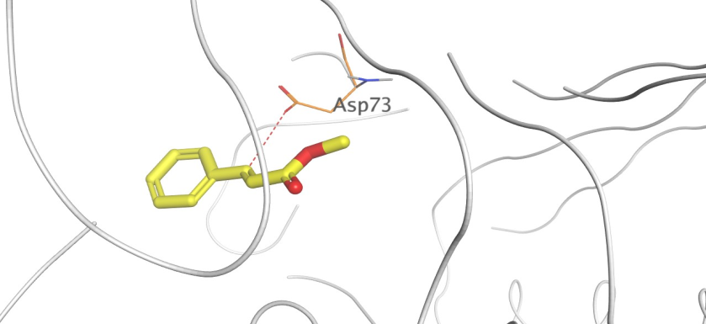 | 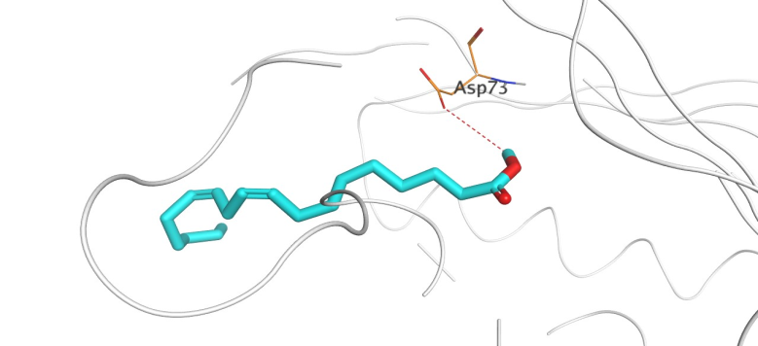
 | (E)- Methyl Cinnamate | 9,12-Octadecadienoic acid, methyl ester
Topoisomerase IV  (5YIG) | 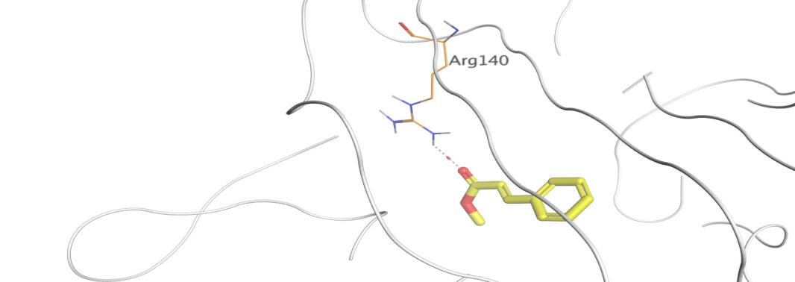 | 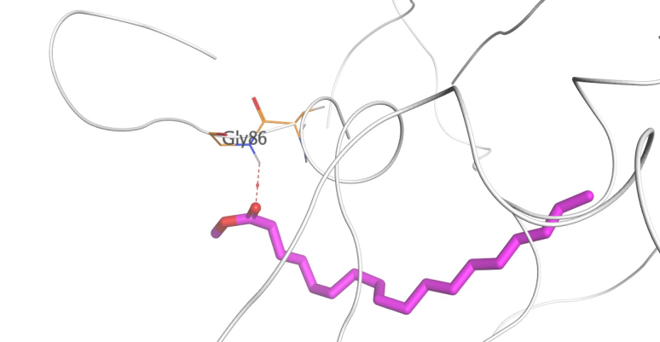
 | (E)- Methyl Cinnamate | Methyl octadecanoate
Penicillin-binding protein (PBP 1a)  (1MWT) | 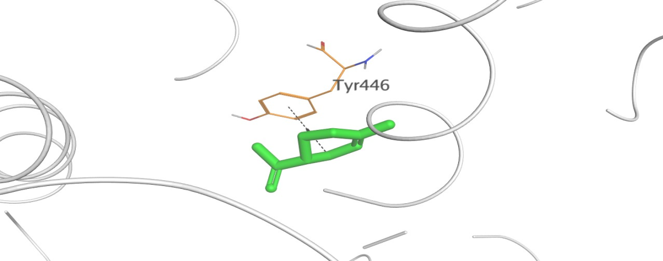 | 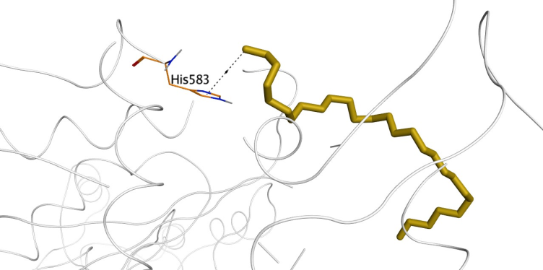
 | D-Limonene | Heptacosane
Dihydrofolate reductase (DHFR)  (4LAE) | 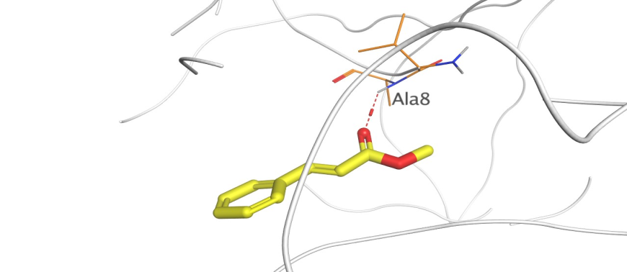 | 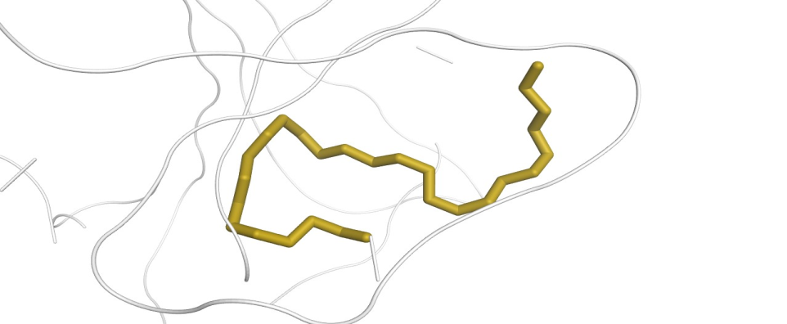
 | (E)- Methyl Cinnamate | Heptacosane
Dihydropteroate synthase (DHPS)  (2VEG) | 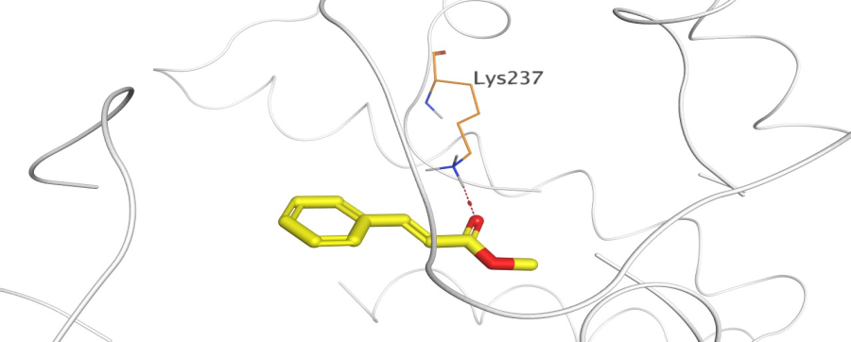 | 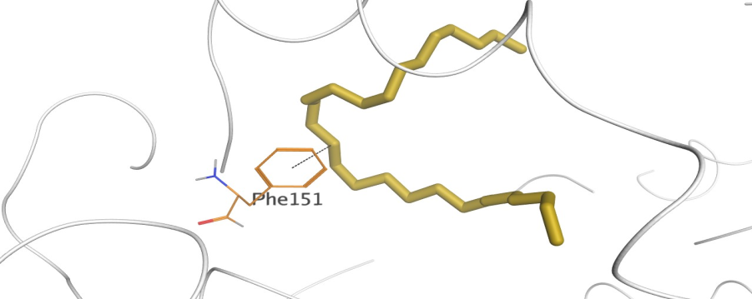
 | (E)- Methyl Cinnamate | Heptacosane
D-alanine ligase (Ddl)  (1EHI) | 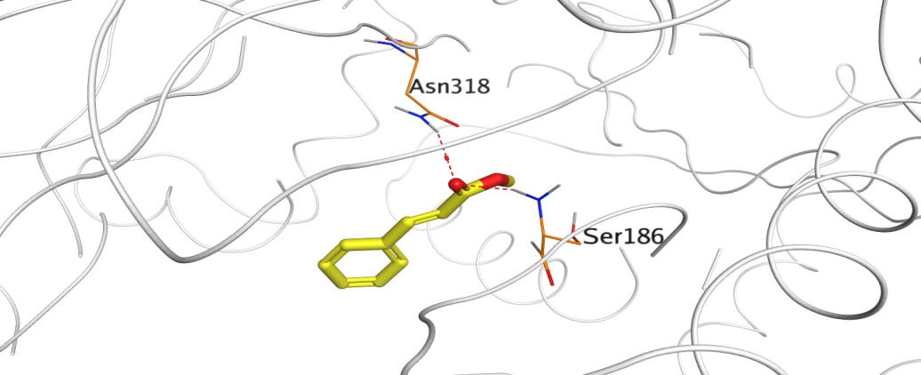
 | (E)- Methyl Cinnamate
Isoleucyl-tRNA synthetase (IARS)  (1JZS) | 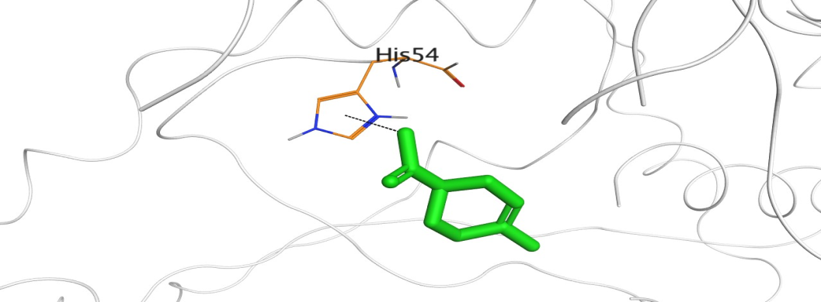 | 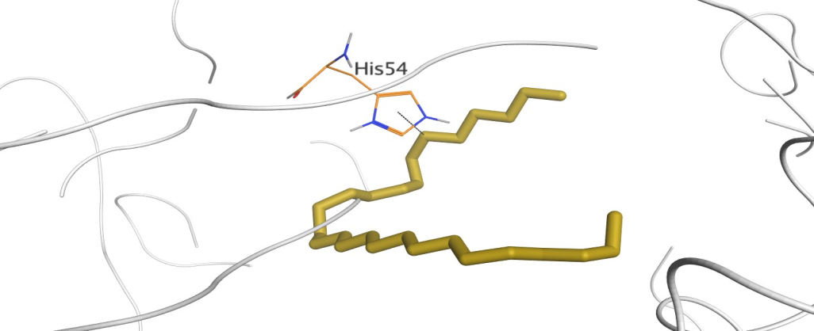 | 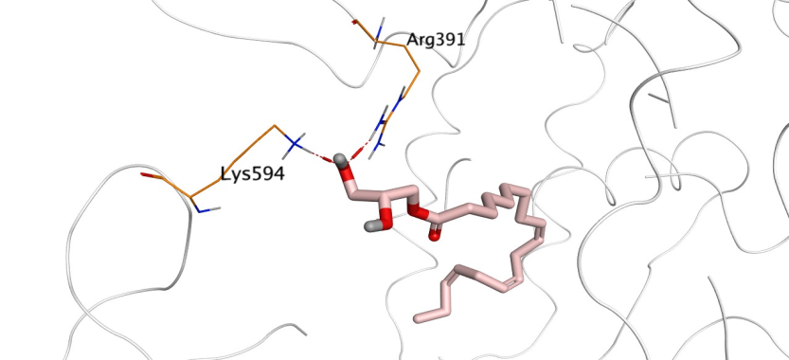
 | D-Limonene | Heptacosane | "Linolein, 1-mono"
RNA polymerase enzyme  (5UAH) | 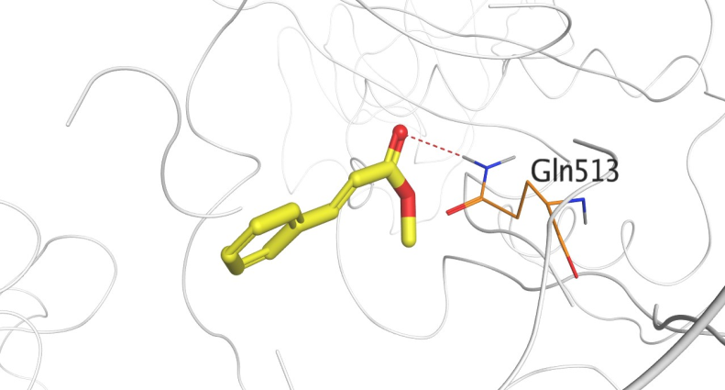 | 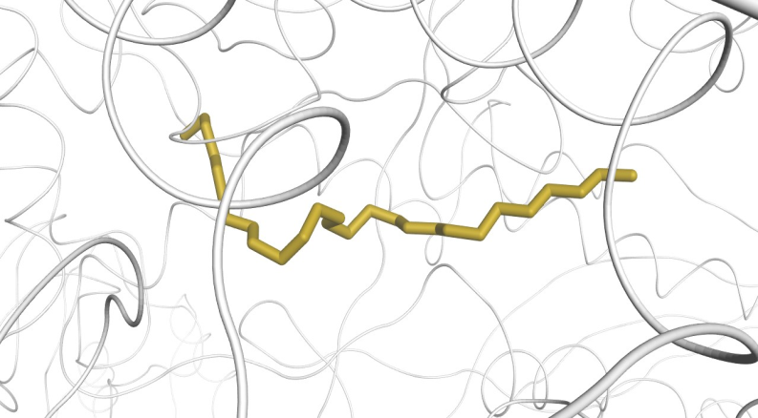
 | (E)- Methyl Cinnamate | Heptacosane
Urease enzyme  (1E9Z) | 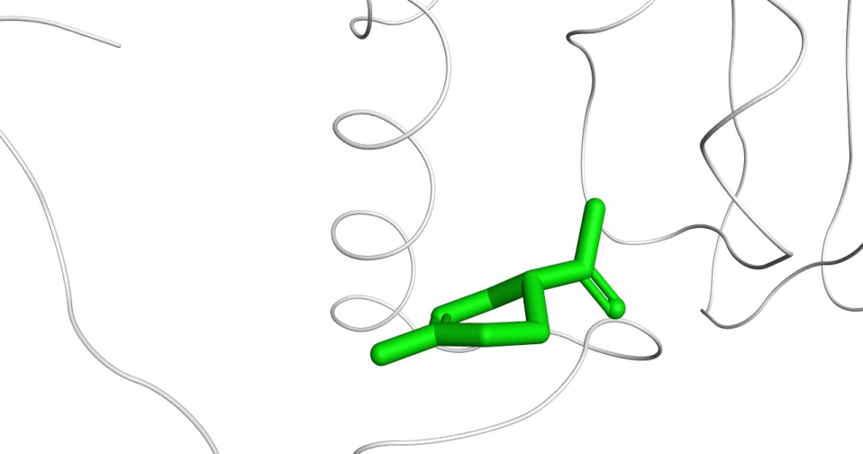 | 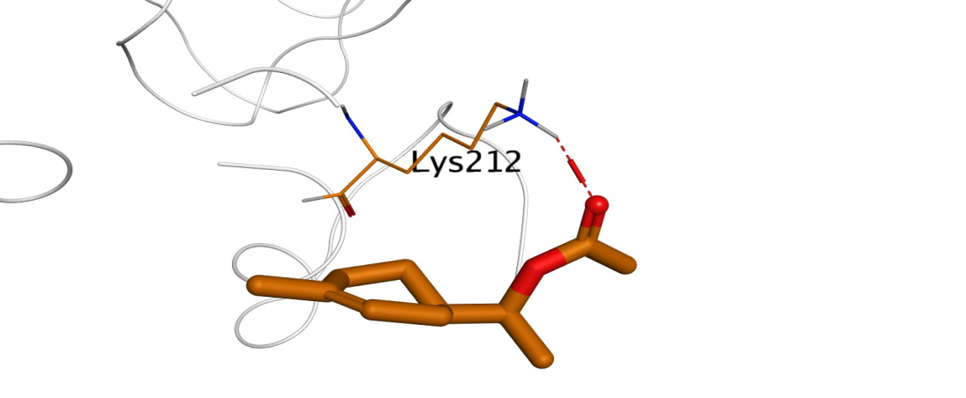 | 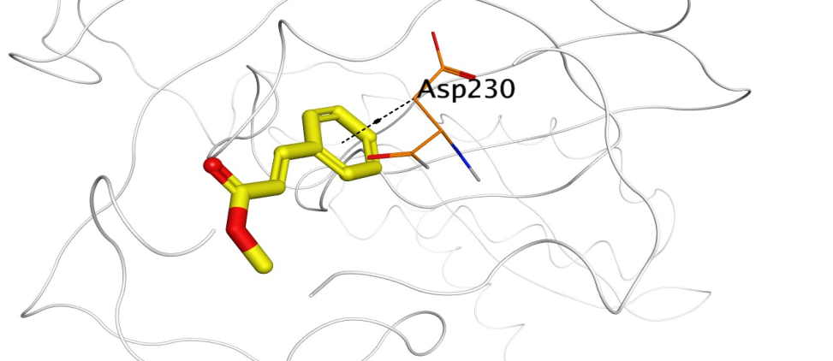 | 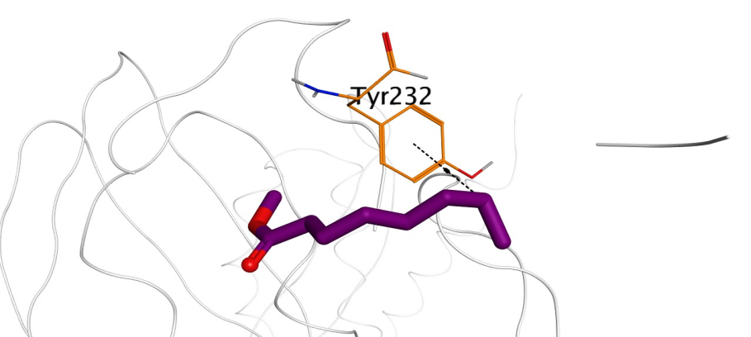
 | D-Limonene | α-Terpinyl acetate | (E)- Methyl Cinnamate | Methyl caprylate
Secretory aspartate protease (SAP5)  (5JWG) | 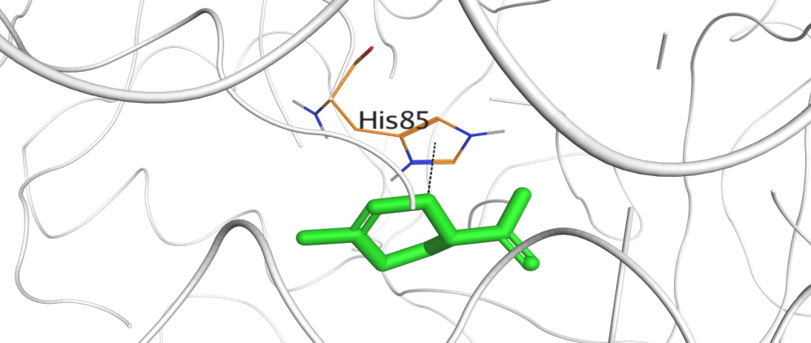 | 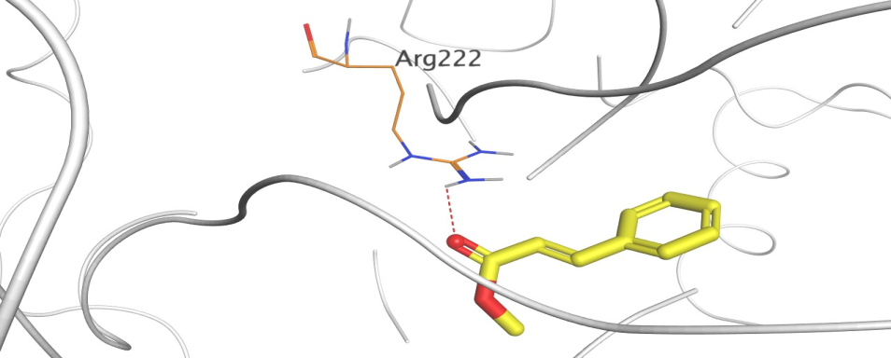 | 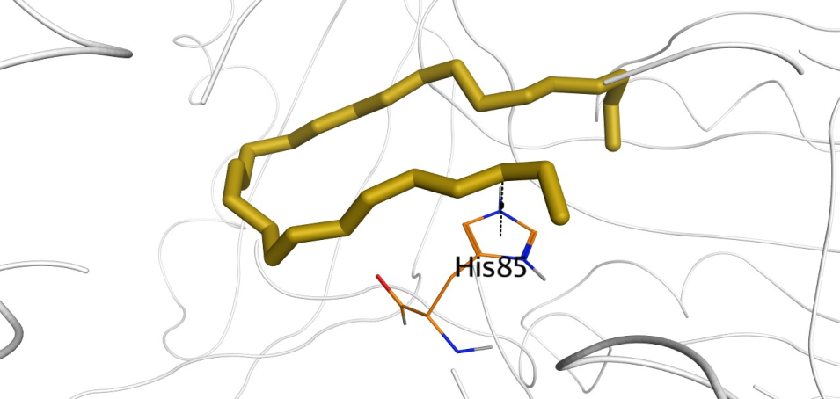
 | D-Limonene | (E)- Methyl Cinnamate | Heptacosane
β-1,3-glucan synthase (β-1,3-GS)  (6PAL) | 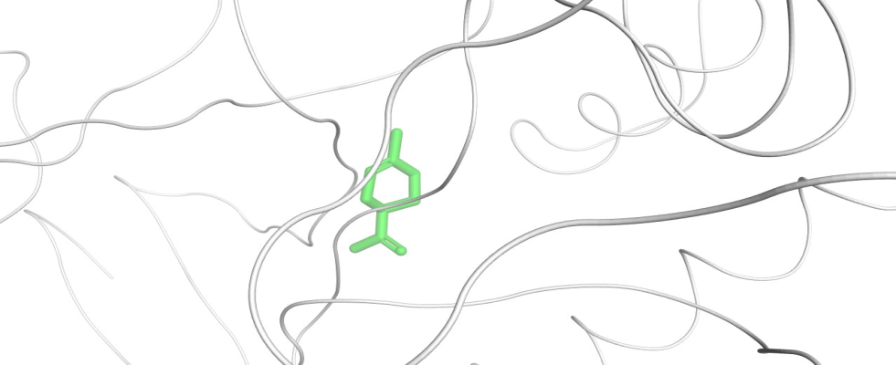 | 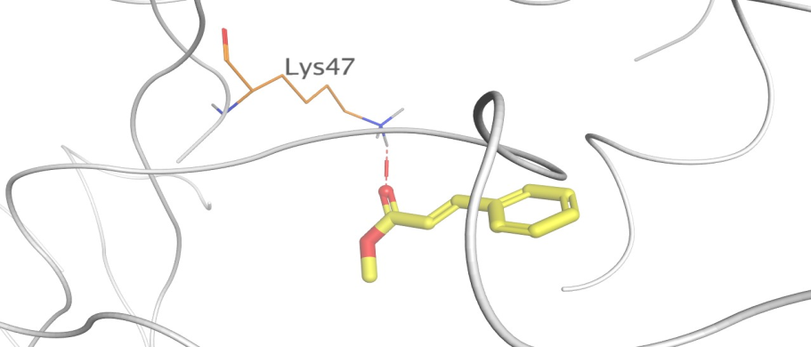 | 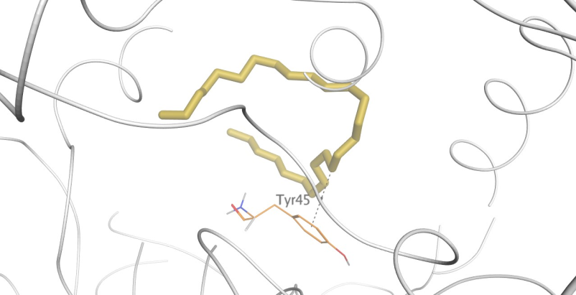
 | D-Limonene | (E)- Methyl Cinnamate | Heptacosane

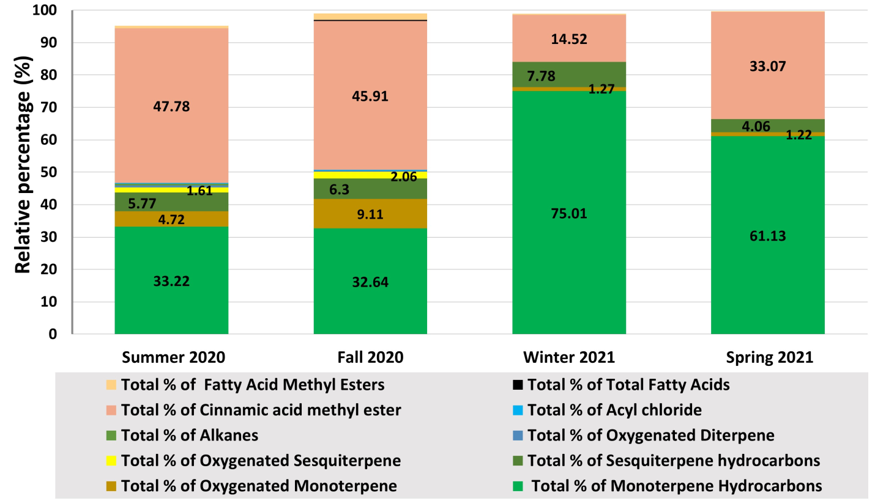

Suppl. Figure 1: Astacked bar chart expressing the values of the chemical classes of compounds detected by GC-MS among the Odorum oil samples over the seasons- expressed as relative percentages (%).
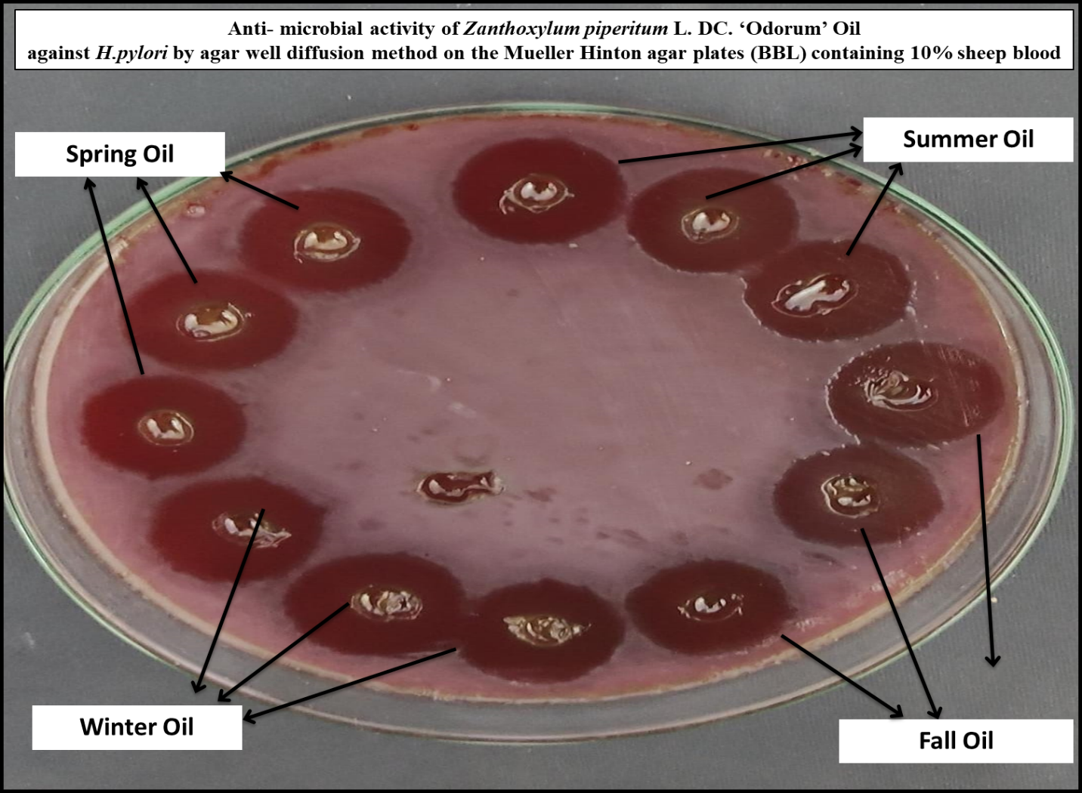
Suppl. Figure 2: Representing the clear inhibition zones of the growth of H.pylori on the Mueller Hinton agar plates (BBL) containing 10% sheep blood caused by the antimicrobial effect of the oil from each season.

