Egypt. J. Chem. Vol. 67, No. 12 pp. 37 - 46 (2024)

Proper retention factor for Avanafil and Dapoxetine Hydrochloride Separation and Validation with RP-HPLC in Bulk, Dosage Form and Rat Plasma; Validation, Degradation, and Pharmacokinetic Application

Heba Abdel-Hafeez Mohamed ª, Asmaa A. El- Zaher^{b}, Omar A. Ahmed-Faridª, M. Badawi N. Eldinª, Sally
Tarek Mahmoud^{b*}

ªEgyptian drug authority (EDA), P.O. Box 29, Cairo, Egypt
^{b}Department of Pharmaceutical Chemistry, Faculty of Pharmacy, Cairo University, Kasr El-Aini St., Cairo, P.O. Box 11562, Egypt

Supporting information

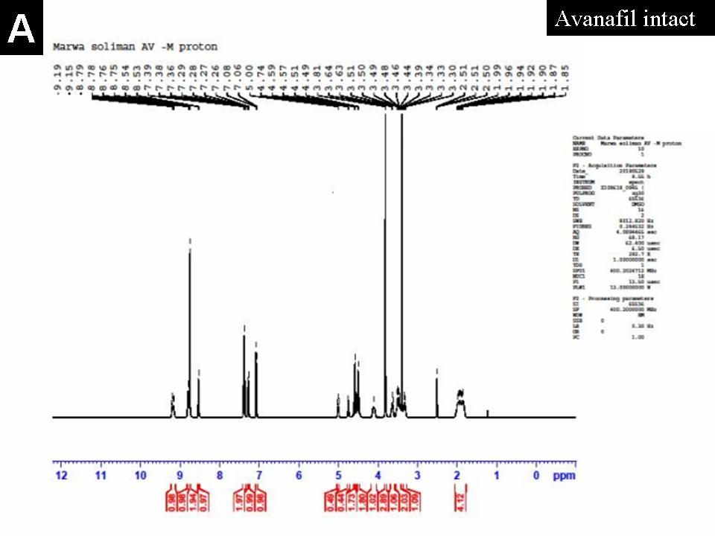
Fig.S1. Proton NMR of avanafil intact chart
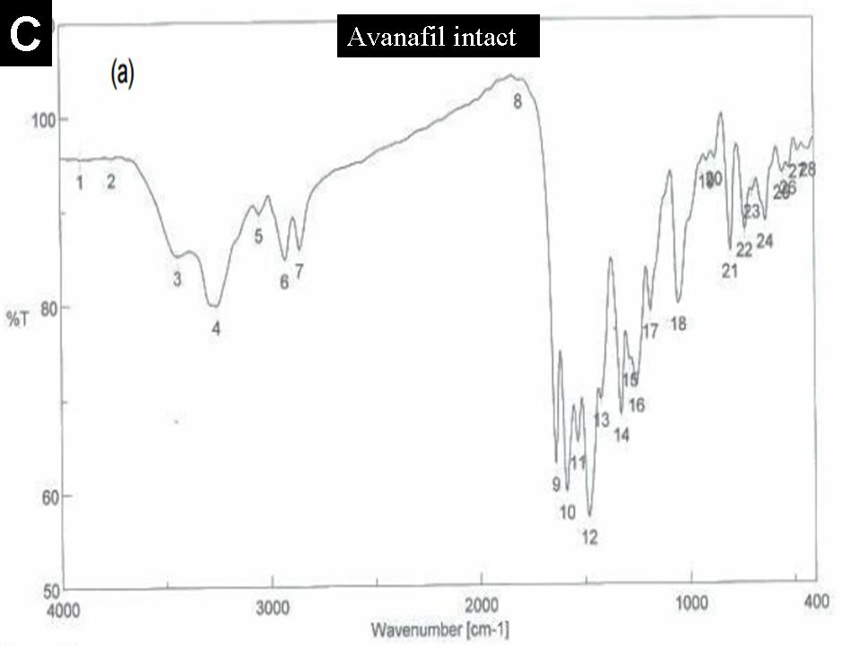
Fig.S2. Proton FTIR of avanafil intact chart
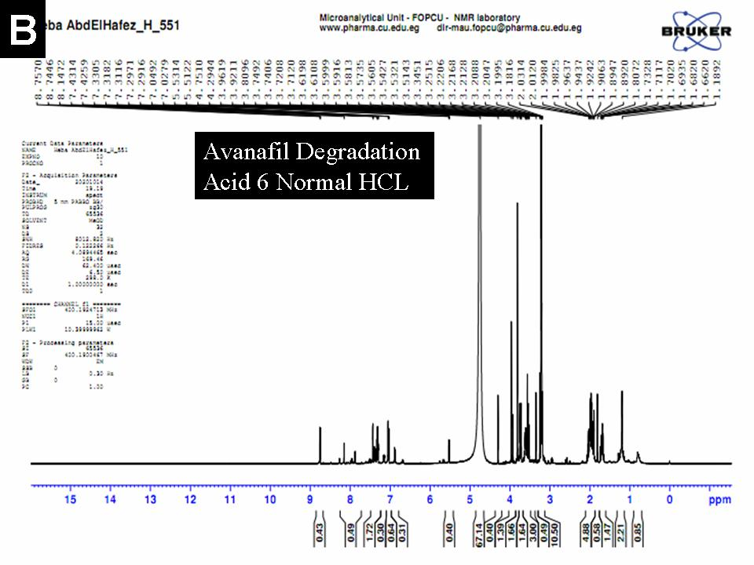
Fig. S3. Proton NMR of avanafil degradation chart
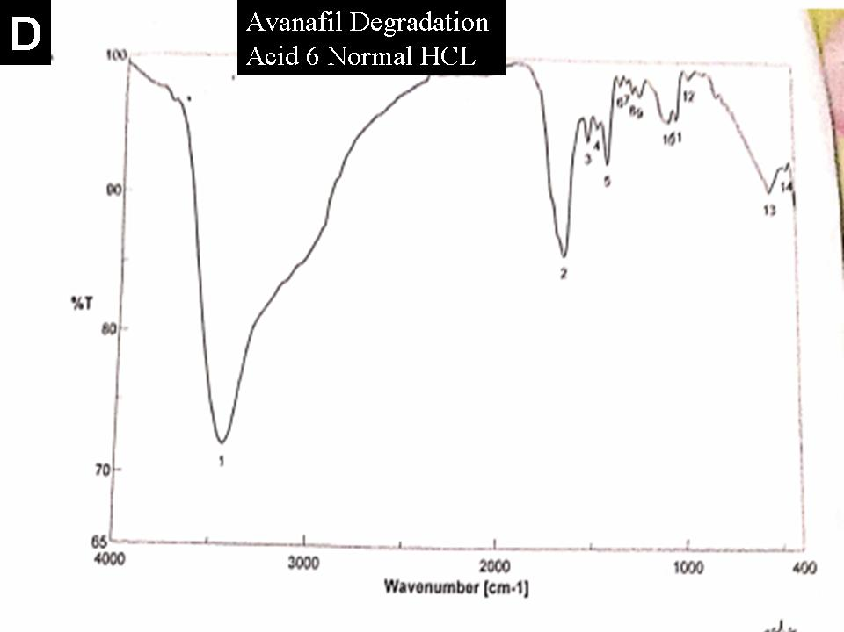
Fig. S4: Proton FTIR of avanafil degradation chart

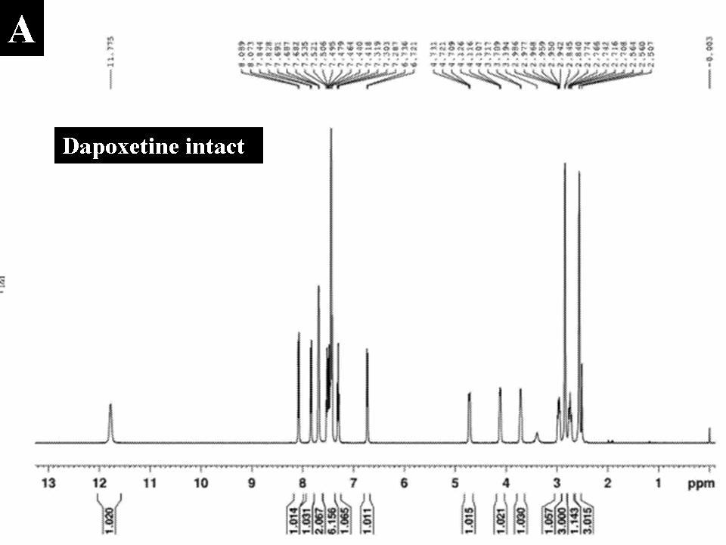
Fig. S5: Proton NMR of dapoxitine intact chart
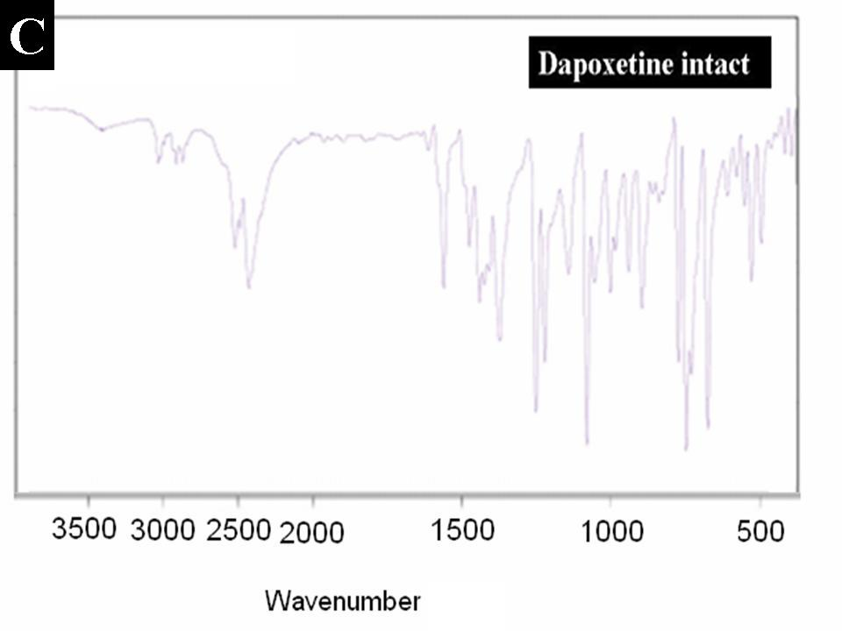
Fig.S6: Proton FTIR of dapoxitine intact chart
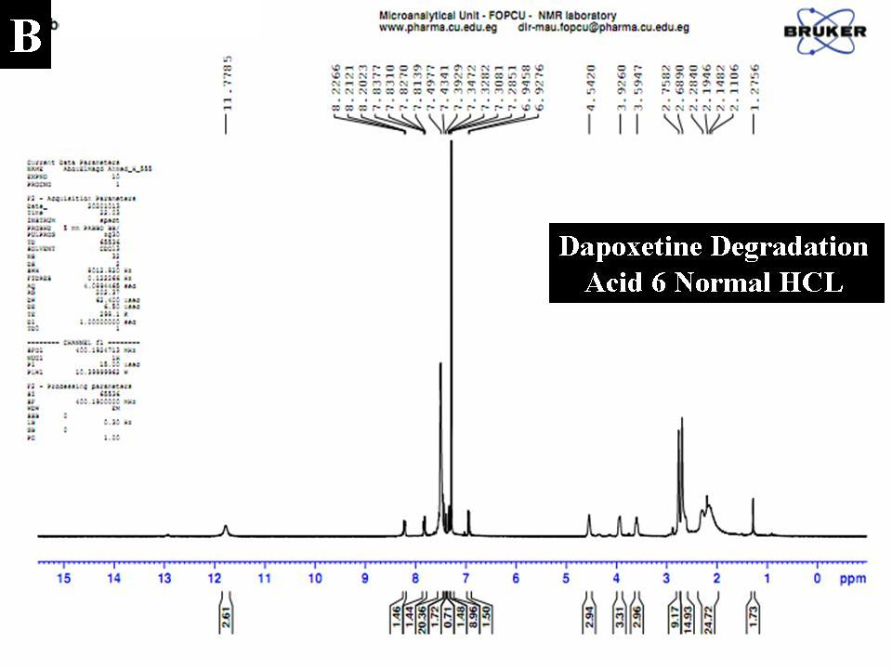
Fig. S7: Proton NMR of dapoxitine degradation chart
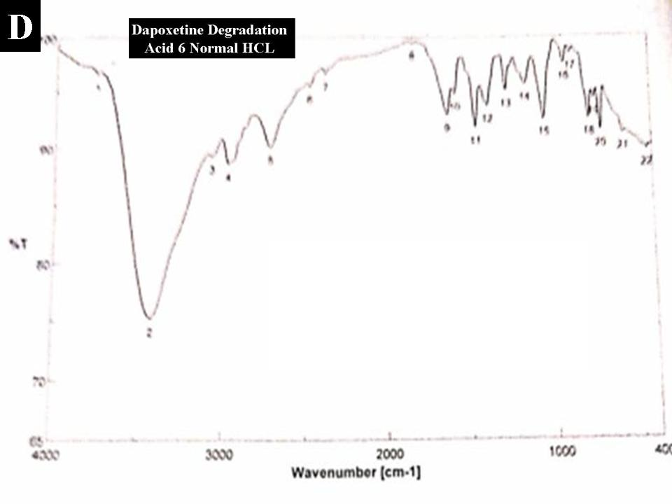
Fig. S8: Proton FTIR of dapoxitine degradation chart.

