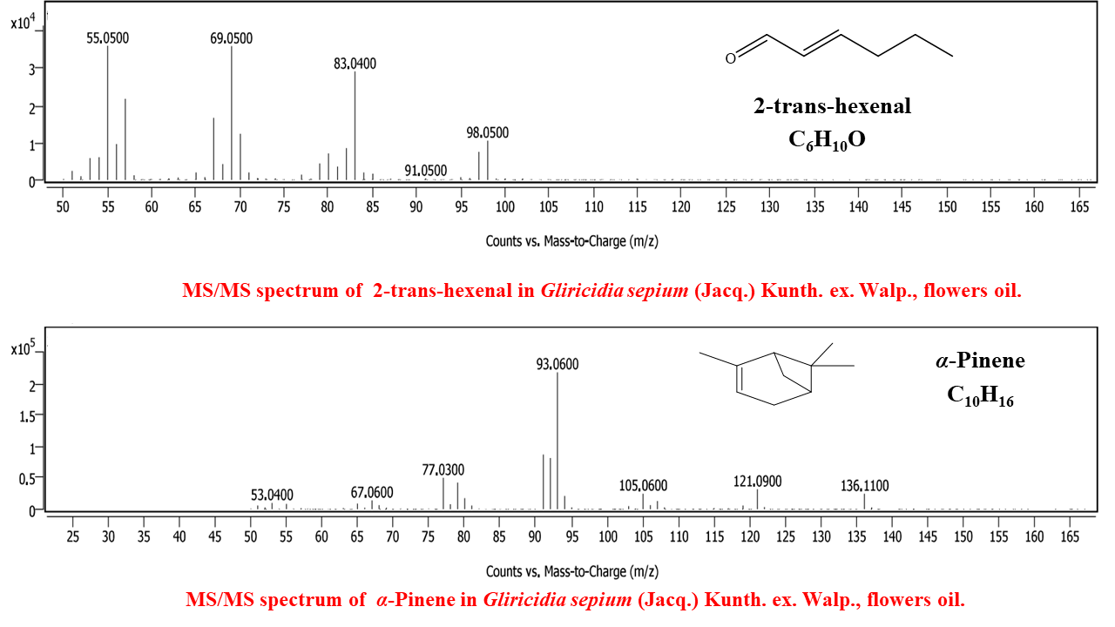
Fig. S1. MS/MS spectrum of 2-trans-hexenal in Gliricidia sepium (Jacq.) Kunth. ex. Walp. flowers oil.

Fig. S2. MS/MS spectrum of α-pinene in Gliricidia sepium (Jacq.) Kunth. ex. Walp. flowers oil.

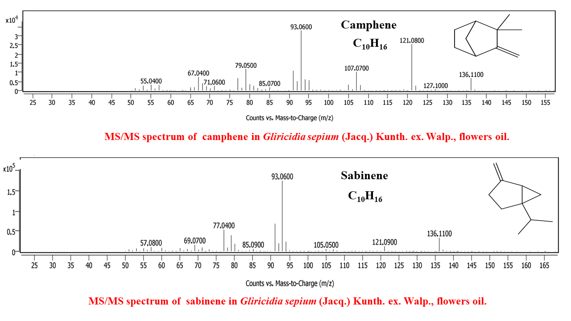

Fig. S3. MS/MS spectrum of camphene in Gliricidia sepium (Jacq.) Kunth. ex. Walp. flowers oil.
Fig. S4. MS/MS spectrum of sabinene in Gliricidia sepium (Jacq.) Kunth. ex. Walp. flowers oil.

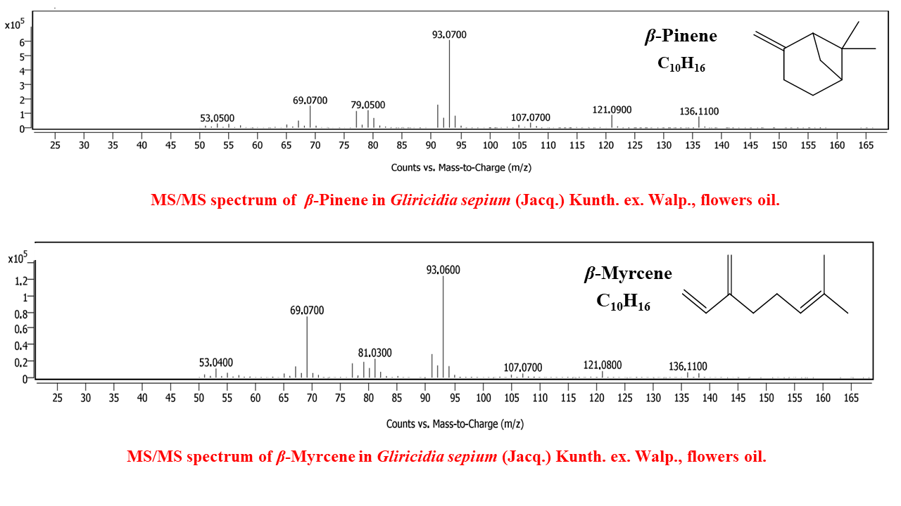
Fig. S5. MS/MS spectrum of β-pinene in Gliricidia sepium (Jacq.) Kunth. ex. Walp. flowers oil.

Fig. S6. MS/MS spectrum of β-myrcene in Gliricidia sepium (Jacq.) Kunth. ex. Walp. flowers oil.
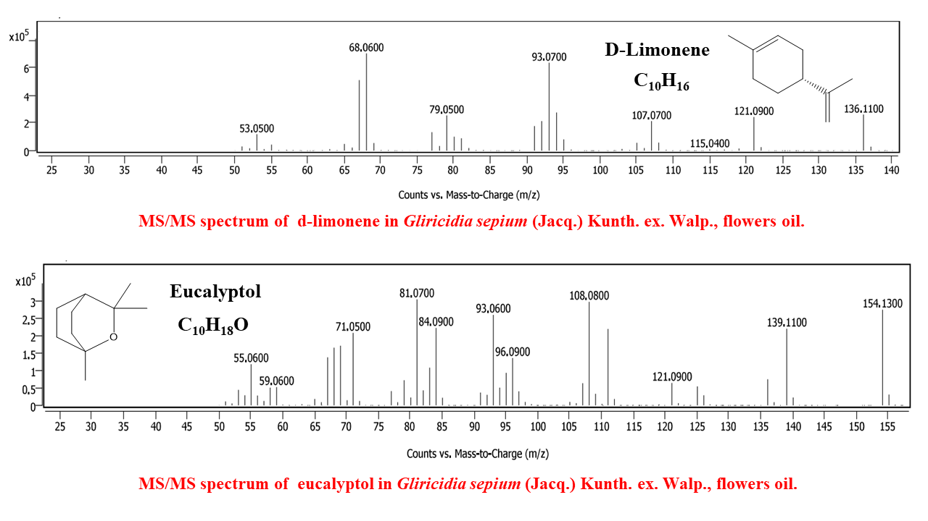

Fig. S7. MS/MS spectrum of d-limonene in Gliricidia sepium (Jacq.) Kunth. ex. Walp. flowers oil.

Fig. S8. MS/MS spectrum of eucalyptol in Gliricidia sepium (Jacq.) Kunth. ex. Walp. flowers oil.

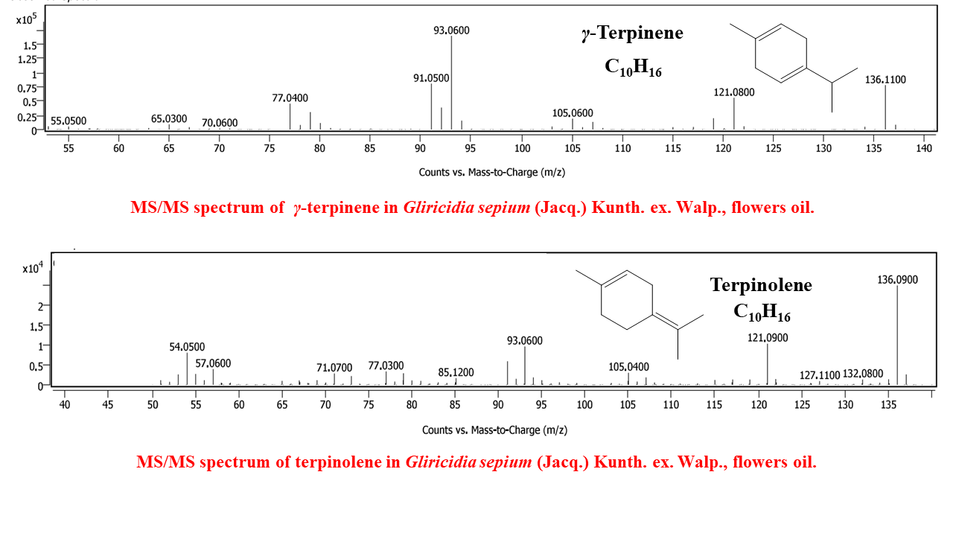
Fig. S9. MS/MS spectrum of γ-terpinene in Gliricidia sepium (Jacq.) Kunth. ex. Walp. flowers oil.

Fig. S10. MS/MS spectrum of terpinolene in Gliricidia sepium (Jacq.) Kunth. ex. Walp. flowers oil.

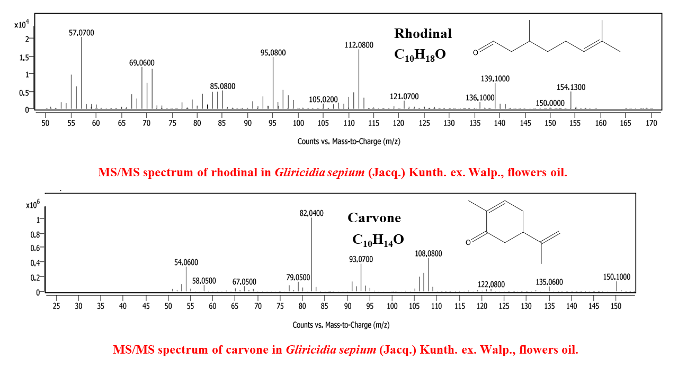
Fig. S11. MS/MS spectrum of rhodinal in Gliricidia sepium (Jacq.) Kunth. ex. Walp. flowers oil.

Fig. S12. MS/MS spectrum of carvone in Gliricidia sepium (Jacq.) Kunth. ex. Walp. flowers oil.

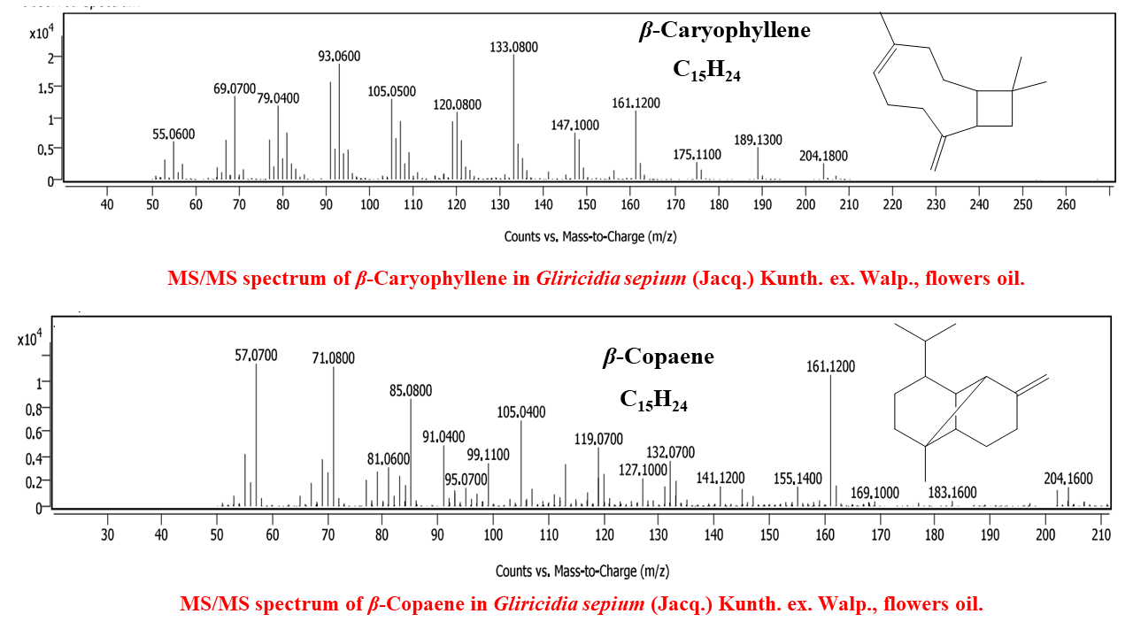
Fig. S13. MS/MS spectrum of β-caryophyllene in Gliricidia sepium (Jacq.) Kunth. ex. Walp. flowers oil.

Fig. S14. MS/MS spectrum of β-copaene in Gliricidia sepium (Jacq.) Kunth. ex. Walp. flowers oil.

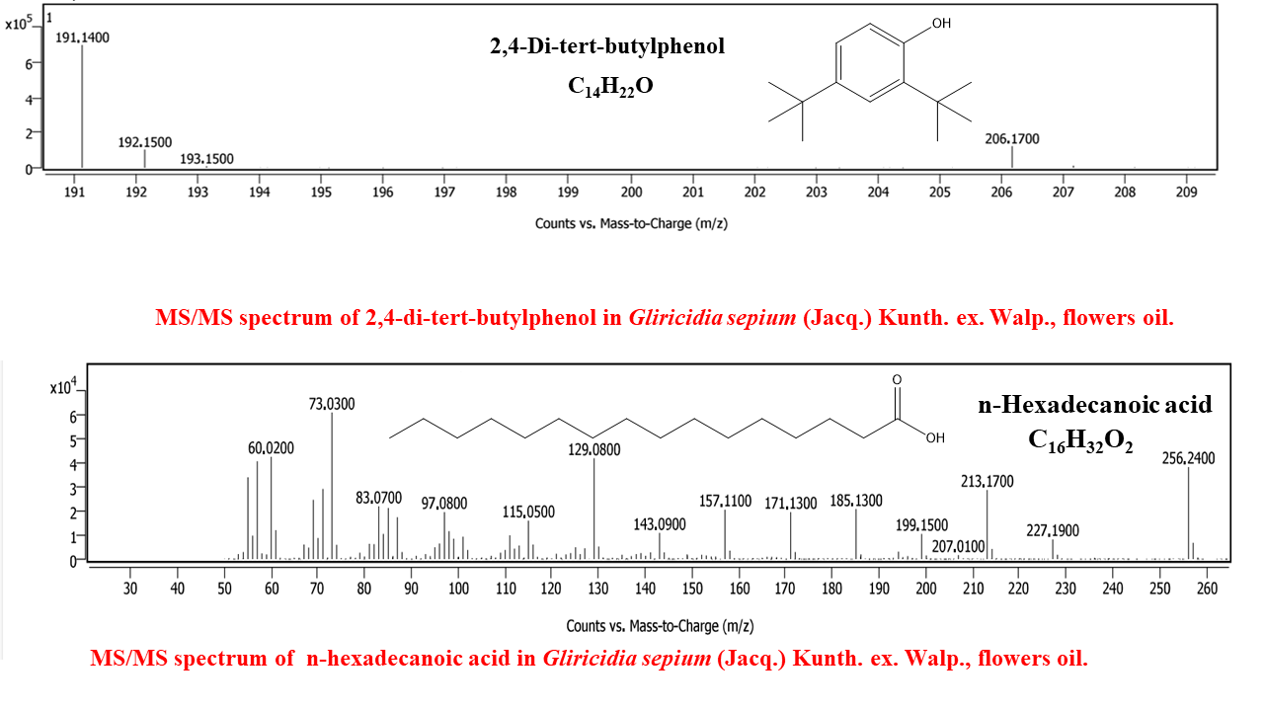
Fig. S15. MS/MS spectrum of 2,4-di-tert-butylphenol in Gliricidia sepium (Jacq.) Kunth. ex. Walp. flowers oil.

Fig. S16. MS/MS spectrum of n-hexadecanoic acid in Gliricidia sepium (Jacq.) Kunth. ex. Walp. flowers oil.

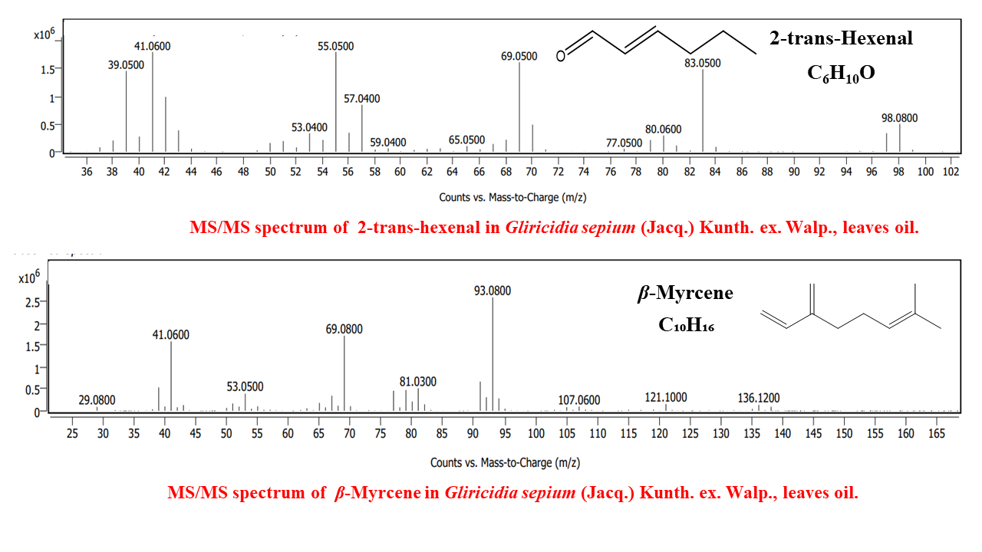
Fig. S17. MS/MS spectrum of 2-trans-hexenal in Gliricidia sepium (Jacq.) Kunth. ex. Walp. leaves oil.

Fig. S18. MS/MS spectrum of β-myrcene in Gliricidia sepium (Jacq.) Kunth. ex. Walp. leaves oil.

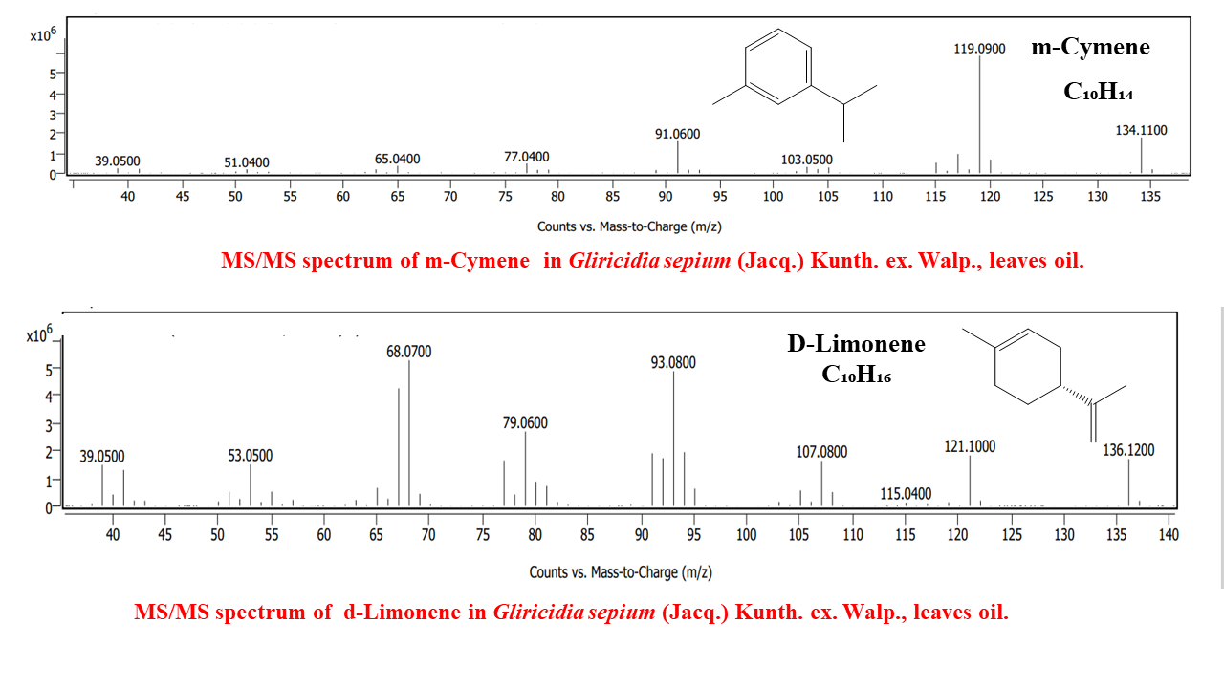
Fig. S19. MS/MS spectrum of m-cymene in Gliricidia sepium (Jacq.) Kunth. ex. Walp. leaves oil.

Fig. S20. MS/MS spectrum of d-limonene in Gliricidia sepium (Jacq.) Kunth. ex. Walp. leaves oil.

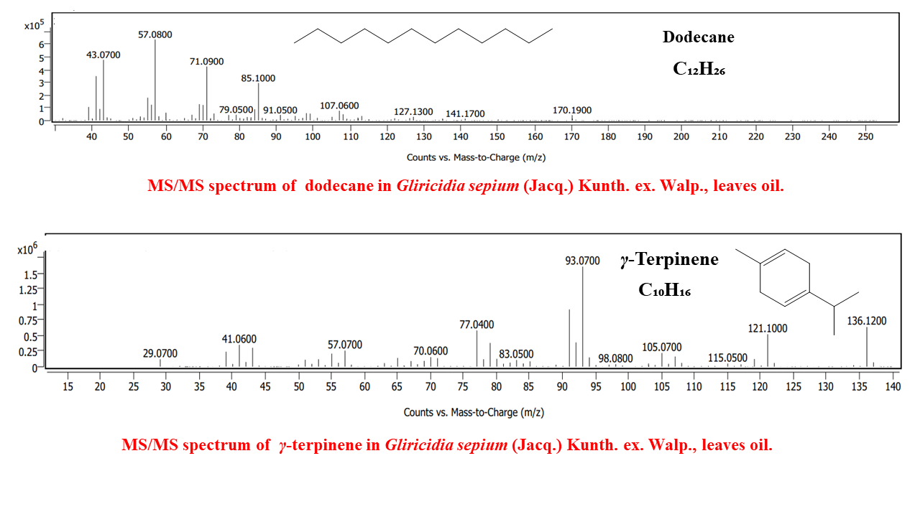

Fig. S21. MS/MS spectrum of dodecane in Gliricidia sepium (Jacq.) Kunth. ex. Walp. leaves oil.

Fig. S22. MS/MS spectrum of γ-terpinene in Gliricidia sepium (Jacq.) Kunth. ex. Walp. leaves oil.

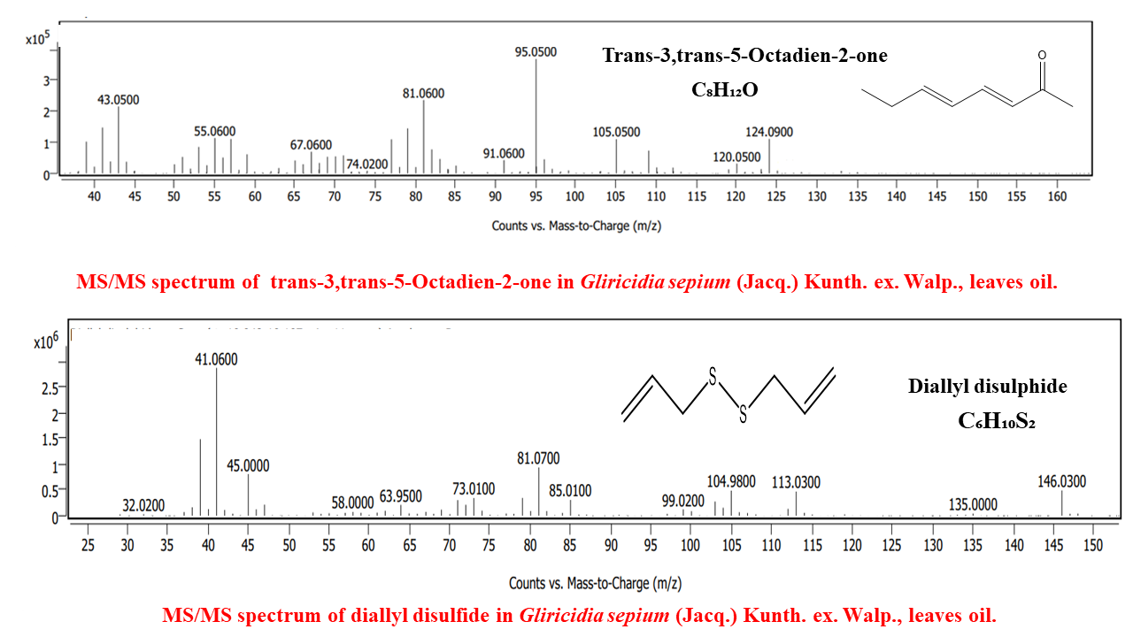
Fig. S23. MS/MS spectrum of trans-3,trans-5-Octadien-2-one in Gliricidia sepium (Jacq.) Kunth. ex. Walp. leaves oil.

Fig. S24. MS/MS spectrum of diallyl disulfide in Gliricidia sepium (Jacq.) Kunth. ex. Walp. leaves oil.

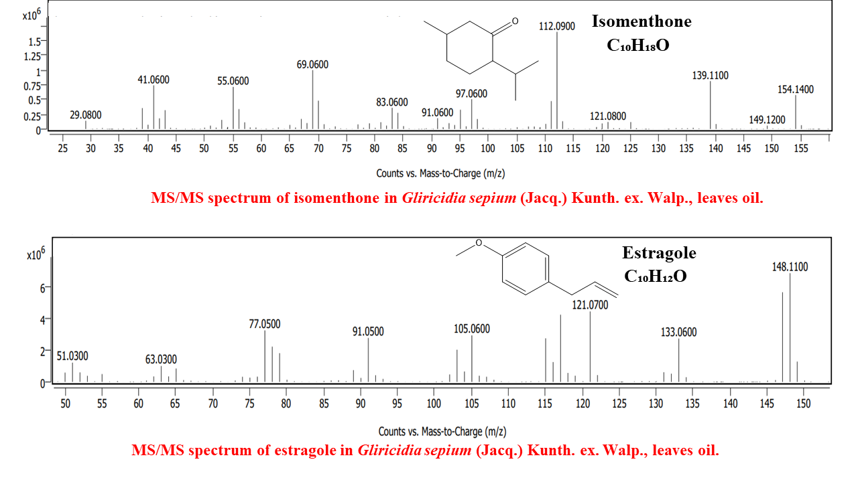
Fig. S25. MS/MS spectrum of isomenthone in Gliricidia sepium (Jacq.) Kunth. ex. Walp. leaves oil.

Fig. S26. MS/MS spectrum of estragole in Gliricidia sepium (Jacq.) Kunth. ex. Walp. leaves oil.

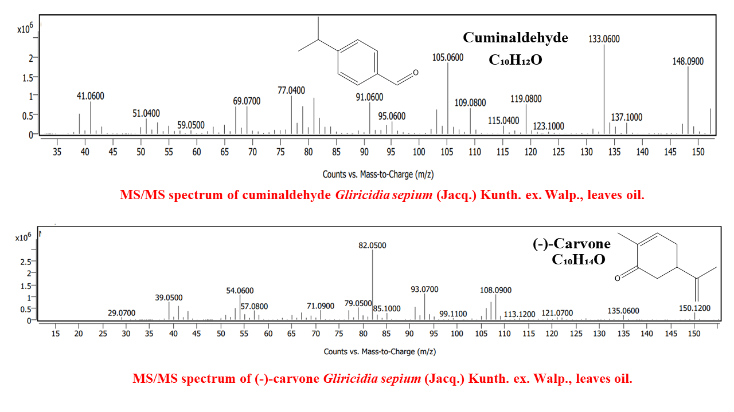

Fig. S27. MS/MS spectrum of cuminaldehyde Gliricidia sepium (Jacq.) Kunth. ex. Walp. leaves oil.

Fig. S28. MS/MS spectrum of (-)-carvone Gliricidia sepium (Jacq.) Kunth. ex. Walp. leaves oil.

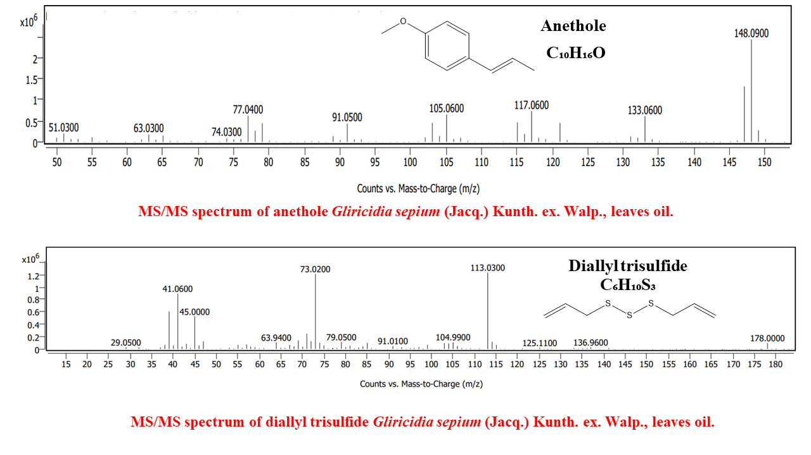
Fig. S29. MS/MS spectrum of anethole Gliricidia sepium (Jacq.) Kunth. ex. Walp. leaves oil.

Fig. S30. MS/MS spectrum of diallyl trisulfide Gliricidia sepium (Jacq.) Kunth. ex. Walp. leaves oil.

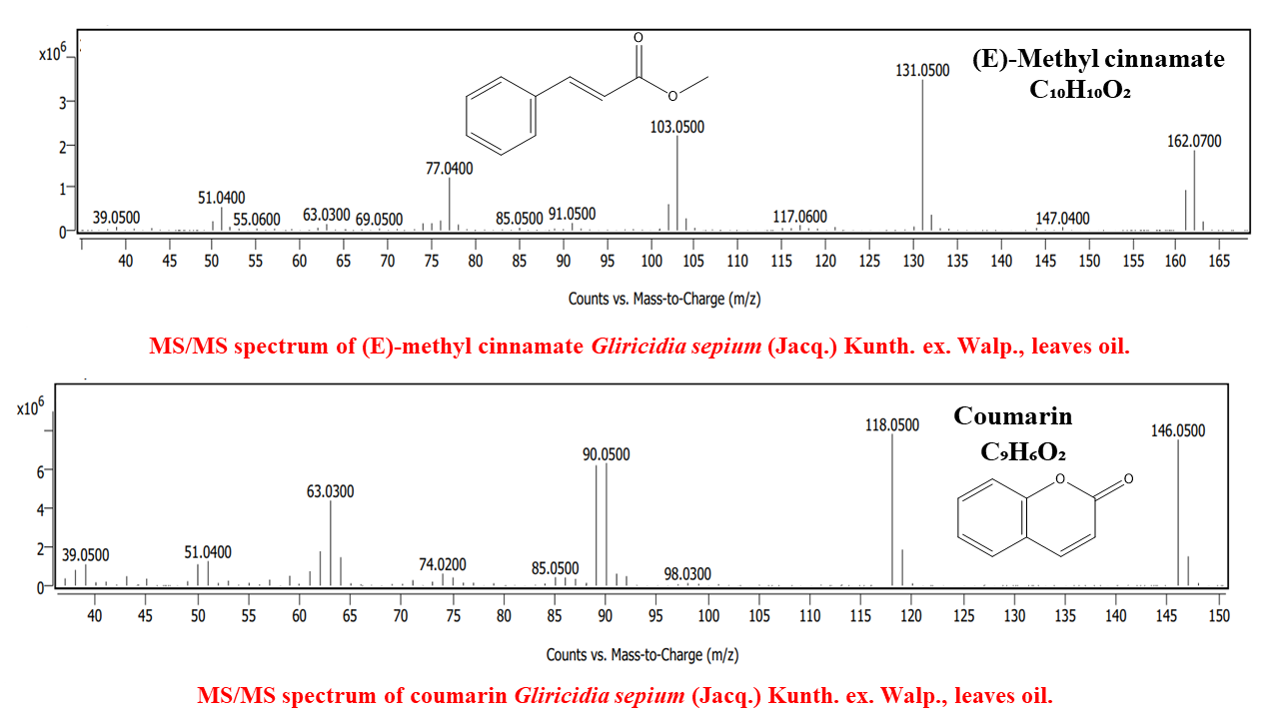
Fig. S31. MS/MS spectrum of (E)-methyl cinnamate Gliricidia sepium (Jacq.) Kunth. ex. Walp. leaves oil.

Fig. S32. MS/MS spectrum of coumarin Gliricidia sepium (Jacq.) Kunth. ex. Walp. leaves oil.

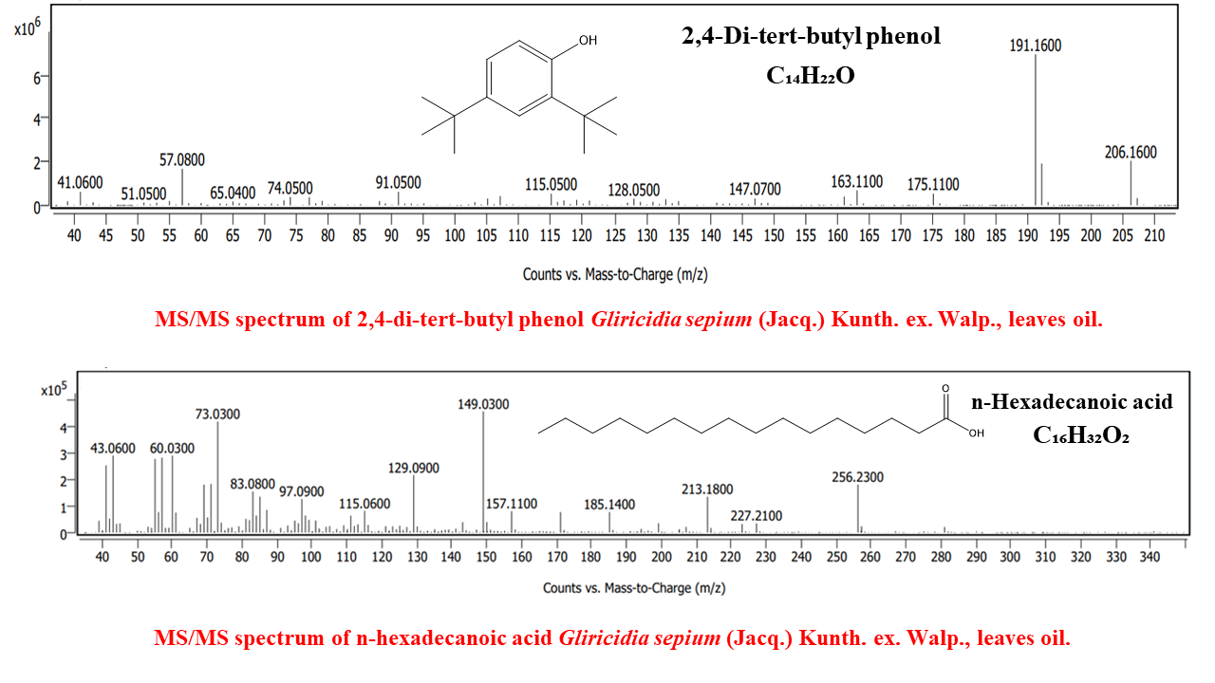

Fig. S33. MS/MS spectrum of 2,4-di-tert-butyl phenol Gliricidia sepium (Jacq.) Kunth. ex. Walp. leaves oil.

Fig. S34. MS/MS spectrum of n-hexadecanoic acid Gliricidia sepium (Jacq.) Kunth. ex. Walp. leaves oil.

