*Egypt. J. Chem.* **Vol. 67**, No. 12 pp. 299 - 305 (2024)

### Volatiles Composition of Fresh Aroma and Hydrodistilled Volatile Oil of *Chrysopogon Zizanioides* Roots Growing In Egypt Along With the Cytotoxic Activities of the Hydrodistilled Oil

### Mahmoud A. M. Arafata, Mohammed N. A. Khalilb, Engy A. Mahrousb,c,*, Essam M. Abd El-kaderd and Seham El-Hawaryb

a Pharmacognosy Department, Faculty of Pharmacy, Heliopolis University, 11361, Egypt

b Pharmacognosy Department, Faculty of Pharmacy, Cairo University, Cairo, 11562, Egypt

c Pharmacognosy Department, Faculty of Pharmacy, Ahram Canadian University, Giza, 12451, Egypt

d Timber Tree Research department, Horticulture Research Institute, Agriculture Research Center, Cairo, 12619, Egypt

**Supplementary material**

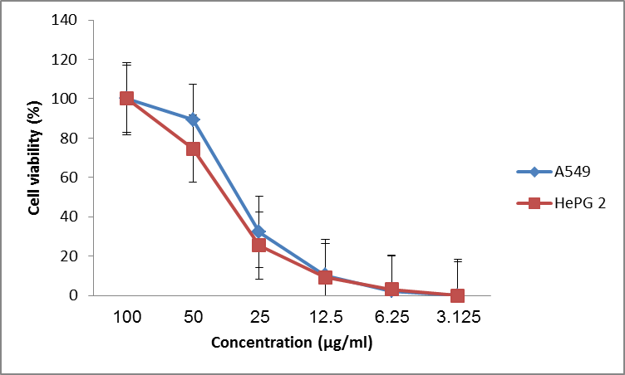

**Figure S1: The cell viability profiles of A549 and HePG2 with *C. zizanioides* oil treatments.**

**Table S1: Composition of the volatile aroma of the fresh sample aroma (FSA) analyzed by headspace (HS) and the hydrodistilled oil (HDO)**

|  |  |  |  |  |  |  |  |
| --- | --- | --- | --- | --- | --- | --- | --- |
|  | | | | Relative contents, % | | |  |
| KI | Components | | | HS | HDO | | Chemical class | |
| 1008 | o-Cymene | | | 0.19 | - | | Monoterpene | |
| 1017 | limonene | | | 0.18 | 0.21 | |
| 1046 | γ-Terpinene | | | 0.09 | - | |
| 1228 | Carvone | | | - | 7.07 | | Oxygenated monoterpenes | |
| 1239 | Carveol | | | - | 0.64 | |
| 1332 | Phenethyl alcohol, 2-(1-hydroxyethyl)-α-methyl | | | 0.57 | - | |
| 1344 | α-Cubebene | | | 0.01 | - | | Sesquiterepnes  (non-oxygneated) | |
| 1361 | Cyclosativene | | | 3.30 | - | |
| 1365 | Ylangene | | | 0.66 | - | |
| 1375 | longipinene | | | 1.53 | - | |
| 1378 | α-Cubebene | | | 0.67 | - | |
| 1393 | β-Cubebene | | | 0.55 | - | |
| 1398 | α-bergamotene | | | 0.42 | - | |
| 1404 | Cedr-8(15)-ene | | | 3.80 | - | |
| 1408 | α-Gurjunene | | | 1.95 | - | |
| 1414 | Caryophyllene | | | - | 0.18 | |
| 1416 | α-Copaene | | | 1.37 | - | |
| 1422 | cis-muurola-4(14),5-diene | | | 0.77 | - | |
| 1430 | α-Guaiene | | | 0.08 | 0.94 | |
| 1433 | Aristol-9-ene | | | 2.16 | - | |
| 1437 | Sativene | | | 11.52 | - | |
| 1442 | Bicyclo[5.2.0]nonane, 2-methylene-4,8,8-trimethyl-4-vinyl | | | 14.17 | - | |
| 1446 | allo-Aromadendrene | | | 4.94 | - | |
| 1456 | Acoradiene | | | 0.98 | - | |
| 1458 | β-ylangene | | | 0.30 | - | |
| 1460 | Neoisolongifolene, 8,9-dehydro- | | | 0.16 | - | |
| 1469 | 1-Isopropyl-4,7-dimethyl-1,2,4a,5,6,8a- | | | 3.51 | - | |
| 1474 | δ-Guaiene | | | 1.03 | - | |
| 1478 | (gamma.-Muurolene) | | | 0.73 | - | |
| 1479 | δ-Selinene | | | 2.07 | - | |
| 1482 | eremophilene | | | 1.51 | - | |
| 1486 | Germacrene D | | | 0.22 | - | |
| 1488 | 4,5-di-epi-aristolochene | | | 1.16 | - | |
| 1495 | δ-Cadinene | | | 1.80 | - | |
| 1496 | α-Muurolene) | | | 0.36 | 0.39 | |
| 1502 | 3-Carene, 4-acetyl | | | - | 0.12 | |
| 1504 | α-(Z,E)-Farnesene | | | 0.04 | - | |
| 1507 | (-)-delta.-Panasinsine | | | 2.30 | - | |
| 1510 | Valencene | | | 9.41 | - | |
| 1522 | Isodaucene | | | - | 0.15 | |
| 1523 | -selinene | | | 0.78 | - | |
| 1531 | α-Bulnesene | | | 0.39 | - | |
| 1538 | β-Vatirenene | | | 1.99 | - | |
| 1548 | Aristolene | | | 0.58 | - | |
| 1549 | α -Curcumene | | | - | 0.21 | |
| 1565 | longifolene | | | 2.44 | - | |
| 1638 | á-Vatirenene | | | - | 0.48 | |
| 1504 | sesquicineole | | | 0.60 | - | | Ethers | |
| 1631 | Ledene oxide-(II) | | | - | 0.27 | |
| 1640 | Aromadendrene oxide-(2) | | | - | 0.88 | |
| 1656 | ç-Gurjunenepoxide-(2) | | | - | 2.25 | |
| 1686 | Aristolene epoxide | | | - | 3.05 | |
| 1764 | Aromadendrene oxide-(1) | | | - | 0.33 | |
| 1772 | Calarene epoxide | | | - | 1.65 | |
| 1792 | 4,6,6-Trimethyl-2-(3-methylbuta 1,3 dienyl)oxatricyclo[5.1.0.0(2,4)]octane | | | 0.70 | - | |
| 1532 | Eudesm-4(14)-en-11-ol | | | - | 3.39 | | Alcohols | |
| 1544 | β-Eudesmol | | | 1.85 | - | |
| 1570 | (cis-Eudesm-6-en-11-ol) | | | 0.52 | - | |
| 1571 | Germacrene D-4-ol | | | 0.6 | - | |
| 1596 | Selina-6-en-4-ol | | | 0.94 | - | |
| 1600 | Humulane-1,6-dien-3-ol | | | 2.13 | - | |
| 1602 | Cubenol | | | - | 0.16 | |
| 1605 | (Selin-6-en-4.alpha.-ol) | | | 0.04 | - | |
| 1613 | (Junenol) | | | 0.42 | - | |
| 1620 | allo-Khusiol | | | - | 0.61 | |
| 1639 | Delta cadinol | | | - | 0.68 | |
| 1642 | Eudesm-7(11)-en-4-ol | | | - | 3.7 | |
| 1643 | Cubenol | | | - | 0.65 | |
| 1645 | Cedr-8(15)-en-9-ol | | | - | 0.47 | |
| 1648 | tau.-Cadinol | | | - | 6.26 | |
| 1677 | Zizanol | | | - | 3 | |
| 1710 | Aristol-1(10)-en-9-ol | | | - | 2.33 | |
| 1712 | Cedr-8-en-13-ol | | | 5.74 | 1.97 | |
| 1714 | 4,11(13)-Eudesmadien-12-ol | | | - | 0.34 | |
| 1718 | (Khusimol) | | | 0.21 | 16.48 | |
| 1735 | à-Vetivol | | | - | 1.06 | |
| 1736 | Valerenol | | | - | 0.74 | |
| 1752 | Aristol-1(10)-en-9-ol | | | - | 12.51 | |
| 1760 | lanceol | | | 2.29 | - | |
| 1770 | α-Muurolene-14-ol | | | - | 0.2 | |
| 1774 | Cyclocopacamphenol | | | - | 7.69 | |
| 1776 | beta-Costol | | | - | 0.6 | |
| 1856 | Isovalencenal | | | - | 2.49 | | Aldehydes | |
| 1607 | 2H-Benzocyclohepten-2-one,3,4,4a,5,6,7,8,9-octahydro-4amethyl-,(S)- | | | - | 0.21 | | Ketons | |
| 1606 | Khusimone | | | - | 2.06 | |
| 1669 | Epizizanone | | | - | 2.02 | |
| 1700 | Oplopanone | | | 0.29 | - | |
| 1780 | ((-)-.beta.-Vetivone) | | | 0.85 | - | |
| 1789 | Nootkatone | | | - | 0.44 | |
| 1801 | Aristol-9-en-8-one | | | 0.98 | - | |
| 1842 | (-)-á-Vetivone | | | - | 3.39 | |
| Relative contents % | | Monoterpenes | 0.46 | | | 0.21 |  | |
| Oxygenated monoterpenes | 0.57 | | | 7.71 |
| Sesquiterpenes (non-oxygenated) | 79.69 | | | 2.47 |
| Sesquiterpenes (ether) | 1.30 | | | 8.43 |
| Sesquiterpenes (alcohol) | 14.14 | | | 63.44 |
| Sesquiterpenes (aldehyde) | - | | | 2.49 |
| Sesquiterpenes (ketones) | 2.11 | | | 8.12 |
| Identified compounds | 98.27 | | | 92.87 |
| Un-identified compounds | 1.73 | | | 7.13 |

**Table S2: Cytotoxicity profile with IC50 values of *C. zizanioides* oil sample and doxorubicin**

|  |  |  |
| --- | --- | --- |
| **Cell line** | **IC50 (µg/ml)** | |
| Oil sample | Doxorubicin |
| A549 | 32.16 ± 1.19 | 28.30 ± 0.08 |
| HePG2 | 37.63 ± 1.02 | 21.60 ± 0.07 |