*Egypt. J. Chem.* **Vol. 68**, No. 12pp. 95 - 105 (2025)

**Standardized *Melaleuca Leucadendra* (L.) L. and *Melaleuca Styphelioides* Sm. Leaf Extracts Attenuate Obesity in High-Fat-Diet-Fed Rats**

**Sahar A.M. Hussein1#, Mahmoud Emam1#, Dina F. Mansour2, Dalia O. Saleh2, Rasha A. Radwan 3, Sherien M. Bakry1, Nesrine M. Hegazi*1**

*1Phytochemistry and Plant Systematics Department, Pharmaceutical Industries Institute, National Research Centre, Dokki, Cairo 12622, Egypt.*

*2Pharmacology Department, Medical Research and Clinical Studies Institute, National Research Centre, Dokki, Cairo 12622, Egypt.*

*3Biochemistry Department, Faculty of Biotechnology, German International University, Regional Ring Rd, East Cairo, New Administrative Capital, Egypt*

# authors contributed equally to this work

Supplementary data

**Supplementary Fig.1: *HPLC chromatogram of nineteen available polyphenol standards* monitored at 280 nm.**

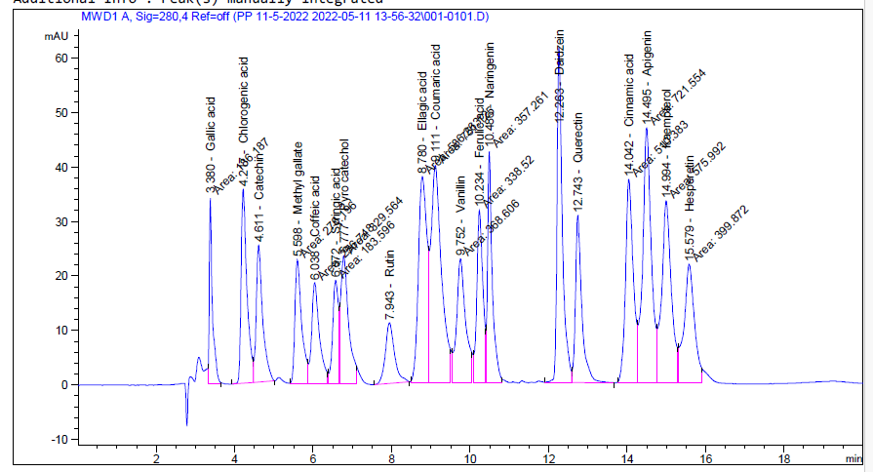

**Supplementary Fig 2: HPLC chromatogram of *M. leucadendra***

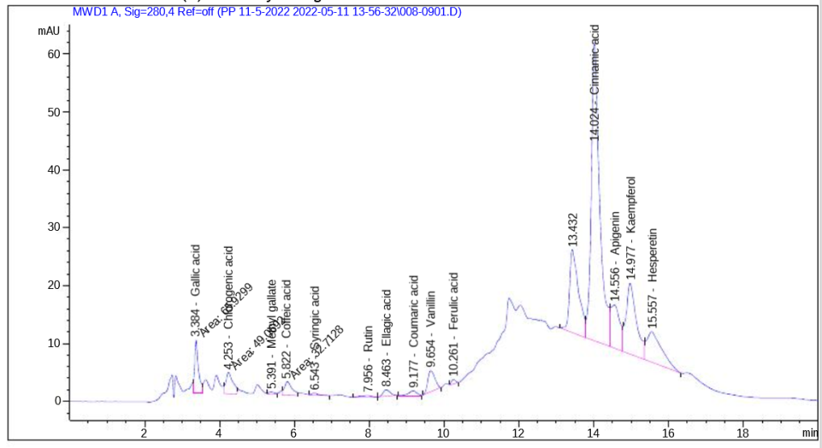

**Supplementary Fig 3: HPLC chromatogram of *M. styphelioides***

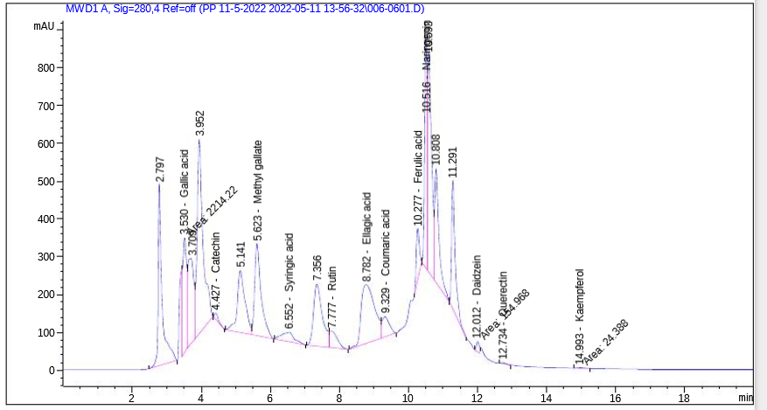

**Supplementary Fig 4: 1H-NMR chromatogram of *M. leucadendra***

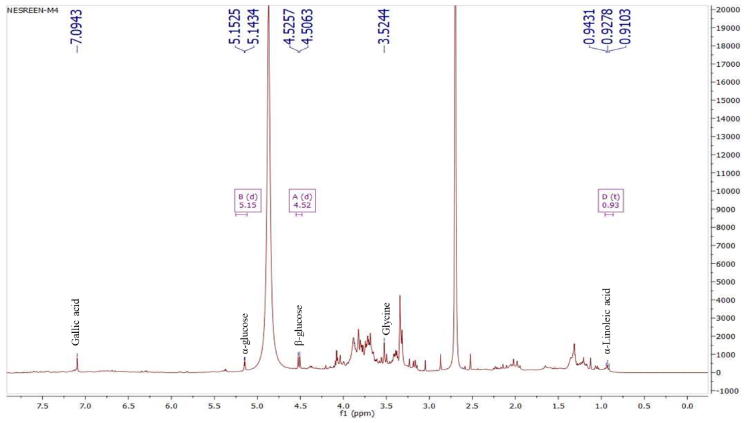

α-Linoleic acid

**Supplementary Fig 5: 1H-NMR chromatogram of *M. styphelioides***

