Supplementary Information
Facile In-Situ Synthesis of Nanocrystalline Celluloses-Silver Bio-nanocomposite for Chitosan Based Active Packaging
Mona T. Al-Shemy¹*, Amira M. El-Shafei², Aly Al-Sayed³ and Abeer M.Ade^{l}
¹ National Research Centre, Cellulose and Paper Department, 33El-Bohouth St. (Former El-Tahrir St.), Dokki, P.O. 12622, Giza, Egypt.
² National Research Centre, Textile Research and Technology Institute, 33El-Bohouth St. (FormerEl-Tahrir St.), Dokki, P.O. 12622, Giza, Egypt.
³ National Research Centre, Water Pollution Research Department, 33El-Bohouth St. (Former El-Tahrir St.), Dokki, P.O. 12622, Giza, Egypt.
Online Resource 1 XRD patterns of the three extracted NCs

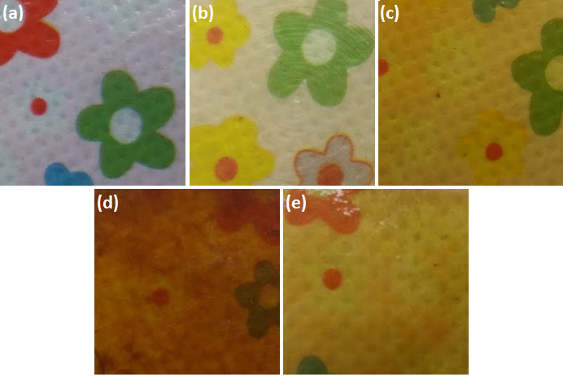
Online Resource 2 Transparency of (a) uncovered background, (b) neat CS film, (c, d & e) CS bio-nanocomposite loaded with ONC-Ag, SNC-Ag and PNC-Ag, respectively

