.

Supplementary Data
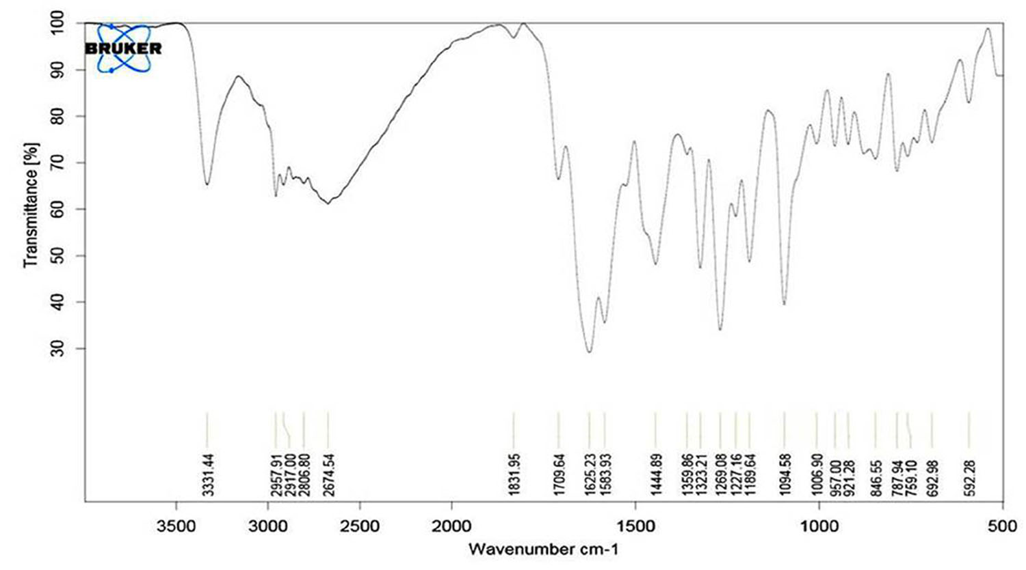
Figure S1: IR spectrum (KBr) of Albendazole sulfoxide

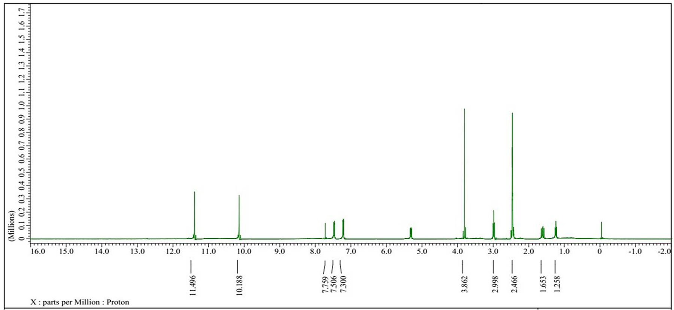
Figure S2: ¹H NMR spectrum (400 MHz, d₆-DMSO) of Albendazole sulfoxide

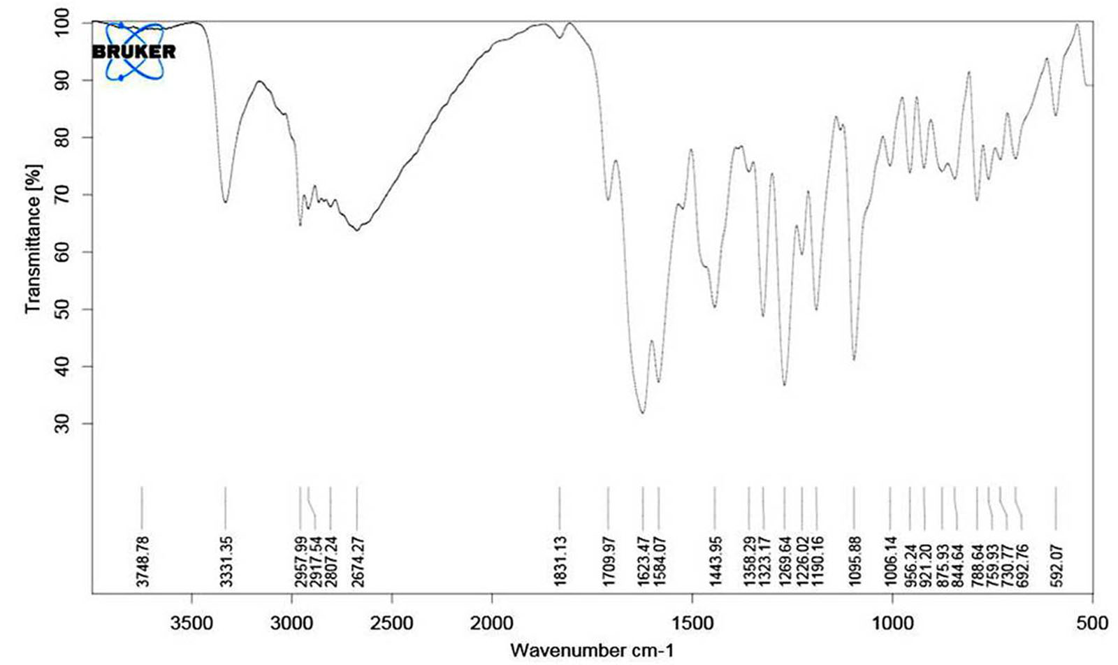
Figure S3: IR spectrum (KBr) of Albendazole sulfone.

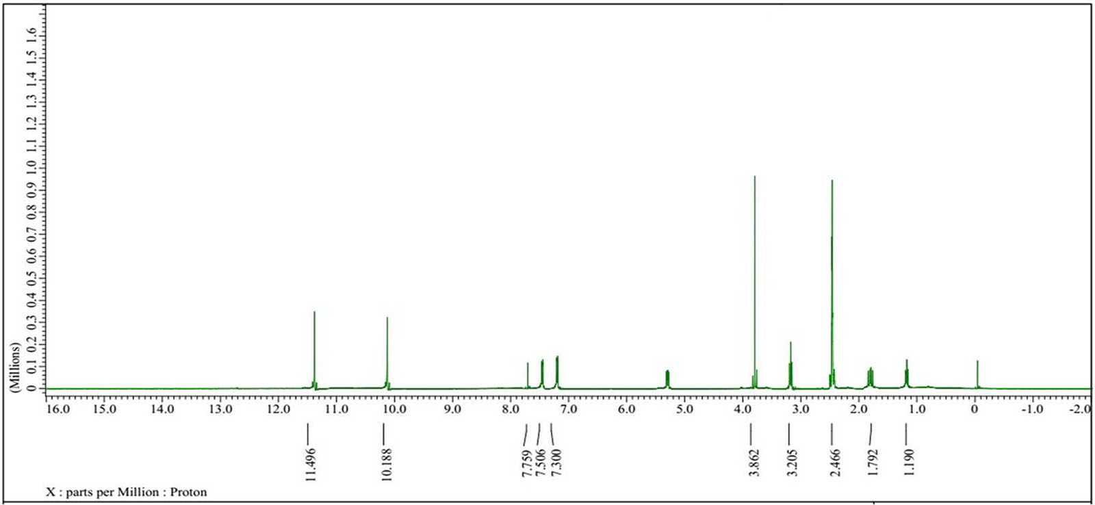
Figure S4: ¹H NMR spectrum (400 MHz, d₆-DMSO) of Albendazole sulfone

Table T1: ¹H₁ NMR values of Albendazole, Albendazole sulfoxide and Albendazole sulfone
Atom index | ABZ | ABZSO | ABZSO2
Atom index | 1H | 1H | 1H
1
2
3 | 11.496 | 11.496 | 11.496
4 | 7.759 | 7.759 | 7.759
5
6 | 7.300 | 7.300 | 7.300
7 | 7.506 | 7.506 | 7.506
8
9 | 2.833 | 2.998 | 3.205
10 | 1.559 | 1.653 | 1.792
11 | 1.103 | 1.258 | 1.190
12 | 10.188 | 10.188 | 10.188
13
14 | 3.862 | 3.862 | 3.862
d₆-DMSO | 2.466 | 2.466 | 2.466

