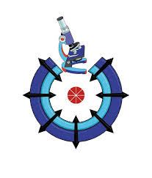
420

Egyptian Journal of Chemistry
http://ejchem.journals.ekb.eg/

Multi-walled Carbon Nanotubes Synthesis from Ethanol and 2-Propanol by Chemical Vapor Deposition
Bashaer J Kahdum Emad Salaam Abood², Ahmed Salim Abed²
¹Department of Food Sciences, Faculty of Agriculture, University of Kufa, Iraq
²Medical Physics Department, Hilla University College, Babylon, Iraq
Abstract
Carbon nanotubes (CNT) have received great consideration owing to their vital features sizes and prospective uses, despite their restricted obtainability cause their big manufacture budget. In the present research, the substitute method may cause dropping the industrial fees of CNTs by means of the use of the chemical vapor deposition technique. For this aim aliphatic-Alcohol's mixture (ethanol, 2-propanol) is utilized as the carbon source. Crystallographic and morphological of multi-walled carbon nanotubes have been categorized exhausting powder X-ray deflection, thermal gravimetric examination, scanning electron microscopy and Raman spectroscopy. The outcomes indicate that produced MWNTs have a pureness of 57.80%, an exterior diameter of 6.6-17.9 nm, an interior diameter of 3.2-6.3 nm, where is equivalent to 3-9 graphene covers, and a tube size of 0.8 to 2 μm.
Keywords: Nanotechnology, Aliphatic alcohols, CVDs, Carbon Nanotubes tubes

Introduction
Nanotechnology is the manipulation, by unique physical or chemical processes, of materials having a nano-scale of 1-100 nm and used in specific applications to shape materials with specific properties.[1] Carbon Nanotubes (CNTs) are tubes that made of carbon in diameter of nanometer, they refer to single-walled CNTs (SWCNTs) or multi-walled nanotubes (MWCNTs). SWCNTs are between fullerene cage and flat grapheme and they are a type of allotropes of carbon, while MWCNTs are nested SWCNTs bonded together with van der Waals interactions like tree structure (Figure 1).[2-4]

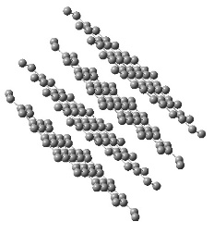  a | 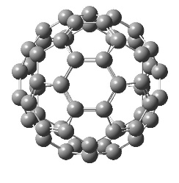  b
c | d
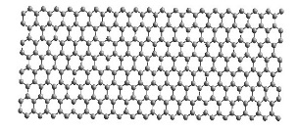  e | 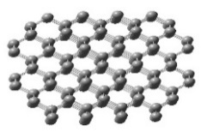  f
Fig. 1. Carbon based materials a- graphite, b-fullerene, c- Single walled carbon nanotubes, d- Multiwalled carbon nanotubes, e graphene and f- Diamond.

CNTs are made using a variety of methods, including laser ablation, arc discharge, and deposition of chemical vapor. CVD is the best method among several methods for synthesis of CNTs because it produces large yields of high purity CNTs. The types of catalysts, precipitation temperatures, and synthesis methods were all employed to border different forms of CNTs (Figure 2).[5]
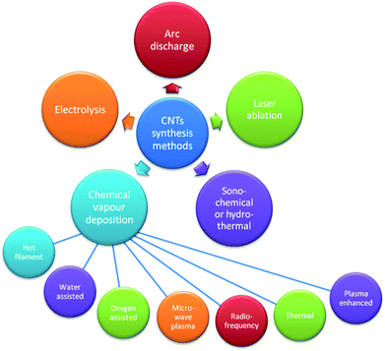
Figure 2: Methods for CNTs synthesis.[5]
Carbon Nanotubes have many applications such as composite materials, applications in many science branches such as nano-medicine, biosensors or polymer[6], Electrochemical system (Li battery, Additives to electrodes of lead-acid batteries, and Electric double-layer capacitor)[7, 8], Multifunctional fillers in polymer composite[6], and medical applications. [6].
So, our article aims to synthesize MWCNTs via carbon source from ethanol and 2-propanol mixture by Chemical Vapor Deposition (CVDs) with a homogeneous length and diameter from 50/50 without support cover, C2/C3 for the growing. The Production depends on the molecular interaction of alcohol in C2 and C3 for homogenous evaporation.
2. Experimental
2.1. Methodology

Alfa Assar provided Ethanol C2H5OH and 2- Propanol, C3H8O with purity levels of 99 % and 99.93 %, respectively. H2O2 peroxide hydrogen for the purification process, 30% weight was purchased from Spain. N2 gas, which was utilized as a transporter gas, was imported from the UAE with a purity of 99.99 %.

Production of MWCNTs
Using three-stage tube furnace (Nabertherm in the United States) to prepare MWCNTs via CVDs (Chemical Vapor Deposition).
Tube furnace is a quartz tube with length 120 cm and diameter 5 cm. A ceramic boat was utilized to keep the precipitation catalyst alive. To remove air from all tube reactions, nitrogen gas was purged with a flow rate 125 cm³/min prior to turning on the tube furnace. The furnace was turned on a 750ºC with flow rate 3.4ºC/min of an ambient heating pressure, at atmosphere pressure and 30 min response time with flow of inert nitrogen gas to achieve the desired temperature. The flow of gas has been steadily reduced to an average level 80 cm³/min. At 70°C., the transfer of N² gas (1:1) C2/C3 evaporates. After being deposed, while carbon sources were distributed during a vaporizer, the oven was switched off and the space was permitted to cool in a steady temperature of N₂.
Phillips PW 1800 was utilized for X-ray diffraction (XRD), Senterra Infinity Broker 1 was used for identified Raman Spectroscopic. Pure CNTs were characterized using SEM analysis and EDX tools (a JEOL JSM-6700F). Thermo-gravimetric analysis is applied via using (Jupiter, STA 449C Netzsch).

Results and discussion

- XRD analysis
Figure 3 displays MWCNTs XRD data, which demonstrates sharp and intense diffraction around 2 = 26.8, which might be due to graphite's C (001) reflection. The (101) and (004) planes of the nanotubes construction are responsible for the maxima around 42.3° and 54.640°, correspondingly [9-12].

Figure 3: XRD patterns of the MWCNTs obtained at 750ºC from 50/50 (v/v) C2:C3in N2 atmosphere
- Raman Spectra
Figure 4 depicts Raman spectroscopy. It has two significant peaks: D band at 1298.71 cm⁻¹, which is connected to sp³ and is caused by the presence of amorphous carbon contaminants and imperfections in the CNTs material. The next G band peak was displaced at 1559.56 cm⁻¹, according to sp² hybridized carbon atoms, while the last faint peak occurred at 2907.9 cm⁻¹, according to the G+D. The peaks belong to MWCNTs with superior crystalline quality and reduced deformation since the ID/IG relation was equal to 1.89, which might be related to usual distribution temperature[13-16].

Figure 4. Raman spectra of MWCNTs obtained at 750ºC from 50/50 (v/v) C2:C3in N2 atmosphere
- SEM image
Figure 4 displays SEM pictures of MWCNTs produced by CVD for 1:1 C2:C3 alcohol at 750 oC in a N2 environment. MWCNTs having a size of much more than 5.5 m and an average size of 35-45 nm, with a scope of 100 nm. The SEM pictures show reveal the tubes possess a bamboo-like structure with various numbers of carbon layers that the Multi-carbon nanotubes are attached to the interfaces of certain unsaved carbon, which generally refers to amorphous carbon in several places. When Ethanol alcohol with a close boiling C2 and denatured alcohol with a high boiling point C3 are mixed in equal ratios, the boiling point for the mixture with different orientation for the molecules is usually reduced.[17-19]

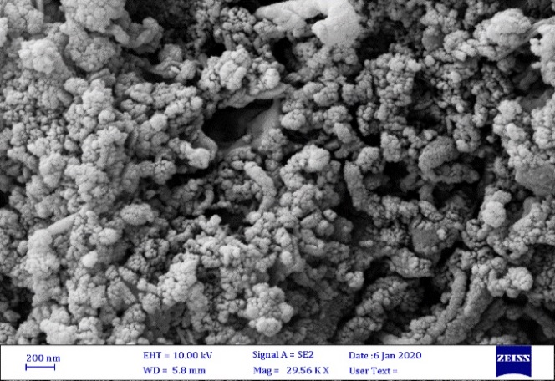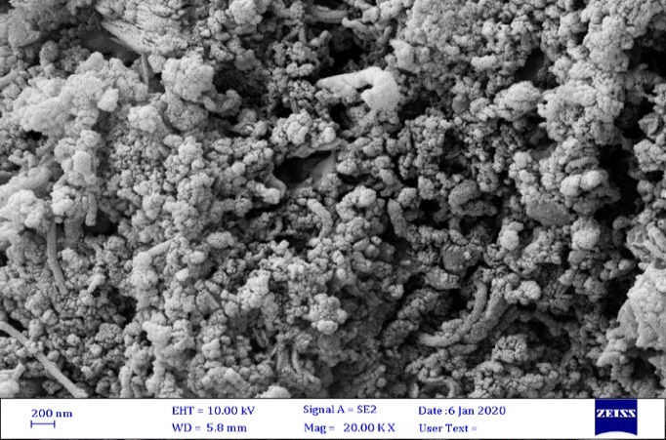
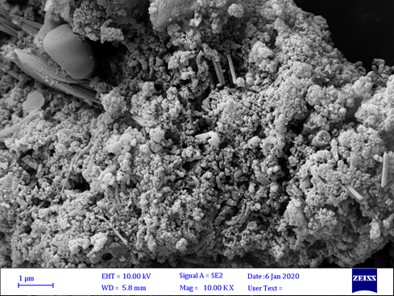
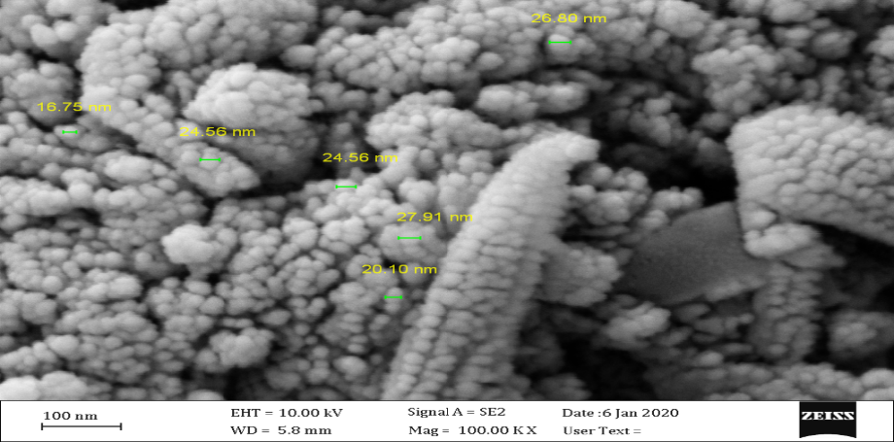
Figure 5. SEM image at size 100 nm for created MWCNTs dumped from C2:C3 at 750 ºC

- EDX analysis
EDX analysis was used to examine the composition of the synthesized CNTs and directly influencing, as shown in Figure 6, which revealed C, O, Na, and Si. Carbon, oxygen, and sodium generated during the refining process by hydrogen peroxide, as well as other components from the equipment, created a peak.[20]
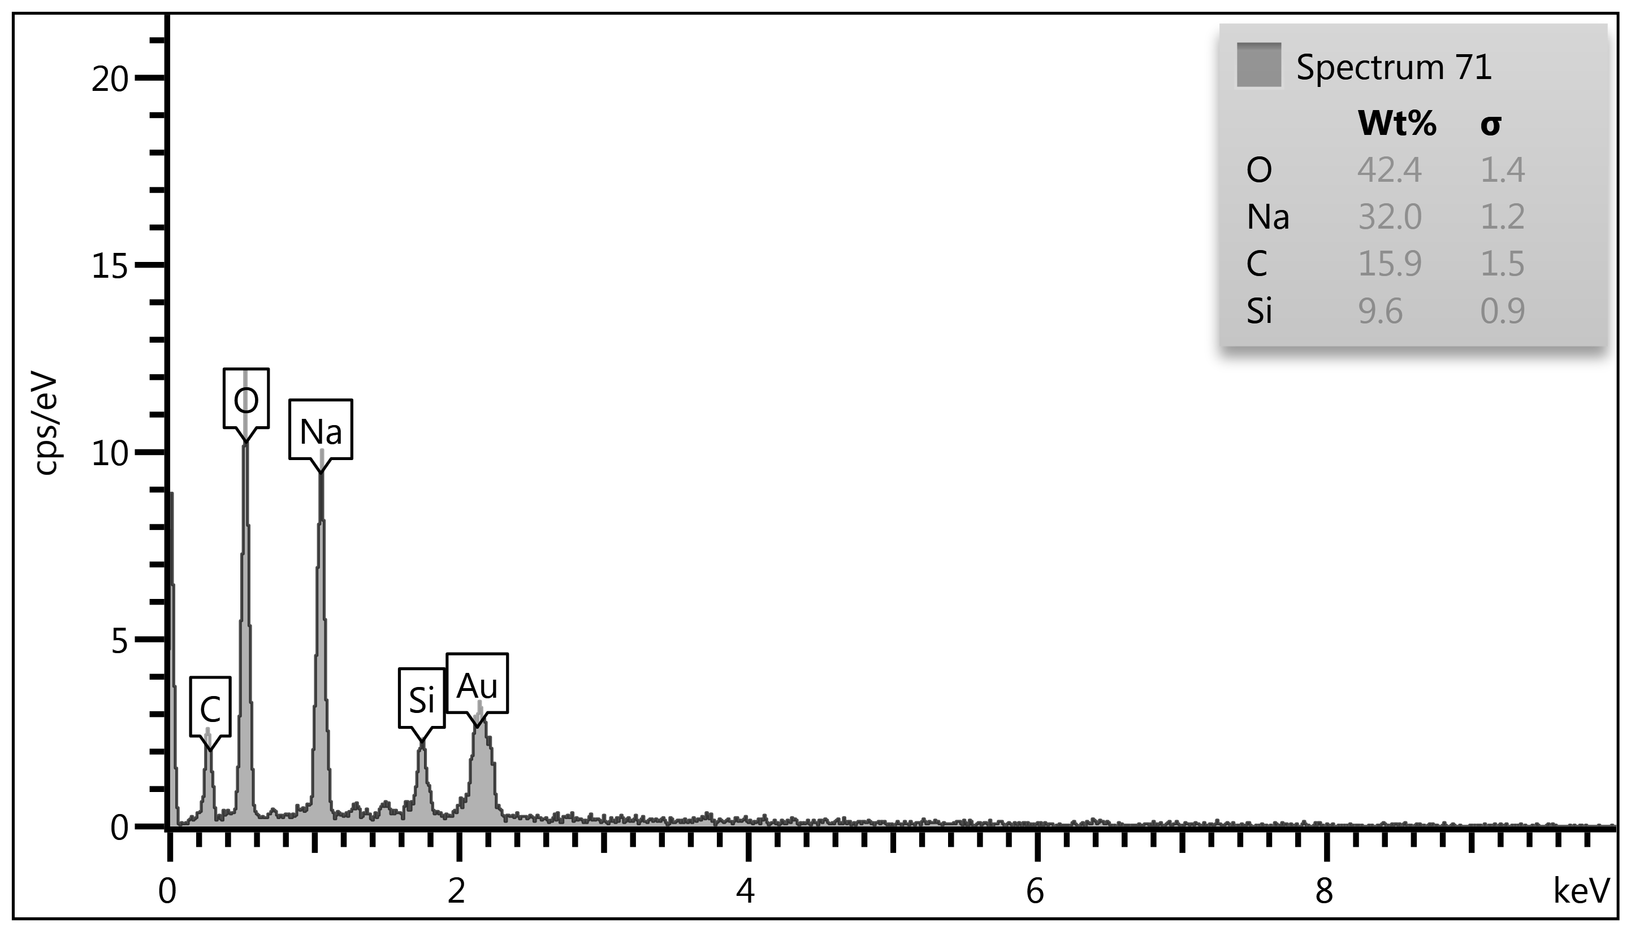
Figure 6 .EDX analysis represents the dispersion of O, Na, Si and C in created MWCNTs popular N2 atmosphere.
- Thermal gravimetric analysis (TGA)
A thermal gravimetric analysis (TGA), as illustrated in Figure 7, was used to determine the tubular structure ratios in the synthesized sample. The result was a modest weight loss between 150 and 200 degrees Celsius, which was attributable to the evaporating of the adsorbed water.[21, 22] The steady losing weight from 550-600 °C occurs at a reasonable pace and hence at higher temperatures, owing to a lower C ratio in comparison to several metals present in the sample, as indicated by EDX analysis. The steady losing weight from 550-600 °C occurs at a reasonable pace and hence at higher temperatures, owing to a lower C ratio in comparison to several metals present in the sample, as indicated by EDX analysis. When heated to 1000°C, this sample lost 76 percent of its mass, and when cooled, 18wt percent of the material survived in the furnace and looked to be a transparent light green film.[22]. The last behaviour can be related to nature of precipitation when the %C in 2-propanol more than %C in ethanol that make it less regular with increases the amorphas carbon in this sample. The total mass loss observed by heating sample to 1000°C is 76 wt% and after cooling18 wt% of the material speckled puck was left in the crucible. Mostly the analysis refers to FWCNTs.

Figure7: Schematic diagram of TGA of CNTs from 2-propanol with ethanol

Conclusion
From pervious results, we can conclude that aliphatic alcohols such as ethanol and propanol are safe in treatment during synthesis of CNTs as a good carbon source with low temperature requirement in evaporation to afford MWCNTs with high quality. Also, CVD is suitable method to afford CNTs efficiently and simply. XRD showed CNTs peaks that located on 26º and 43º. Raman spectra confirms CNTs indicator at three peaks D band, G band Gʹ band. The average highest length and lowest diameters of produced CNTs was found 5.5 µ and 35-45 nm respectively.

References
[1] K.A. Dick, K. Deppert, M.W. Larsson, T. Mårtensson, W. Seifert, L.R. Wallenberg, L. Samuelson, Synthesis of branched'nanotrees' by controlled seeding of multiple branching events, Nature materials 3(6) (2004) 380-384.
[2] S. Iijima, Helical microtubules of graphitic carbon, nature 354(6348) (1991) 56-58.
[3] M.S. Dresselhaus, G. Dresselhaus, P. Eklund, A. Rao, Carbon nanotubes, The physics of fullerene-based and fullerene-related materials, Springer2000, pp. 331-379.
[4] D. Vairavapandian, P. Vichchulada, M.D. Lay, Preparation and modification of carbon nanotubes: Review of recent advances and applications in catalysis and sensing, Analytica chimica acta 626(2) (2008) 119-129.
[5] J. Prasek, J. Drbohlavova, J. Chomoucka, J. Hubalek, O. Jasek, V. Adam, R. Kizek, Methods for carbon nanotubes synthesis, Journal of Materials Chemistry 21(40) (2011) 15872-15884.
[6] B. Scheibe, E. Borowiak-Palen, R.J. Kalenczuk, Oxidation and reduction of multiwalled carbon nanotubes—preparation and characterization, Materials Characterization 61(2) (2010) 185-191.
[7] M. Endo, T. Hayashi, Y.A. Kim, H. Muramatsu, Development and application of carbon nanotubes, Japanese Journal of Applied Physics 45(6R) (2006) 4883.
[8] R. Shoukat, M.I. Khan, Carbon nanotubes: A review on properties, synthesis methods and applications in micro and nanotechnology, Microsystem Technologies (2021) 1-10.
[9] K. Nishimura, N. Okazaki, L. Pan, Y. Nakayama, In situ study of iron catalysts for carbon nanotube growth using X-ray diffraction analysis, Japanese journal of applied physics 43(4A) (2004) L471.
[10] D. Maity, K. Rajavel, R.T.R. Kumar, Polyvinyl alcohol wrapped multiwall carbon nanotube (MWCNTs) network on fabrics for wearable room temperature ethanol sensor, Sensors and Actuators B: Chemical 261 (2018) 297-306.
[11] H. Ezzat, M. Ibrahim, H. Elhaes, Molecular Modeling Applied For Carbon Nano Materials, Egyptian Journal of Chemistry 63(12) (2020) 4777-4787.
[12] M. Ahmed, M. Elshafie, U. Kandil, M.R. Taha, Improving the Mechanical Properties of Thermoplastic Polyolefins Using Recycled Low-Density Polyethylene and Multi-Walled Carbon Nanotubes, Egyptian Journal of Chemistry 64(5) (2021) 2517-2523.
[13] P. Delhaes, M. Couzi, M. Trinquecoste, J. Dentzer, H. Hamidou, C. Vix-Guterl, A comparison between Raman spectroscopy and surface characterizations of multiwall carbon nanotubes, Carbon 44(14) (2006) 3005-3013.
[14] L.a. Bokobza, J. Zhang, Raman spectroscopic characterization of multiwall carbon nanotubes and of composites, Express Polymer Letters 6(7) (2012).
[15] A. Alkahlawy, R. El-Salamony, H.M. Gobara, Photocatalytic Degradation of Congo Red Dye via Multi-Walled Carbon Nanotubes Modified CuO and ZnO Nanoparticles under Visible Light Irradiation, Egyptian Journal of Chemistry 64(3) (2021) 10-11.
[16] A.E.-f.F. Shaaban, A.A.E.-s. Khalil, B.S. Elewa, M. Ismail, U.M. Eldemerdash, A New Modified Exfoliated Graphene Oxide for Removal of Copper (II), Lead (II) and Nickel (II) Ions from Aqueous Solutions, Egyptian Journal of Chemistry 62(10) (2019) 1823-1849.
[17] H.J. Li, W. Lu, J. Li, X. Bai, C. Gu, Multichannel ballistic transport in multiwall carbon nanotubes, Physical review letters 95(8) (2005) 086601.
[18] J.H. Lehman, M. Terrones, E. Mansfield, K.E. Hurst, V. Meunier, Evaluating the characteristics of multiwall carbon nanotubes, Carbon 49(8) (2011) 2581-2602.
[19] M. Albozahid, S. Mateab, Study the effect of adding mwcnts on the hardness, impact strength, and structural properties of composite materials based on epoxy polymer, Egyptian Journal of Chemistry (2021).
[20] N.A. Fathy, S.M. Elkhouly, R. Aboelenin, Carbon xerogel/Carbon Nanotubes Nanohybrid Doped with Ti for Removal of Methylene Blue Dye, Egyptian Journal of Chemistry 62(12) (2019) 2277-2288.
[21] V. Datsyuk, M. Kalyva, K. Papagelis, J. Parthenios, D. Tasis, A. Siokou, I. Kallitsis, C. Galiotis, Chemical oxidation of multiwalled carbon nanotubes, carbon 46(6) (2008) 833-840.
[22] E.G. Ordoñez-Casanova, M. Román-Aguirre, A. Aguilar-Elguezabal, F. Espinosa-Magaña, Synthesis of carbon nanotubes of few walls using aliphatic alcohols as a carbon source, Materials 6(6) (2013) 2534-2542.

